## location: asia, europe, north america

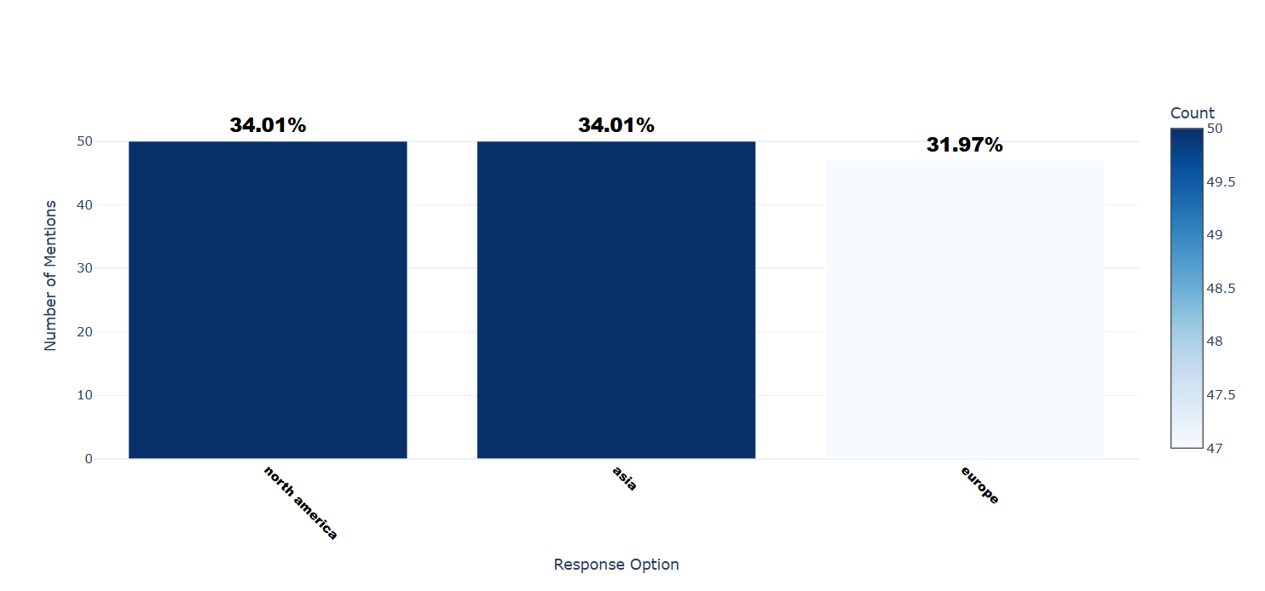

Number of respondents: 147

Breakdown of responses:

north america: 50 (34.01%)

asia: 50 (34.01%)

europe: 47 (31.97%)

## Q1.1: Consent for Prolific Participants You are invited to participate in a research project being conducted by Shreyash Parajuli, an undergraduate student in the School of Computing and Information Science at the University of Maine under the supervision of associate professor Dr. Sepideh Ghanavati at the University of Maine in the School of Computing and Information Science. The goal of this study is to explore how cultural norms affect privacy perception. To participate in this study, you must: ● Be between 18 and 65 years old ● Reside in North America, Europe, or Asia ● Be proficient in English ● Have access to a device with an internet connection ● Be willing to answer questions about privacy perceptions and online behaviors What Will You Be Asked to Do? If you decide to participate, you will be asked to take an anonymous online survey. The survey will ask about your experiences and opinions on IoT devices in smart homes. It should take 15-20 minutes. Risks: There are no risks associated with participating in this survey other than your time and inconvenience. Benefits: ● There are no direct benefits to you. ● This research may help us learn more about how culture affects privacy. That information will support the development of tools that accommodate diverse users and their preferences. Compensation Upon successful submission of the survey, you will automatically receive a credit of $4 per 20 minutes to your Prolific account, depending on the time taken to finish. Compensation will be provided per your contract with Prolific. Confidentiality This survey is anonymous ; please do not include your name anywhere on the survey. We do not collect any personal information during the survey, and there will be no record connecting your responses with your identity. All data will be stored on a password-protected computer indefinitely. Voluntary Participation is voluntary. Participants are asked to answer questions to the best of their ability. If you start the survey and do not wish to continue, you may stop anytime, and your responses will not be submitted. Contact Information If you have any questions about this study, please contact me at shreyash.parajuli@maine.edu. You may also reach out to the faculty advisor on this study at sepideh.ghanavati@maine.edu. If you have any questions about your rights as a research participant, please contact the Office of Research Compliance, University of Maine, 207-581-2657 (or e-mail umric@maine.edu). Do you give your consent to continue with the survey?

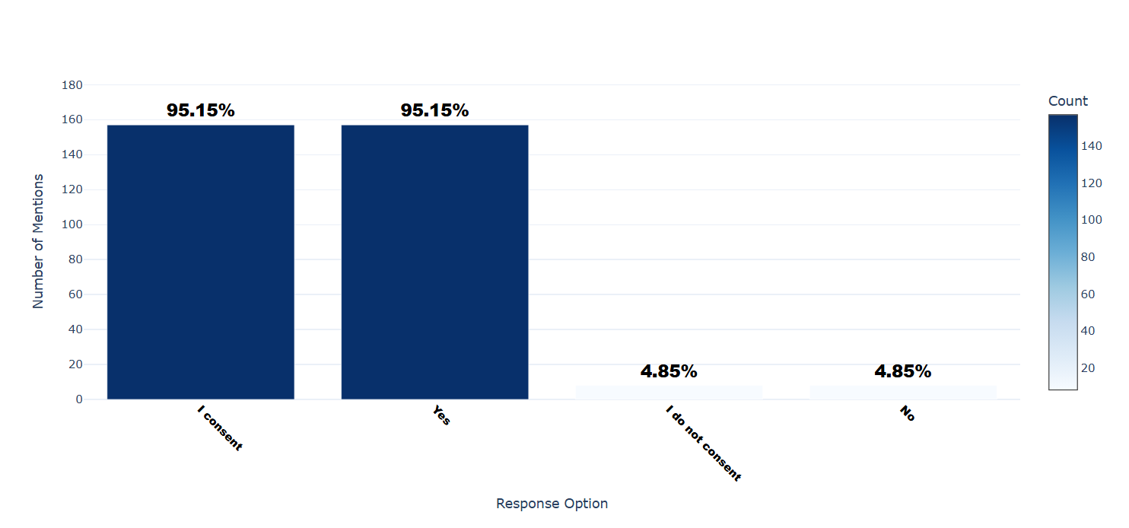

Number of respondents: 165

Breakdown of responses:

I consent: 157 (95.15%)

Yes: 157 (95.15%)

I do not consent: 8 (4.85%)

No: 8 (4.85%)

## Q3.1_1: How comfortable are you sharing the following types of personal information online? - Name

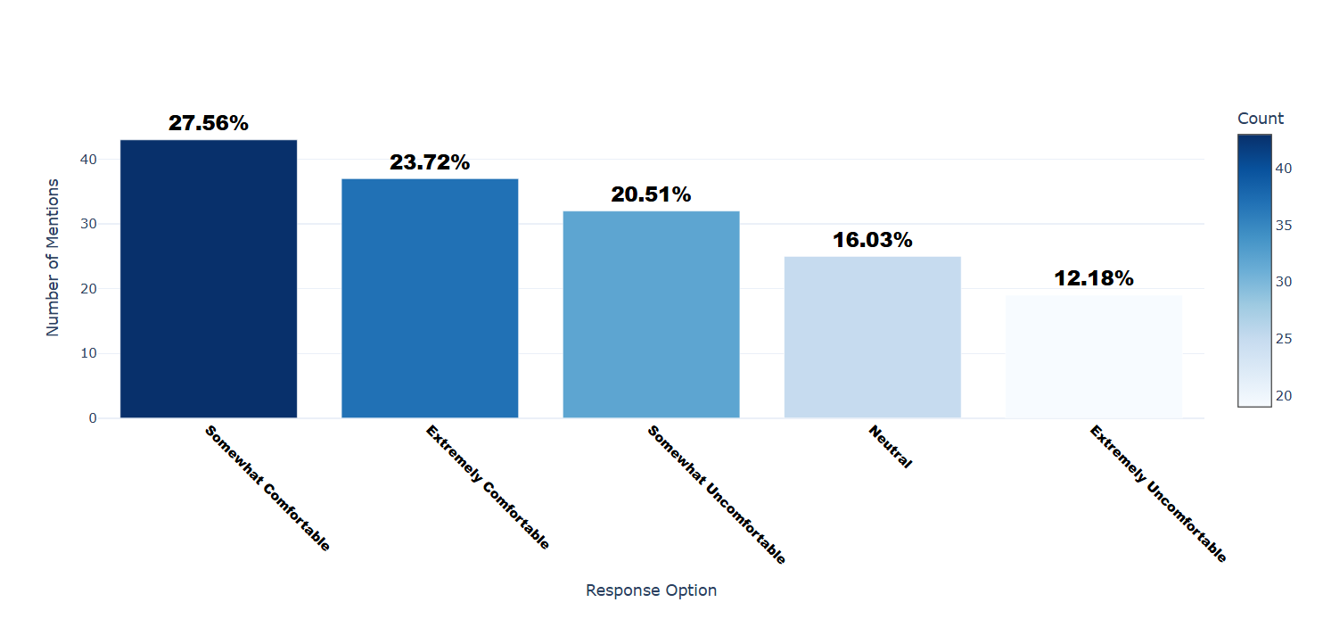

Number of respondents: 156

Breakdown of responses:

Somewhat Comfortable: 43 (27.56%)

Extremely Comfortable: 37 (23.72%)

Somewhat Uncomfortable: 32 (20.51%)

Neutral: 25 (16.03%)

Extremely Uncomfortable: 19 (12.18%)

## Q3.1_2: How comfortable are you sharing the following types of personal information online? - Address

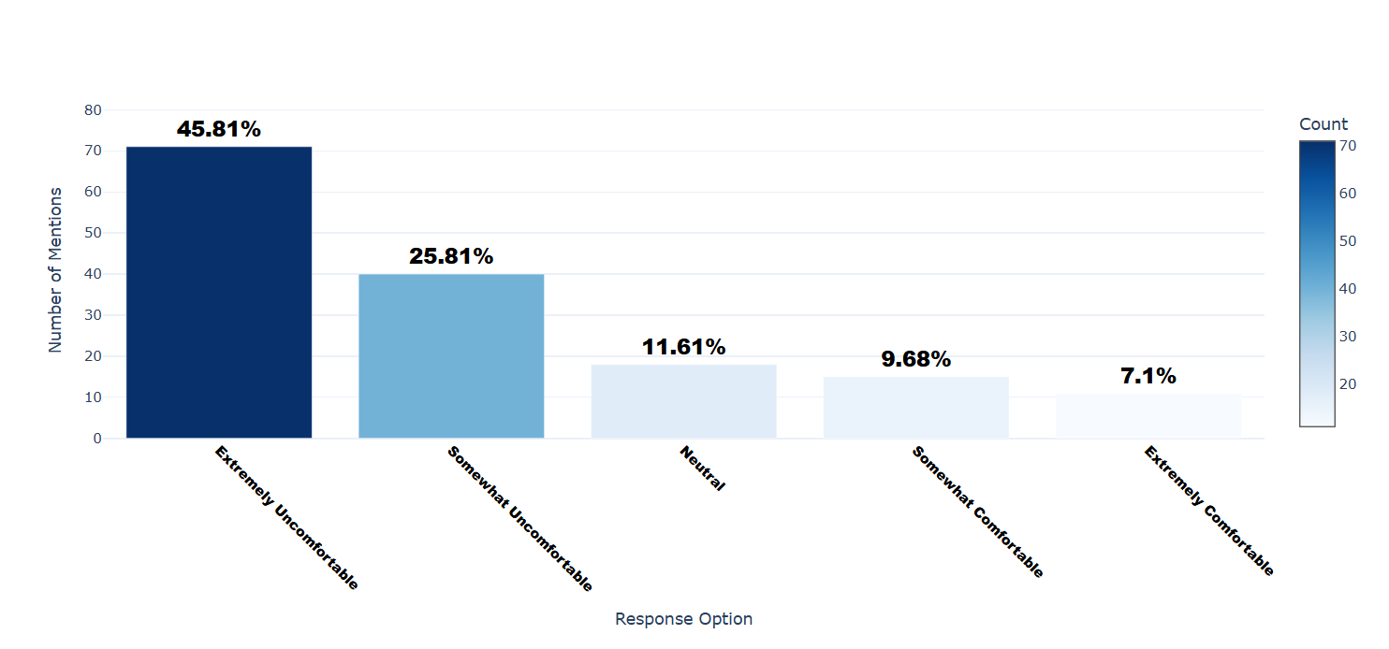

Number of respondents: 155

Breakdown of responses:

Extremely Uncomfortable: 71 (45.81%)

Somewhat Uncomfortable: 40 (25.81%)

Neutral: 18 (11.61%)

Somewhat Comfortable: 15 (9.68%)

Extremely Comfortable: 11 (7.1%)

## Q3.1_3: How comfortable are you sharing the following types of personal information online? - Location

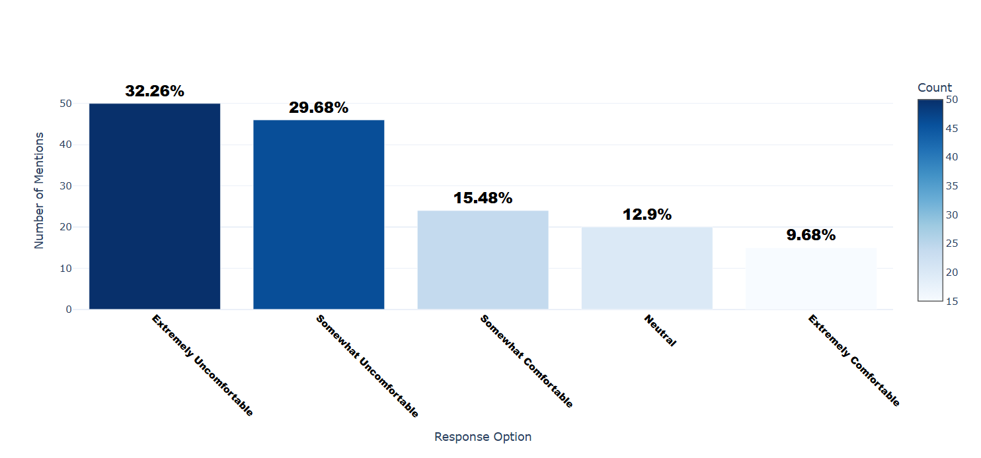

Number of respondents: 155

Breakdown of responses:

Extremely Uncomfortable: 50 (32.26%)

Somewhat Uncomfortable: 46 (29.68%)

Somewhat Comfortable: 24 (15.48%)

Neutral: 20 (12.9%)

Extremely Comfortable: 15 (9.68%)

## Q3.1_4: How comfortable are you sharing the following types of personal information online? - Phone Number

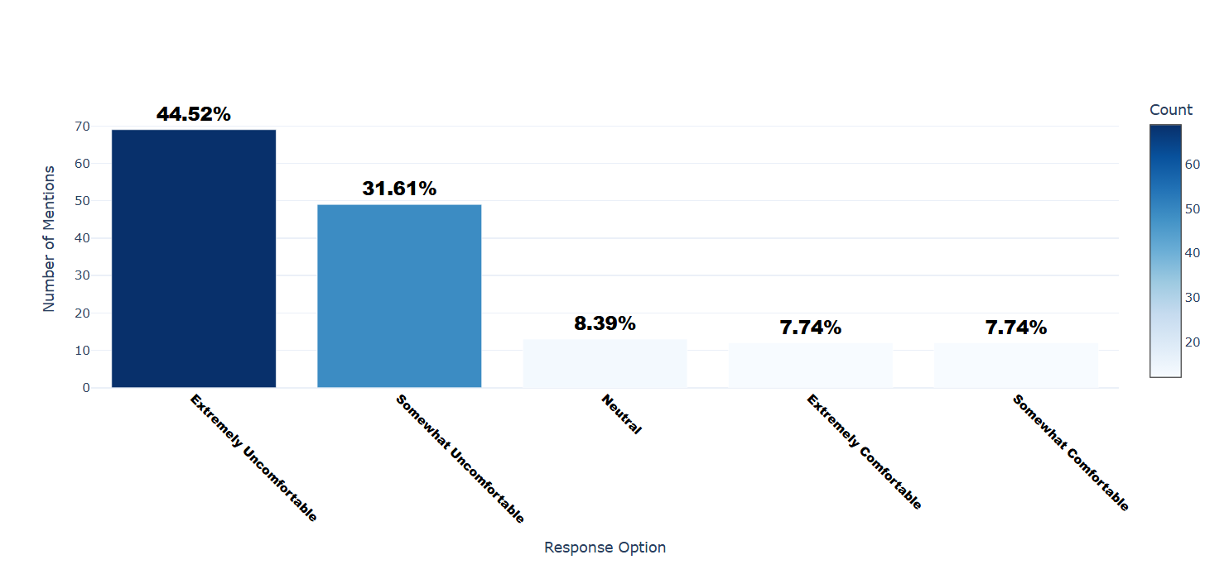

Number of respondents: 155

Breakdown of responses:

Extremely Uncomfortable: 69 (44.52%)

Somewhat Uncomfortable: 49 (31.61%)

Neutral: 13 (8.39%)

Extremely Comfortable: 12 (7.74%)

Somewhat Comfortable: 12 (7.74%)

## Q3.1_5: How comfortable are you sharing the following types of personal information online? - Financial Information

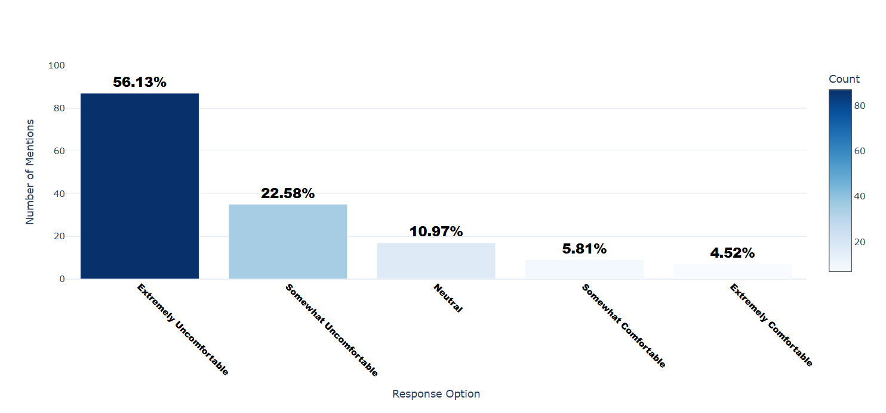

Number of respondents: 155

Breakdown of responses:

Extremely Uncomfortable: 87 (56.13%)

Somewhat Uncomfortable: 35 (22.58%)

Neutral: 17 (10.97%)

Somewhat Comfortable: 9 (5.81%)

Extremely Comfortable: 7 (4.52%)

## Q3.1_6: How comfortable are you sharing the following types of personal information online? - Health Information

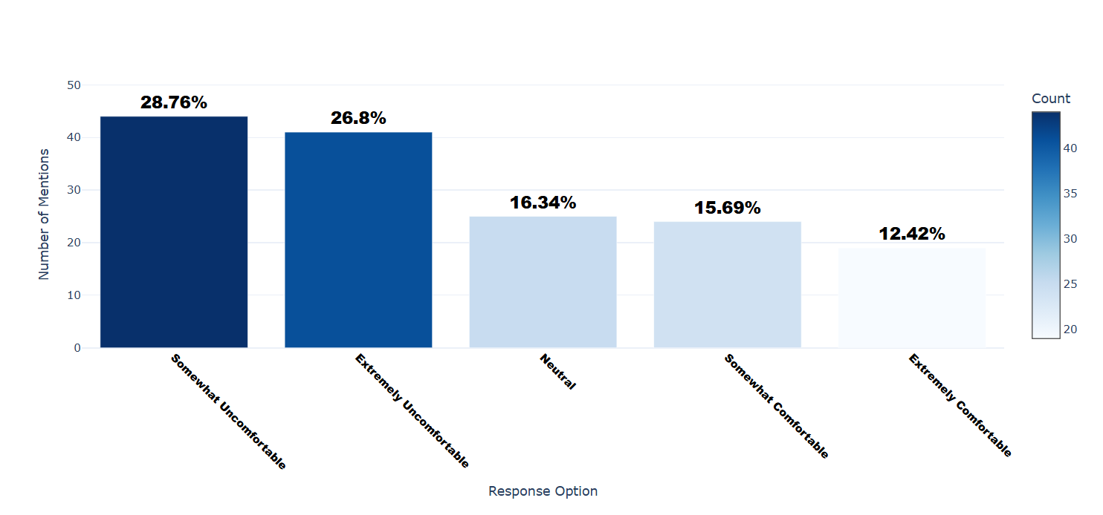

Number of respondents: 153

Breakdown of responses:

Somewhat Uncomfortable: 44 (28.76%)

Extremely Uncomfortable: 41 (26.8%)

Neutral: 25 (16.34%)

Somewhat Comfortable: 24 (15.69%)

Extremely Comfortable: 19 (12.42%)

## Q3.1_7: How comfortable are you sharing the following types of personal information online? - Social Security Number

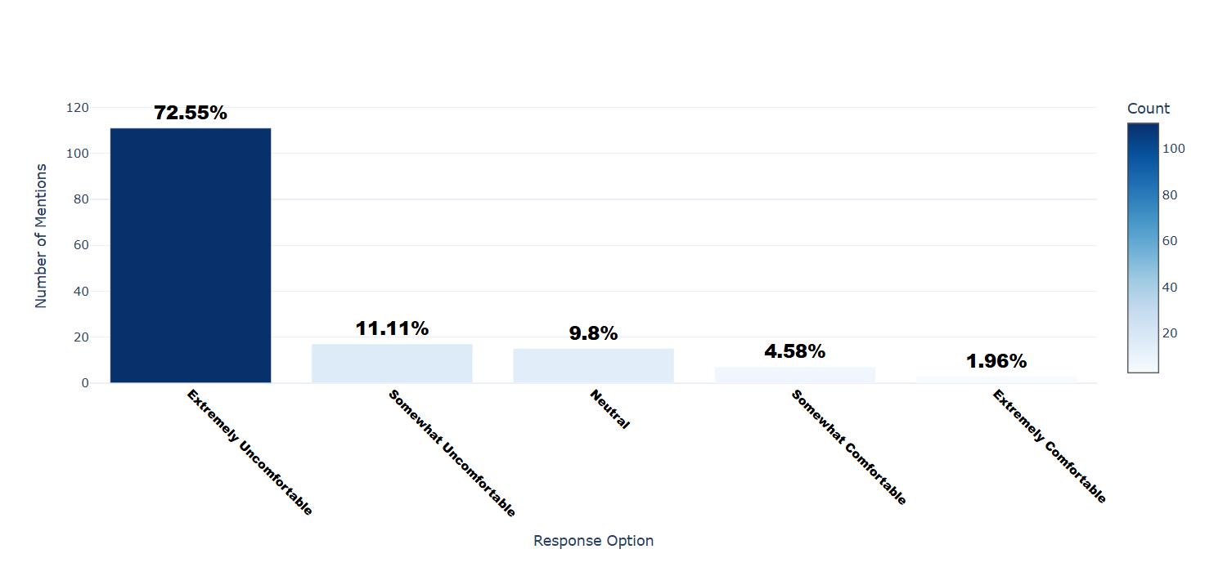

Number of respondents: 153

Breakdown of responses:

Extremely Uncomfortable: 111 (72.55%)

Somewhat Uncomfortable: 17 (11.11%)

Neutral: 15 (9.8%)

Somewhat Comfortable: 7 (4.58%)

Extremely Comfortable: 3 (1.96%)

## Q3.1_8: How comfortable are you sharing the following types of personal information online? - Password

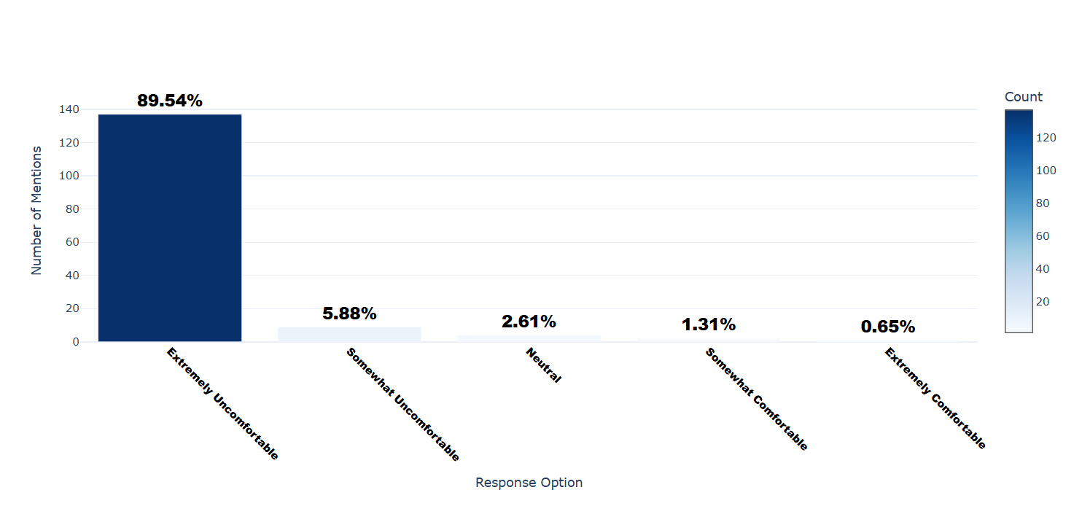

Number of respondents: 153

Breakdown of responses:

Extremely Uncomfortable: 137 (89.54%)

Somewhat Uncomfortable: 9 (5.88%)

Neutral: 4 (2.61%)

Somewhat Comfortable: 2 (1.31%)

Extremely Comfortable: 1 (0.65%)

## Q3.1_9: How comfortable are you sharing the following types of personal information online? - Browsing Data

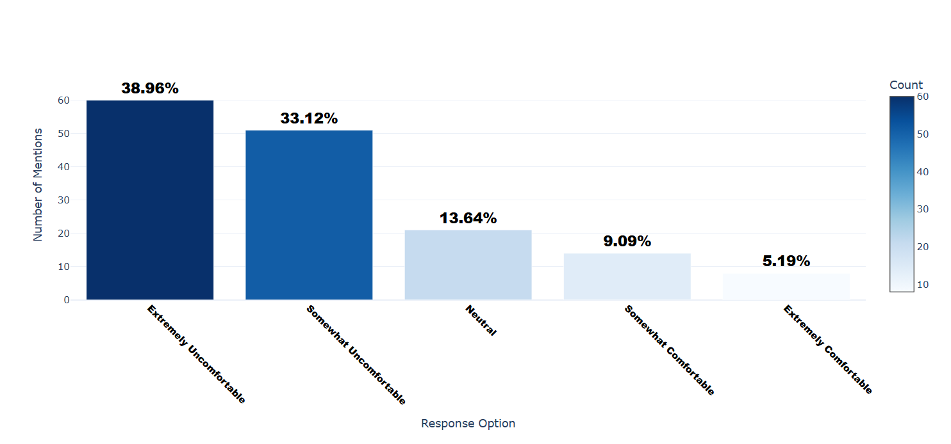

Number of respondents: 154

Breakdown of responses:

Extremely Uncomfortable: 60 (38.96%)

Somewhat Uncomfortable: 51 (33.12%)

Neutral: 21 (13.64%)

Somewhat Comfortable: 14 (9.09%)

Extremely Comfortable: 8 (5.19%)

## Q3.1_10: How comfortable are you sharing the following types of personal information online? - Audio or Video Recordings

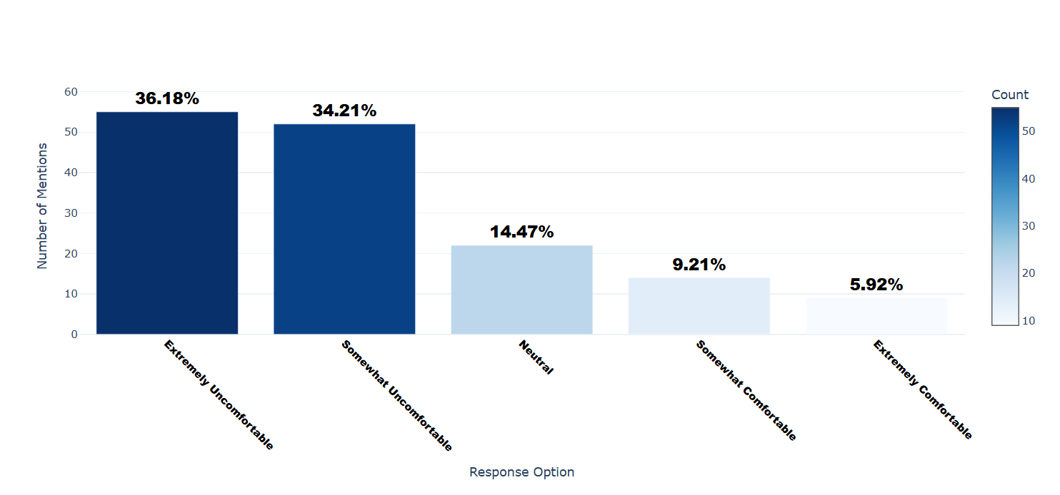

Number of respondents: 152

Breakdown of responses:

Extremely Uncomfortable: 55 (36.18%)

Somewhat Uncomfortable: 52 (34.21%)

Neutral: 22 (14.47%)

Somewhat Comfortable: 14 (9.21%)

Extremely Comfortable: 9 (5.92%)

## Q3.1_11: How comfortable are you sharing the following types of personal information online? - Demographic Information

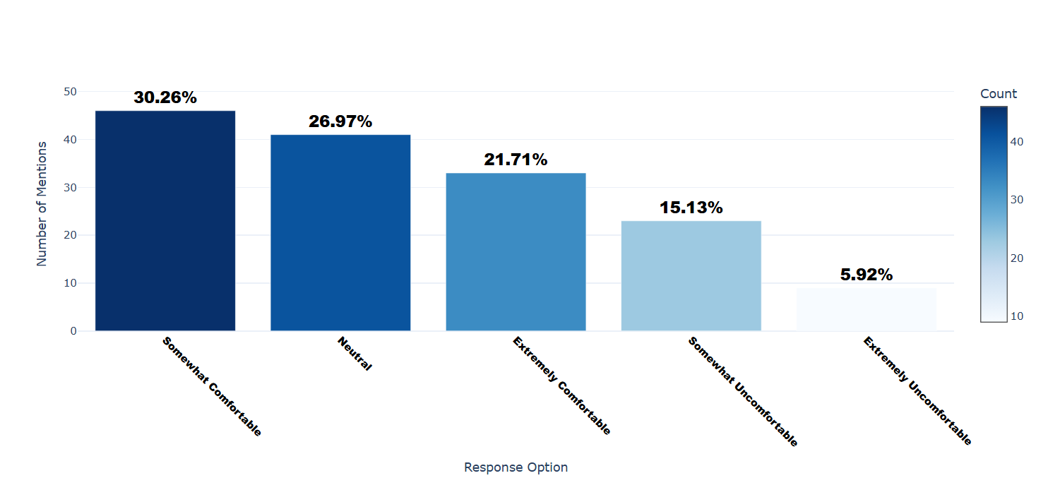

Number of respondents: 152

Breakdown of responses:

Somewhat Comfortable: 46 (30.26%)

Neutral: 41 (26.97%)

Extremely Comfortable: 33 (21.71%)

Somewhat Uncomfortable: 23 (15.13%)

Extremely Uncomfortable: 9 (5.92%)

## Q3.1_12: How comfortable are you sharing the following types of personal information online? - Physical Characteristics

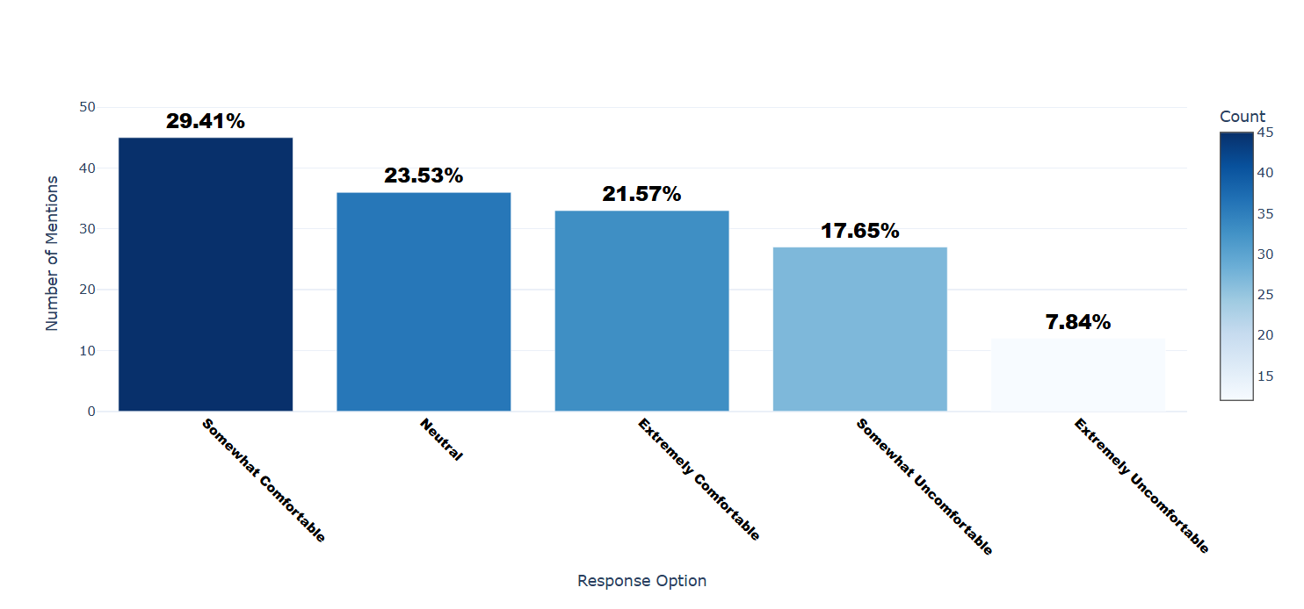

Number of respondents: 153

Breakdown of responses:

Somewhat Comfortable: 45 (29.41%)

Neutral: 36 (23.53%)

Extremely Comfortable: 33 (21.57%)

Somewhat Uncomfortable: 27 (17.65%)

Extremely Uncomfortable: 12 (7.84%)

## Q3.1_13: How comfortable are you sharing the following types of personal information online? - Email

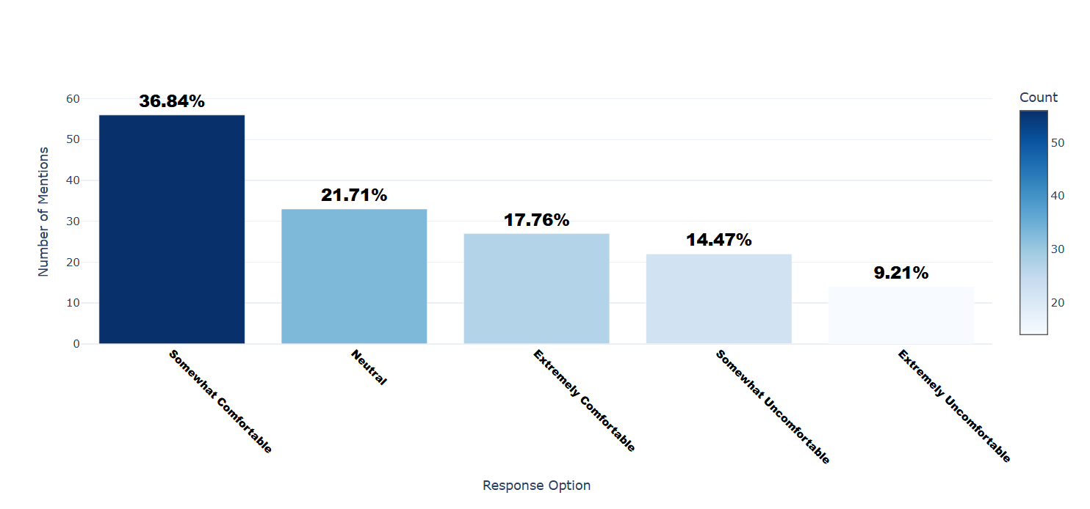

Number of respondents: 152

Breakdown of responses:

Somewhat Comfortable: 56 (36.84%)

Neutral: 33 (21.71%)

Extremely Comfortable: 27 (17.76%)

Somewhat Uncomfortable: 22 (14.47%)

Extremely Uncomfortable: 14 (9.21%)

## Q3.1_14: How comfortable are you sharing the following types of personal information online? - IP Address

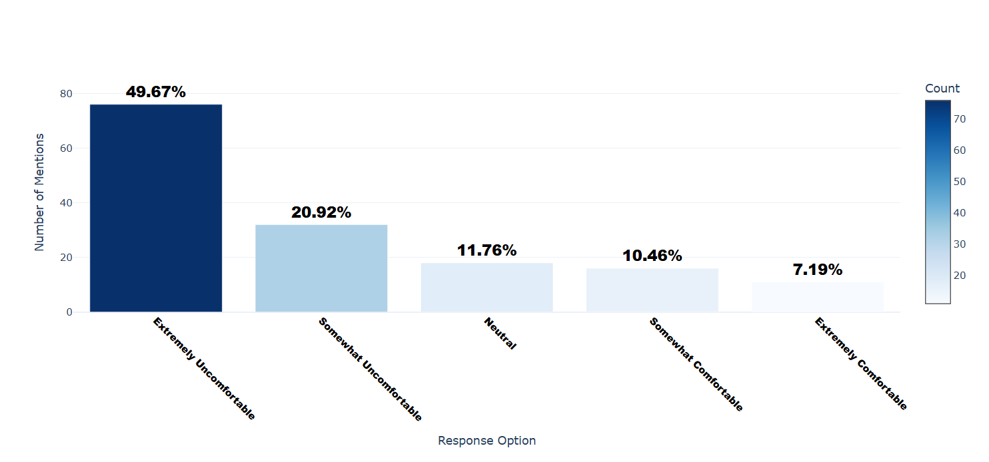

Number of respondents: 153

Breakdown of responses:

Extremely Uncomfortable: 76 (49.67%)

Somewhat Uncomfortable: 32 (20.92%)

Neutral: 18 (11.76%)

Somewhat Comfortable: 16 (10.46%)

Extremely Comfortable: 11 (7.19%)

## Q3.1_15: How comfortable are you sharing the following types of personal information online? - Identification Information

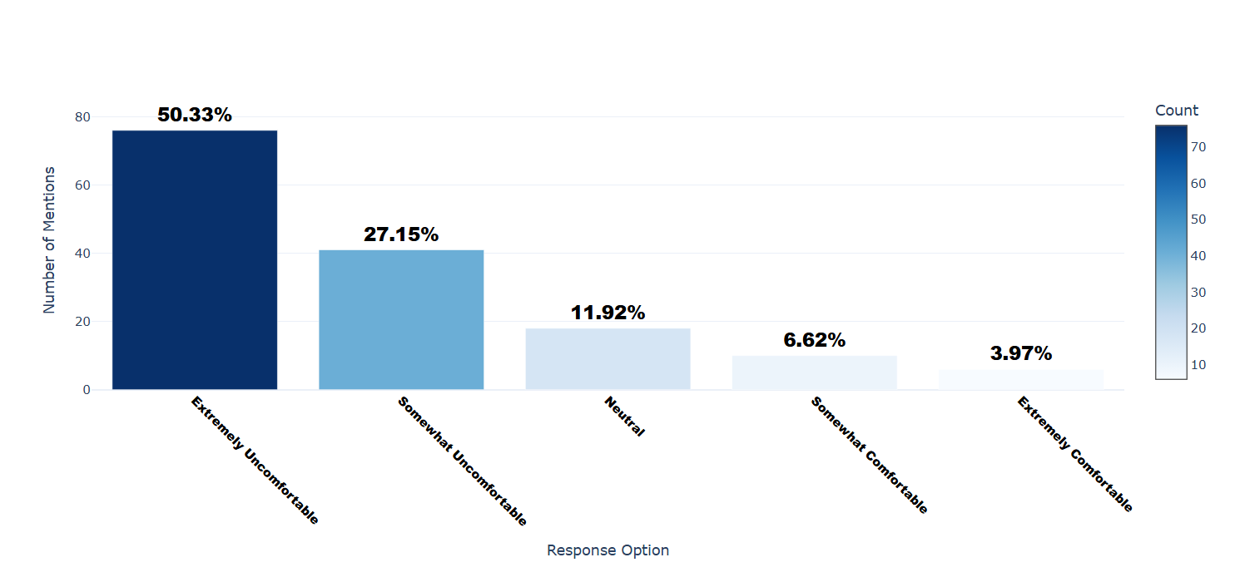

Number of respondents: 151

Breakdown of responses:

Extremely Uncomfortable: 76 (50.33%)

Somewhat Uncomfortable: 41 (27.15%)

Neutral: 18 (11.92%)

Somewhat Comfortable: 10 (6.62%)

Extremely Comfortable: 6 (3.97%)

## Q3.1_16: How comfortable are you sharing the following types of personal information online? - Biometric Information

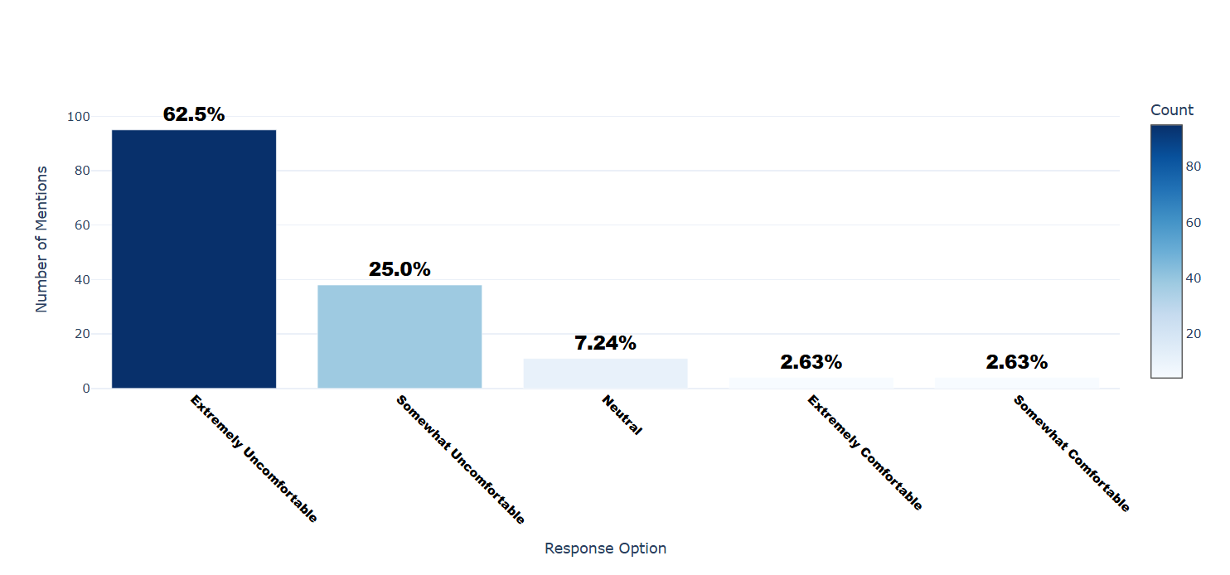

Number of respondents: 152

Breakdown of responses:

Extremely Uncomfortable: 95 (62.5%)

Somewhat Uncomfortable: 38 (25.0%)

Neutral: 11 (7.24%)

Extremely Comfortable: 4 (2.63%)

Somewhat Comfortable: 4 (2.63%)

## Q3.1_17: How comfortable are you sharing the following types of personal information online? - Employment Information

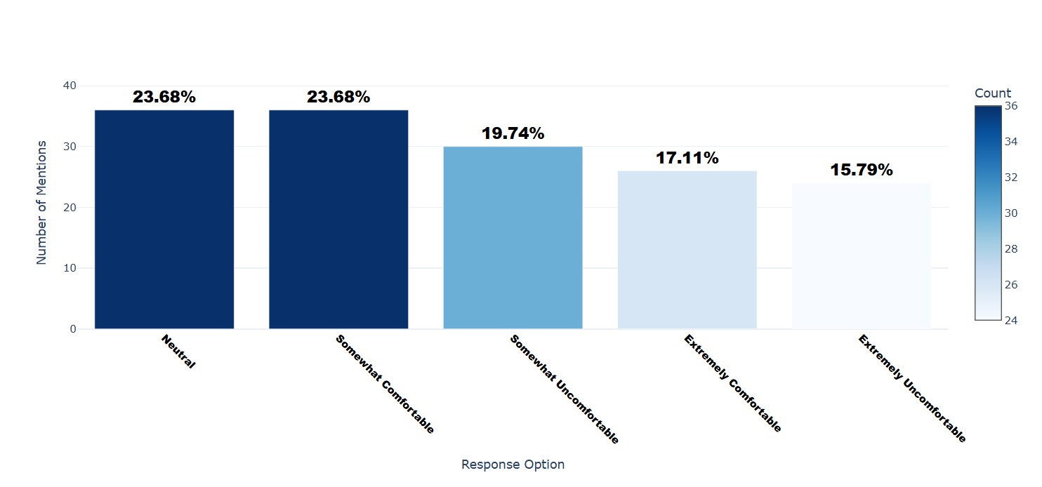

Number of respondents: 152

Breakdown of responses:

Neutral: 36 (23.68%)

Somewhat Comfortable: 36 (23.68%)

Somewhat Uncomfortable: 30 (19.74%)

Extremely Comfortable: 26 (17.11%)

Extremely Uncomfortable: 24 (15.79%)

## Q3.1_18: How comfortable are you sharing the following types of personal information online? - Geolocation data

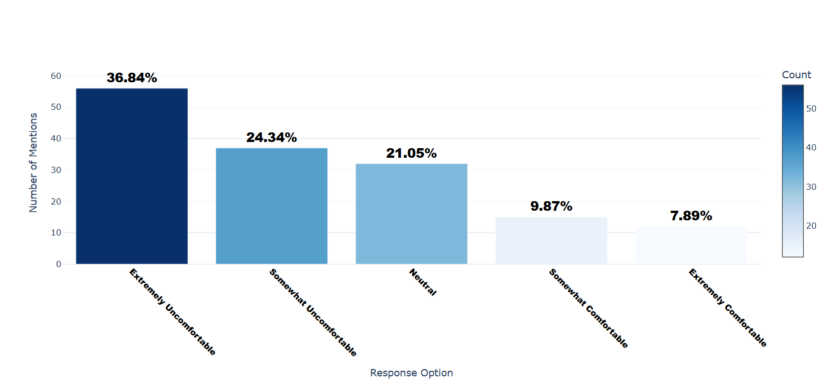

Number of respondents: 152

Breakdown of responses:

Extremely Uncomfortable: 56 (36.84%)

Somewhat Uncomfortable: 37 (24.34%)

Neutral: 32 (21.05%)

Somewhat Comfortable: 15 (9.87%)

Extremely Comfortable: 12 (7.89%)

## Q3.1_19: How comfortable are you sharing the following types of personal information online? - Cookies

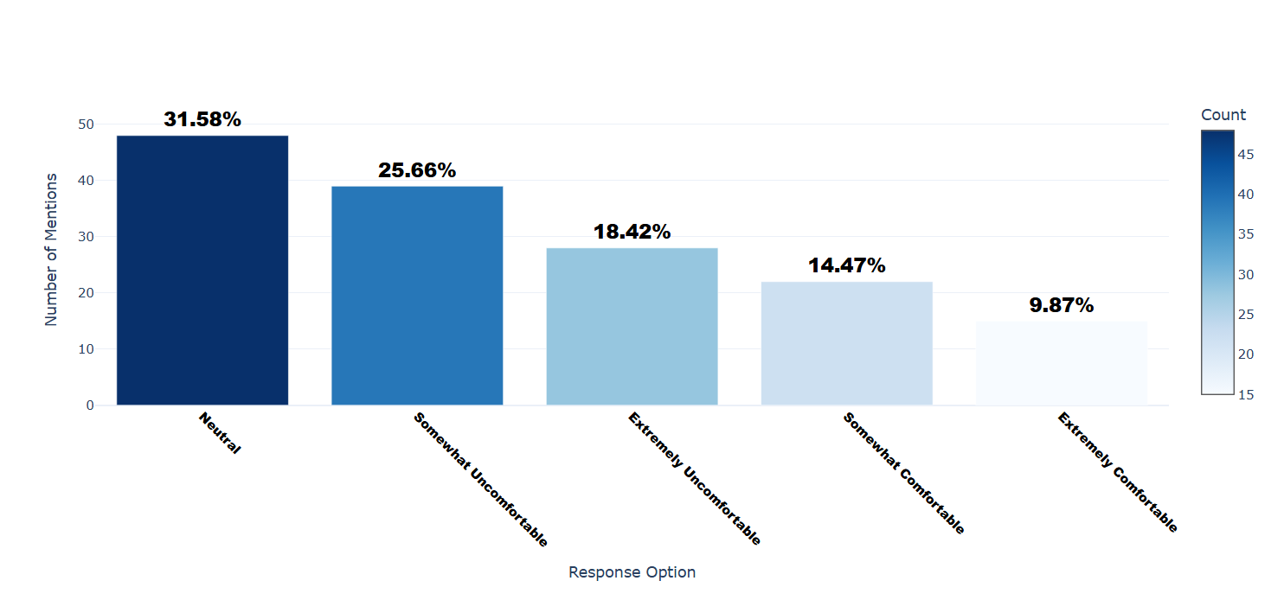

Number of respondents: 152

Breakdown of responses:

Neutral: 48 (31.58%)

Somewhat Uncomfortable: 39 (25.66%)

Extremely Uncomfortable: 28 (18.42%)

Somewhat Comfortable: 22 (14.47%)

Extremely Comfortable: 15 (9.87%)

## Q3.1_20: How comfortable are you sharing the following types of personal information online? - Sexual Orientation

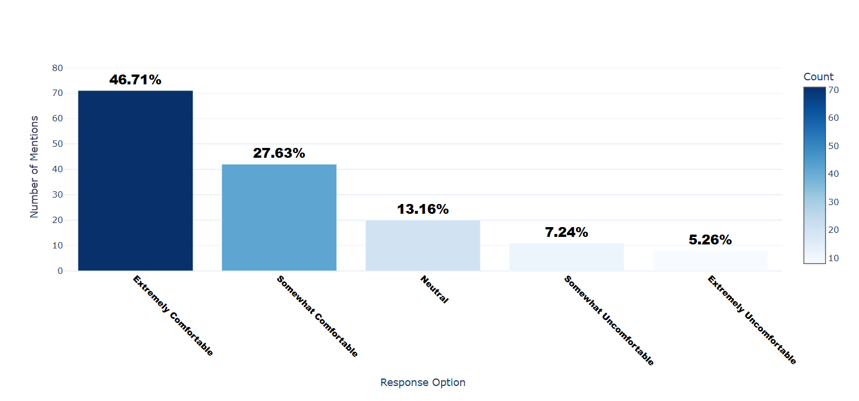

Number of respondents: 152

Breakdown of responses:

Extremely Comfortable: 71 (46.71%)

Somewhat Comfortable: 42 (27.63%)

Neutral: 20 (13.16%)

Somewhat Uncomfortable: 11 (7.24%)

Extremely Uncomfortable: 8 (5.26%)

## Q3.1_21: How comfortable are you sharing the following types of personal information online? - Religious Belief

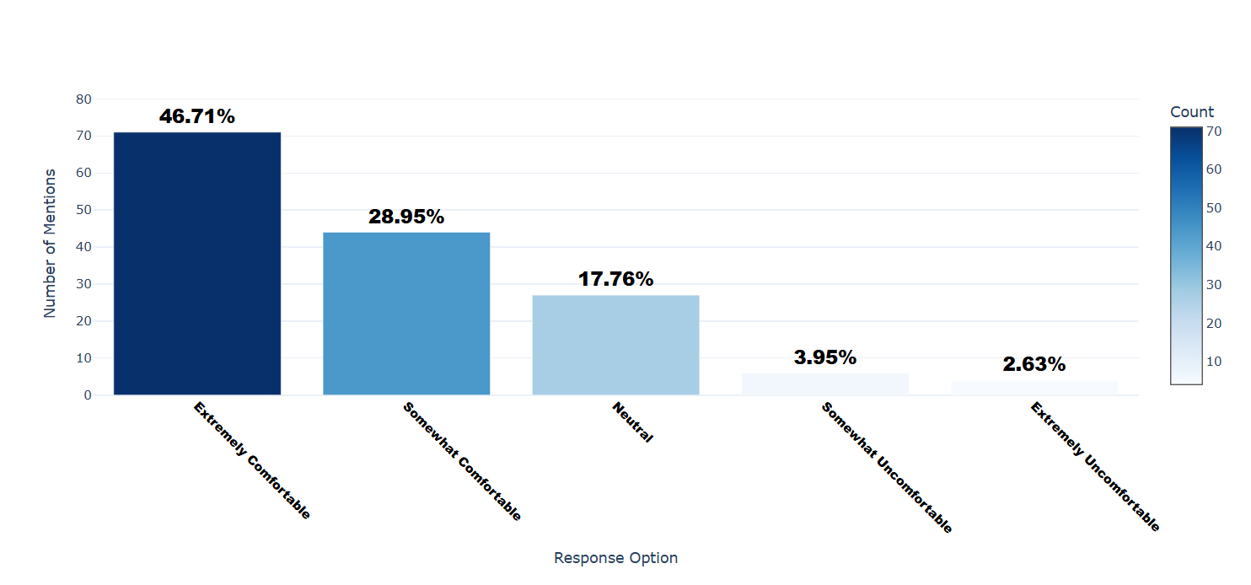

Number of respondents: 152

Breakdown of responses:

Extremely Comfortable: 71 (46.71%)

Somewhat Comfortable: 44 (28.95%)

Neutral: 27 (17.76%)

Somewhat Uncomfortable: 6 (3.95%)

Extremely Uncomfortable: 4 (2.63%)

## Q3.1_22: How comfortable are you sharing the following types of personal information online? - Income

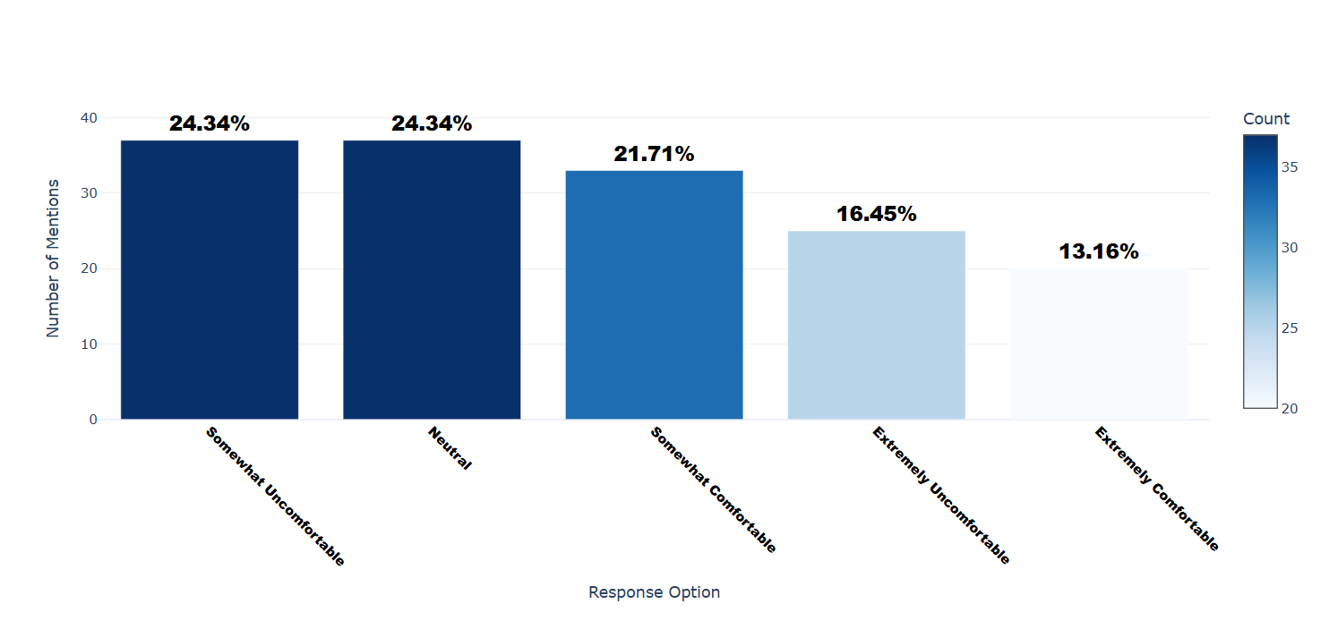

Number of respondents: 152

Breakdown of responses:

Somewhat Uncomfortable: 37 (24.34%)

Neutral: 37 (24.34%)

Somewhat Comfortable: 33 (21.71%)

Extremely Uncomfortable: 25 (16.45%)

Extremely Comfortable: 20 (13.16%)

## Q3.1_23: How comfortable are you sharing the following types of personal information online? - Content of communication

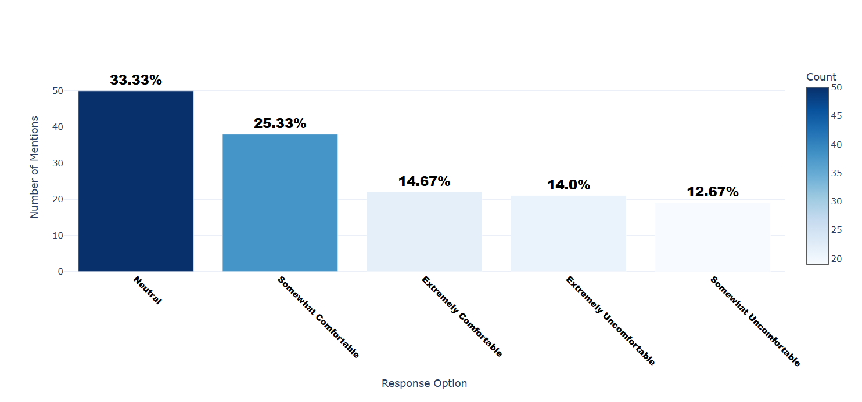

Number of respondents: 150

Breakdown of responses:

Neutral: 50 (33.33%)

Somewhat Comfortable: 38 (25.33%)

Extremely Comfortable: 22 (14.67%)

Extremely Uncomfortable: 21 (14.0%)

Somewhat Uncomfortable: 19 (12.67%)

## Q3.1_24: How comfortable are you sharing the following types of personal information online? - Others

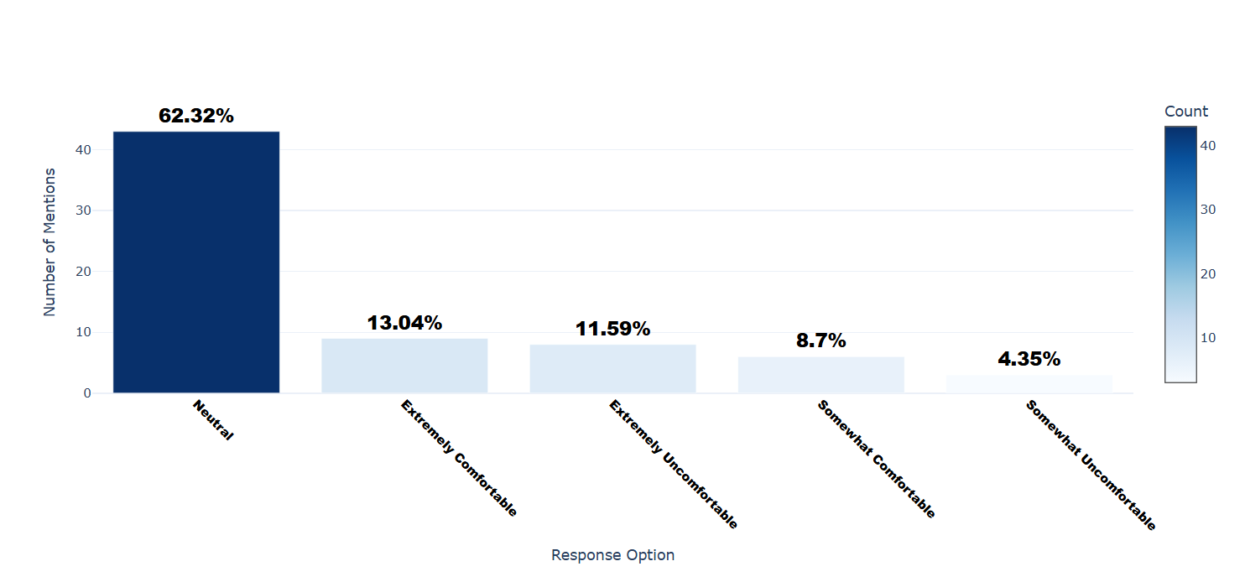

Number of respondents: 69

Breakdown of responses:

Neutral: 43 (62.32%)

Extremely Comfortable: 9 (13.04%)

Extremely Uncomfortable: 8 (11.59%)

Somewhat Comfortable: 6 (8.7%)

Somewhat Uncomfortable: 3 (4.35%)

## Q3.1_24_TEXT: How comfortable are you sharing the following types of personal information online? - Others - Text

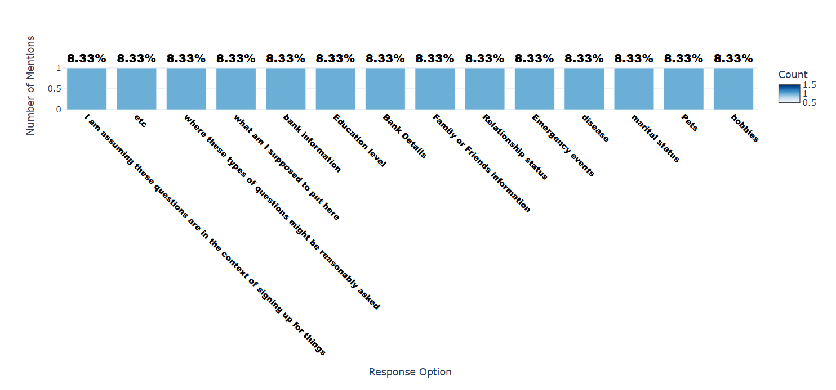

Number of respondents: 12

Breakdown of responses:

I am assuming these questions are in the context of signing up for things: 1 (8.33%)

etc: 1 (8.33%)

where these types of questions might be reasonably asked: 1 (8.33%)

what am I supposed to put here: 1 (8.33%)

bank information: 1 (8.33%)

Education level: 1 (8.33%)

Bank Details: 1 (8.33%)

Family or Friends information: 1 (8.33%)

Relationship status: 1 (8.33%)

Emergency events: 1 (8.33%)

disease: 1 (8.33%)

marital status: 1 (8.33%)

Pets: 1 (8.33%)

hobbies: 1 (8.33%)

## Q3.2: Are there any types of personal information that you would never share online, regardless of the circumstances? - Selected Choice

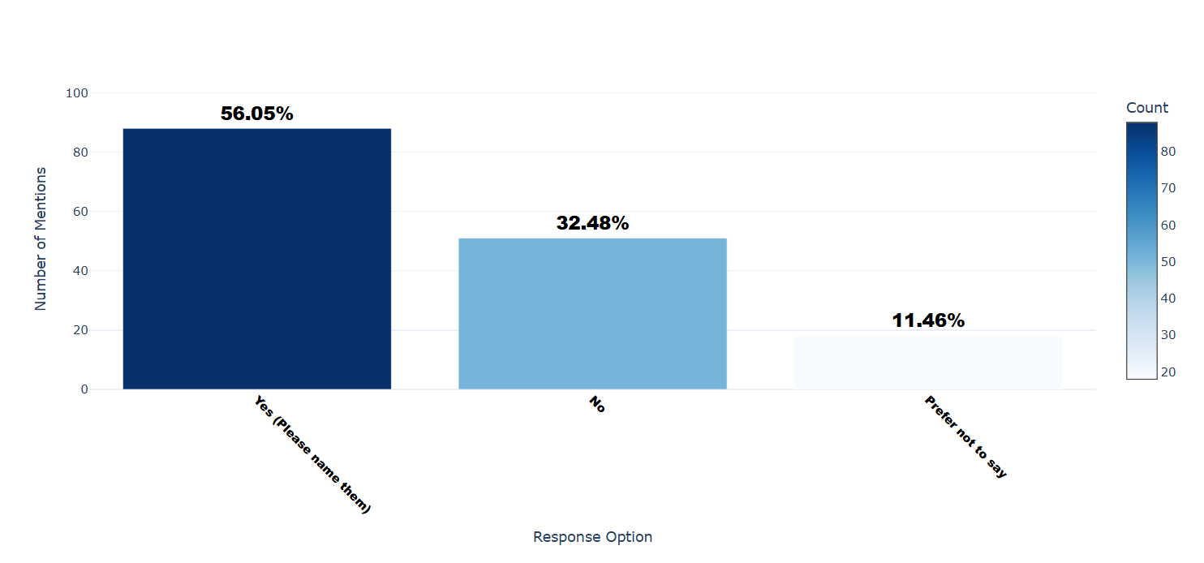

Number of respondents: 157

Breakdown of responses:

Yes (Please name them): 88 (56.05%)

No: 51 (32.48%)

Prefer not to say: 18 (11.46%)

## Q3.3: How comfortable are you with the security of your personal data when using your smartphone for financial transactions?

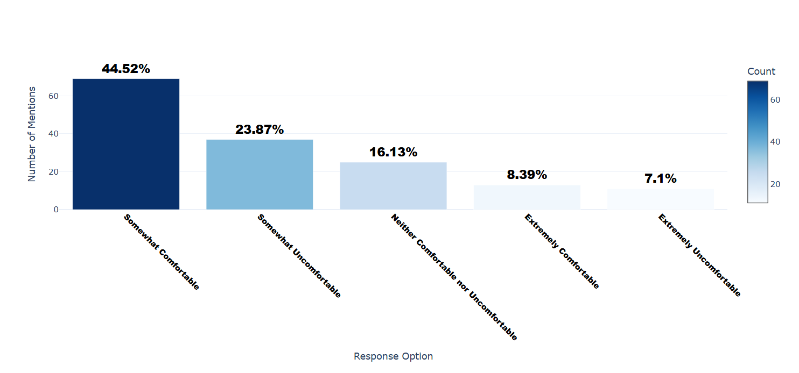

Number of respondents: 155

Breakdown of responses:

Somewhat Comfortable: 69 (44.52%)

Somewhat Uncomfortable: 37 (23.87%)

Neither Comfortable nor Uncomfortable: 25 (16.13%)

Extremely Comfortable: 13 (8.39%)

Extremely Uncomfortable: 11 (7.1%)

## Q3.4: Do you regularly use fitness trackers or health apps?

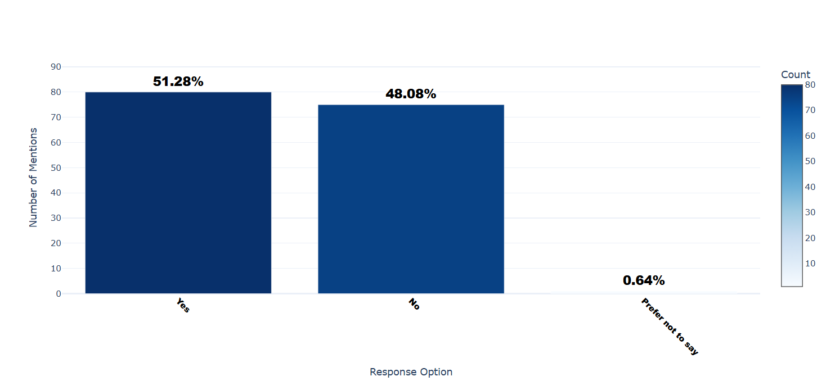

Number of respondents: 156

Breakdown of responses:

Yes: 80 (51.28%)

No: 75 (48.08%)

Prefer not to say: 1 (0.64%)

## Q3.5: How often do you share your health data collected by fitness trackers or health apps with others?

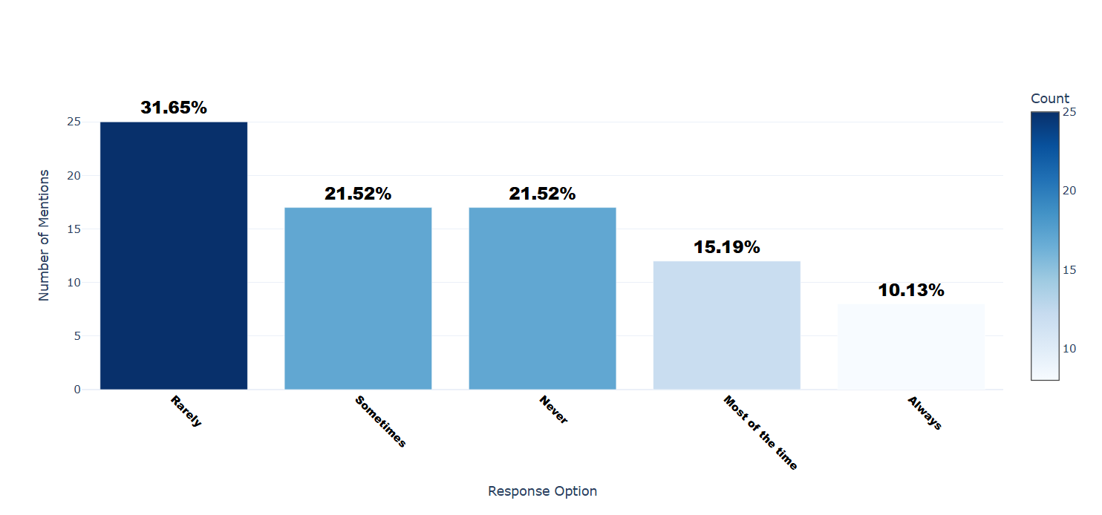

Number of respondents: 79

Breakdown of responses:

Rarely: 25 (31.65%)

Sometimes: 17 (21.52%)

Never: 17 (21.52%)

Most of the time: 12 (15.19%)

Always: 8 (10.13%)

## Q3.6_1: How comfortable are you with sharing your health data with the following types of organizations? - Third party Companies

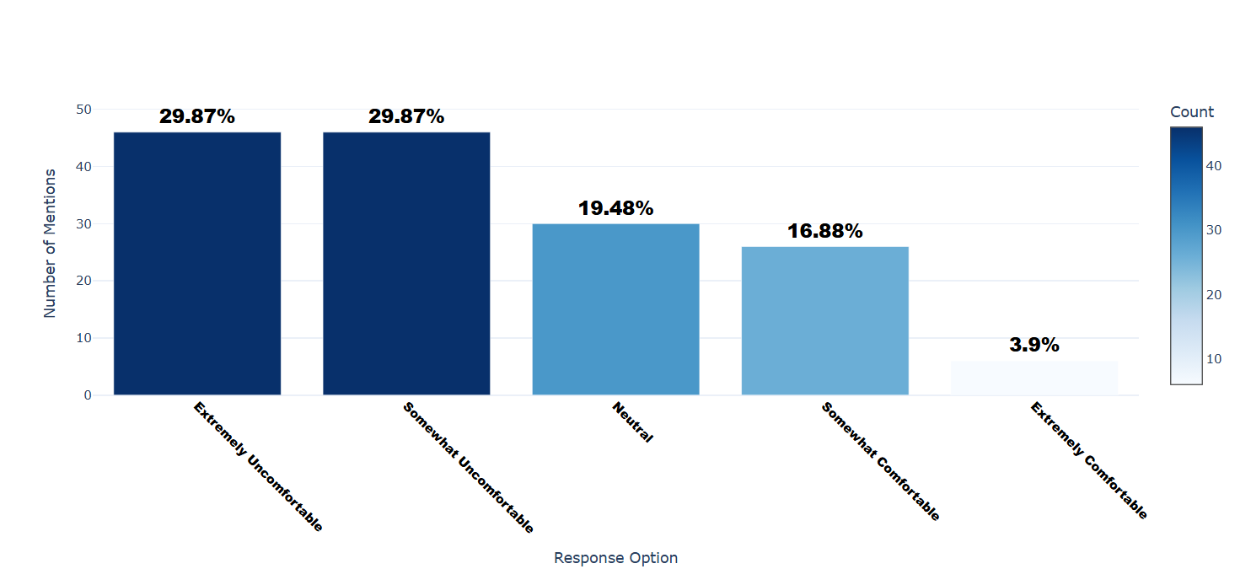

Number of respondents: 154

Breakdown of responses:

Extremely Uncomfortable: 46 (29.87%)

Somewhat Uncomfortable: 46 (29.87%)

Neutral: 30 (19.48%)

Somewhat Comfortable: 26 (16.88%)

Extremely Comfortable: 6 (3.9%)

## Q3.6_2: How comfortable are you with sharing your health data with the following types of organizations? - Government agencies

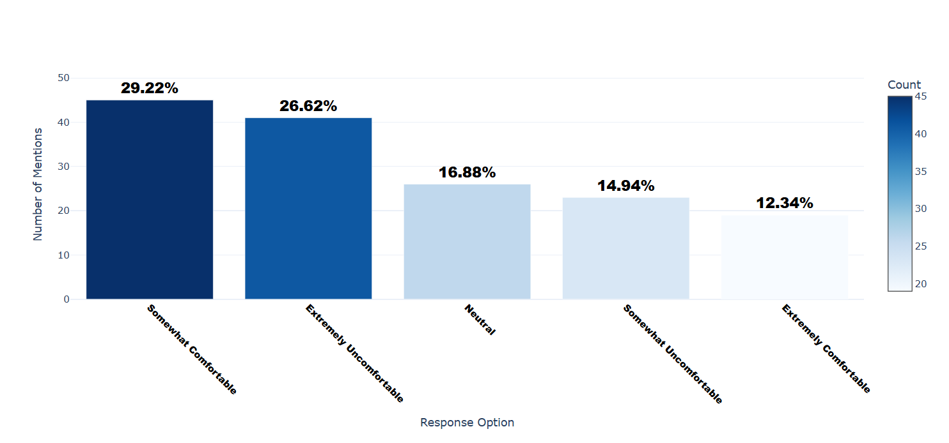

Number of respondents: 154

Breakdown of responses:

Somewhat Comfortable: 45 (29.22%)

Extremely Uncomfortable: 41 (26.62%)

Neutral: 26 (16.88%)

Somewhat Uncomfortable: 23 (14.94%)

Extremely Comfortable: 19 (12.34%)

## Q3.6_3: How comfortable are you with sharing your health data with the following types of organizations? - Fitness app developers

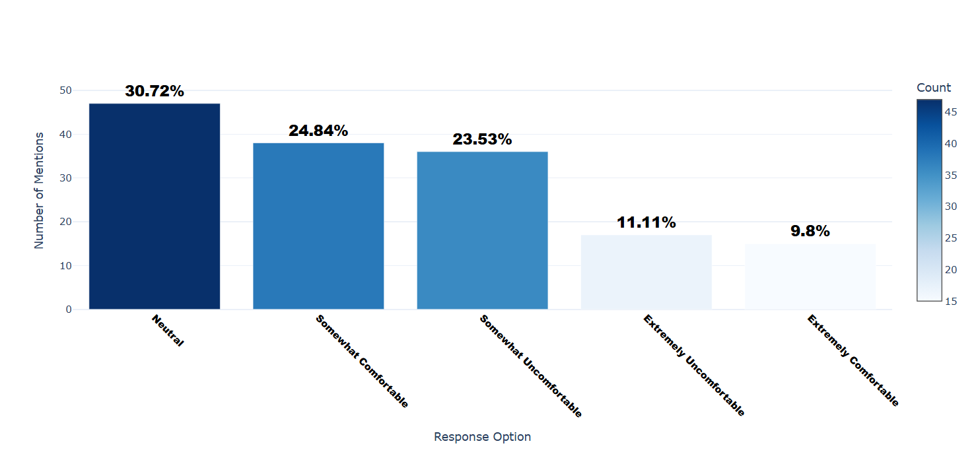

Number of respondents: 153

Breakdown of responses:

Neutral: 47 (30.72%)

Somewhat Comfortable: 38 (24.84%)

Somewhat Uncomfortable: 36 (23.53%)

Extremely Uncomfortable: 17 (11.11%)

Extremely Comfortable: 15 (9.8%)

## Q3.6_4: How comfortable are you with sharing your health data with the following types of organizations? - Healthcare Providers

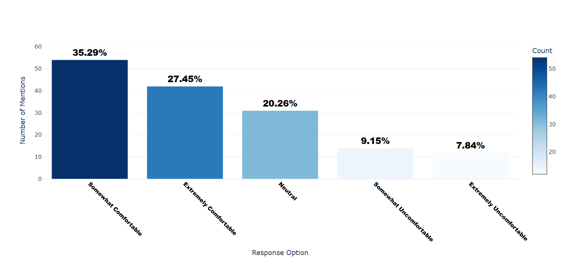

Number of respondents: 153

Breakdown of responses:

Somewhat Comfortable: 54 (35.29%)

Extremely Comfortable: 42 (27.45%)

Neutral: 31 (20.26%)

Somewhat Uncomfortable: 14 (9.15%)

Extremely Uncomfortable: 12 (7.84%)

## Q3.6_5: How comfortable are you with sharing your health data with the following types of organizations? - Health insurance Companies

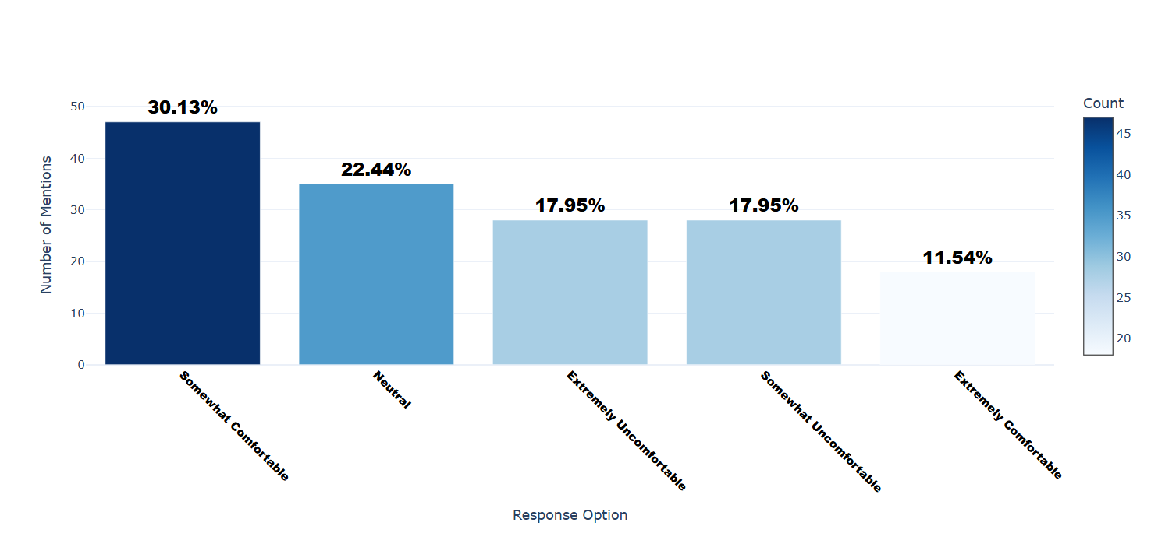

Number of respondents: 156

Breakdown of responses:

Somewhat Comfortable: 47 (30.13%)

Neutral: 35 (22.44%)

Extremely Uncomfortable: 28 (17.95%)

Somewhat Uncomfortable: 28 (17.95%)

Extremely Comfortable: 18 (11.54%)

## Q3.6_6: How comfortable are you with sharing your health data with the following types of organizations? - Research institutions

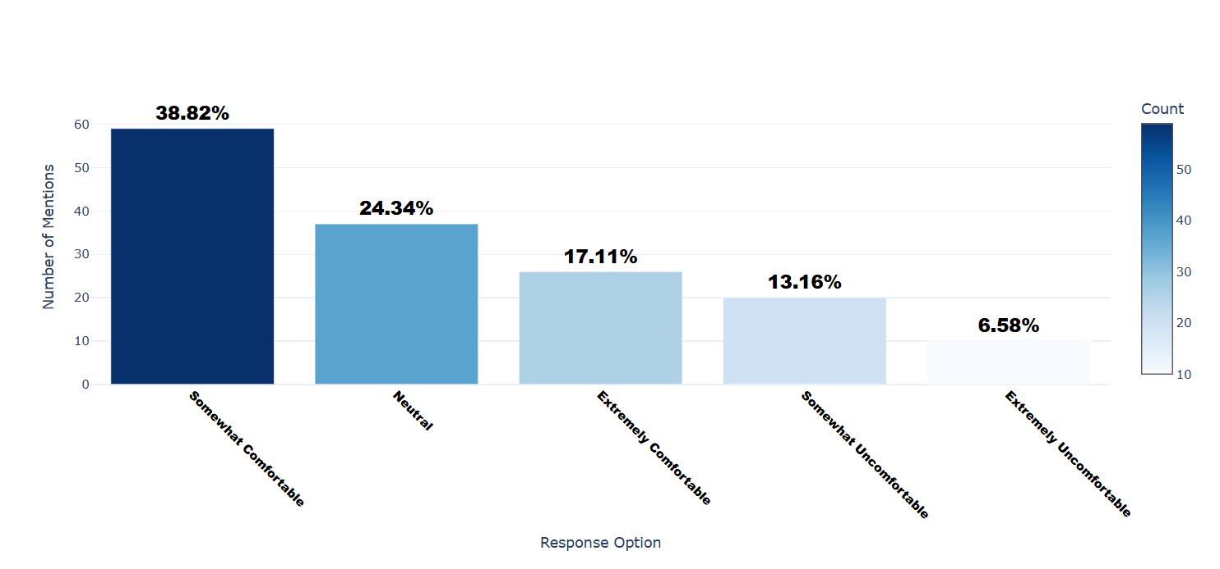

Number of respondents: 152

Breakdown of responses:

Somewhat Comfortable: 59 (38.82%)

Neutral: 37 (24.34%)

Extremely Comfortable: 26 (17.11%)

Somewhat Uncomfortable: 20 (13.16%)

Extremely Uncomfortable: 10 (6.58%)

## Q3.6_7: How comfortable are you with sharing your health data with the following types of organizations? - Other (Please Specify)

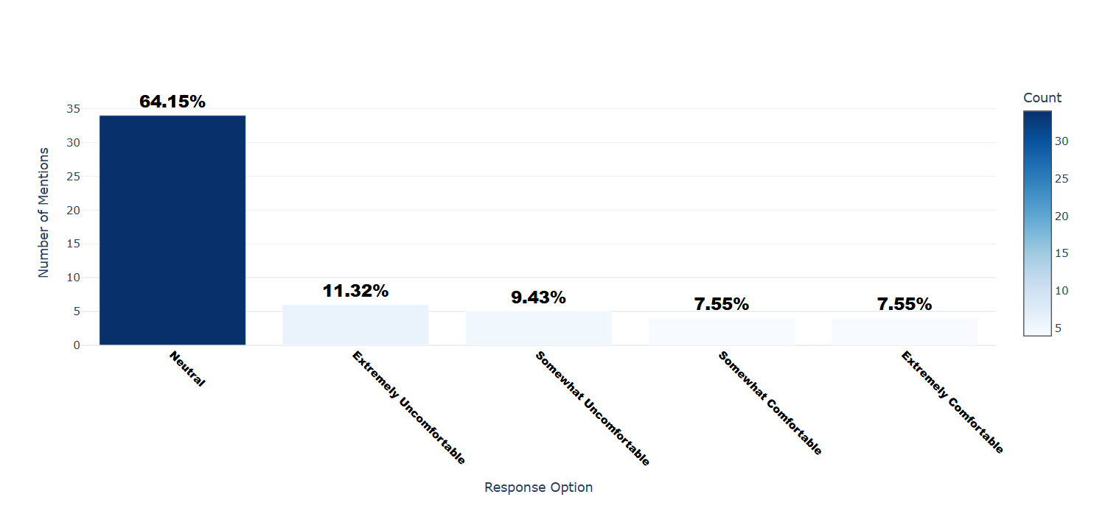

Number of respondents: 53

Breakdown of responses:

Neutral: 34 (64.15%)

Extremely Uncomfortable: 6 (11.32%)

Somewhat Uncomfortable: 5 (9.43%)

Somewhat Comfortable: 4 (7.55%)

Extremely Comfortable: 4 (7.55%)

## Q3.6_7_TEXT: How comfortable are you with sharing your health data with the following types of organizations? - Other (Please Specify) - Text

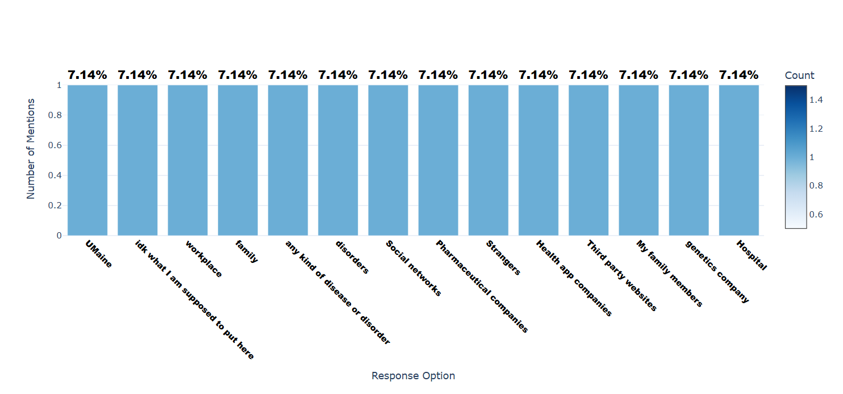

Number of respondents: 14

Breakdown of responses:

UMaine: 1 (7.14%)

idk what I am supposed to put here: 1 (7.14%)

workplace: 1 (7.14%)

family: 1 (7.14%)

any kind of disease or disorder: 1 (7.14%)

disorders: 1 (7.14%)

Social networks: 1 (7.14%)

Pharmaceutical companies: 1 (7.14%)

Strangers: 1 (7.14%)

Health app companies: 1 (7.14%)

Third party websites: 1 (7.14%)

My family members: 1 (7.14%)

genetics company: 1 (7.14%)

Hospital: 1 (7.14%)

## Q3.7_1: To what extent do the following factors influence your comfort level with sharing location data with apps? - Benefits of Sharing

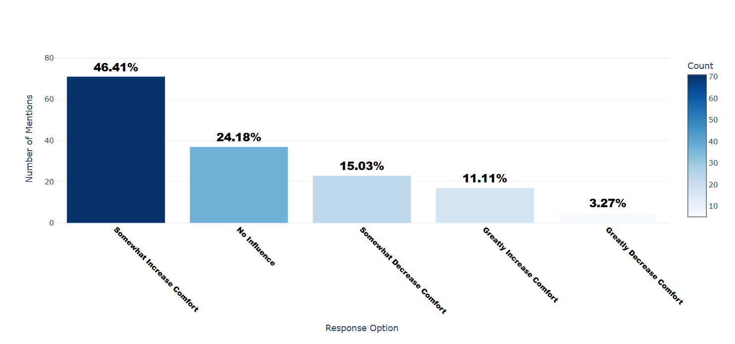

Number of respondents: 153

Breakdown of responses:

Somewhat Increase Comfort: 71 (46.41%)

No Influence: 37 (24.18%)

Somewhat Decrease Comfort: 23 (15.03%)

Greatly Increase Comfort: 17 (11.11%)

Greatly Decrease Comfort: 5 (3.27%)

## Q3.7_2: To what extent do the following factors influence your comfort level with sharing location data with apps? - Trust in Applications

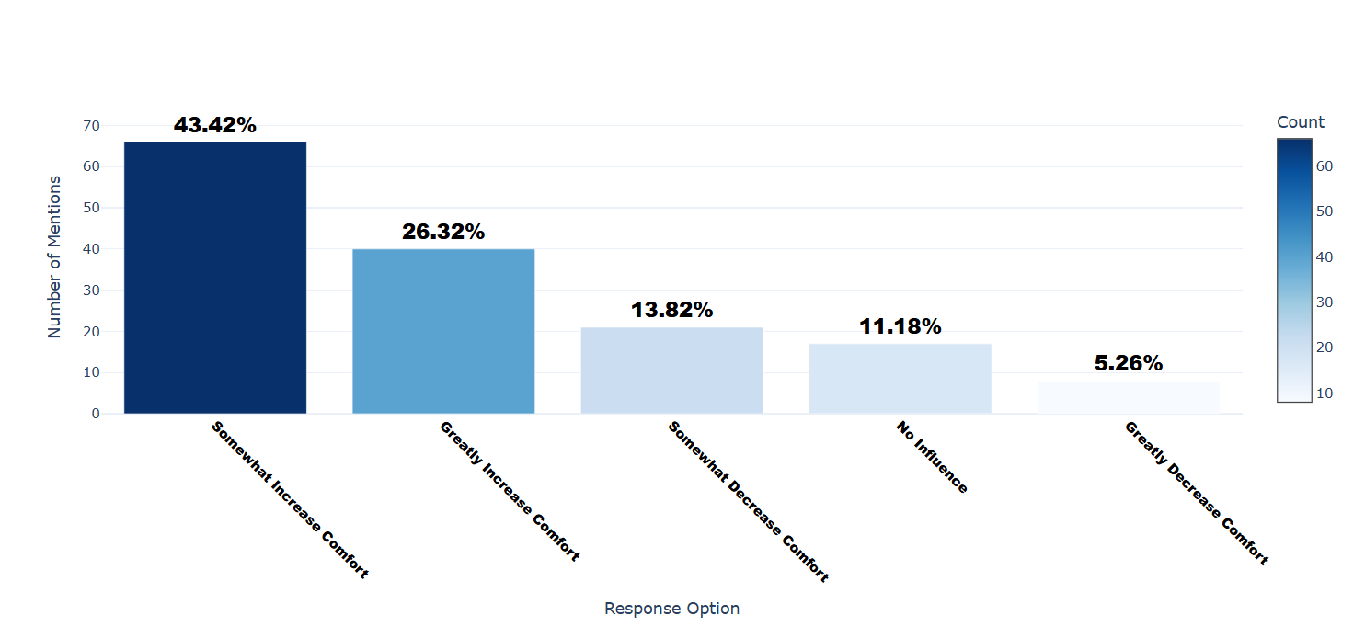

Number of respondents: 152

Breakdown of responses:

Somewhat Increase Comfort: 66 (43.42%)

Greatly Increase Comfort: 40 (26.32%)

Somewhat Decrease Comfort: 21 (13.82%)

No Influence: 17 (11.18%)

Greatly Decrease Comfort: 8 (5.26%)

## Q3.7_3: To what extent do the following factors influence your comfort level with sharing location data with apps? - Privacy Concerns

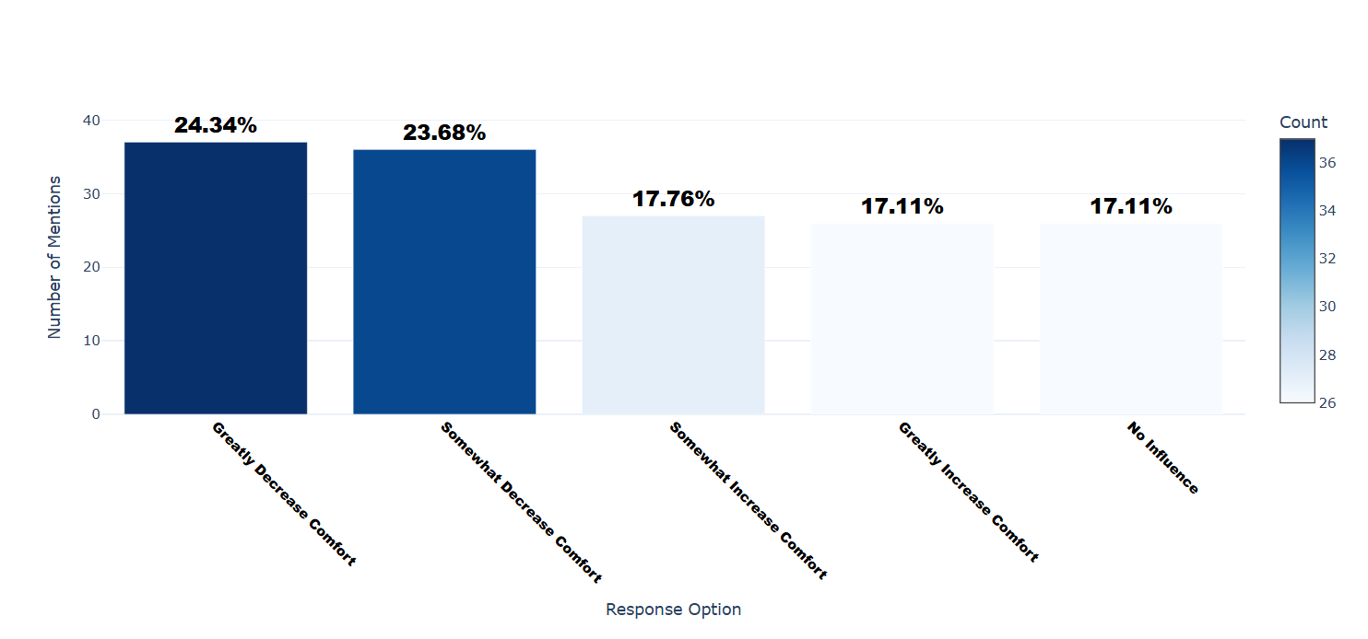

Number of respondents: 152

Breakdown of responses:

Greatly Decrease Comfort: 37 (24.34%)

Somewhat Decrease Comfort: 36 (23.68%)

Somewhat Increase Comfort: 27 (17.76%)

Greatly Increase Comfort: 26 (17.11%)

No Influence: 26 (17.11%)

## Q3.7_4: To what extent do the following factors influence your comfort level with sharing location data with apps? - Security Measures

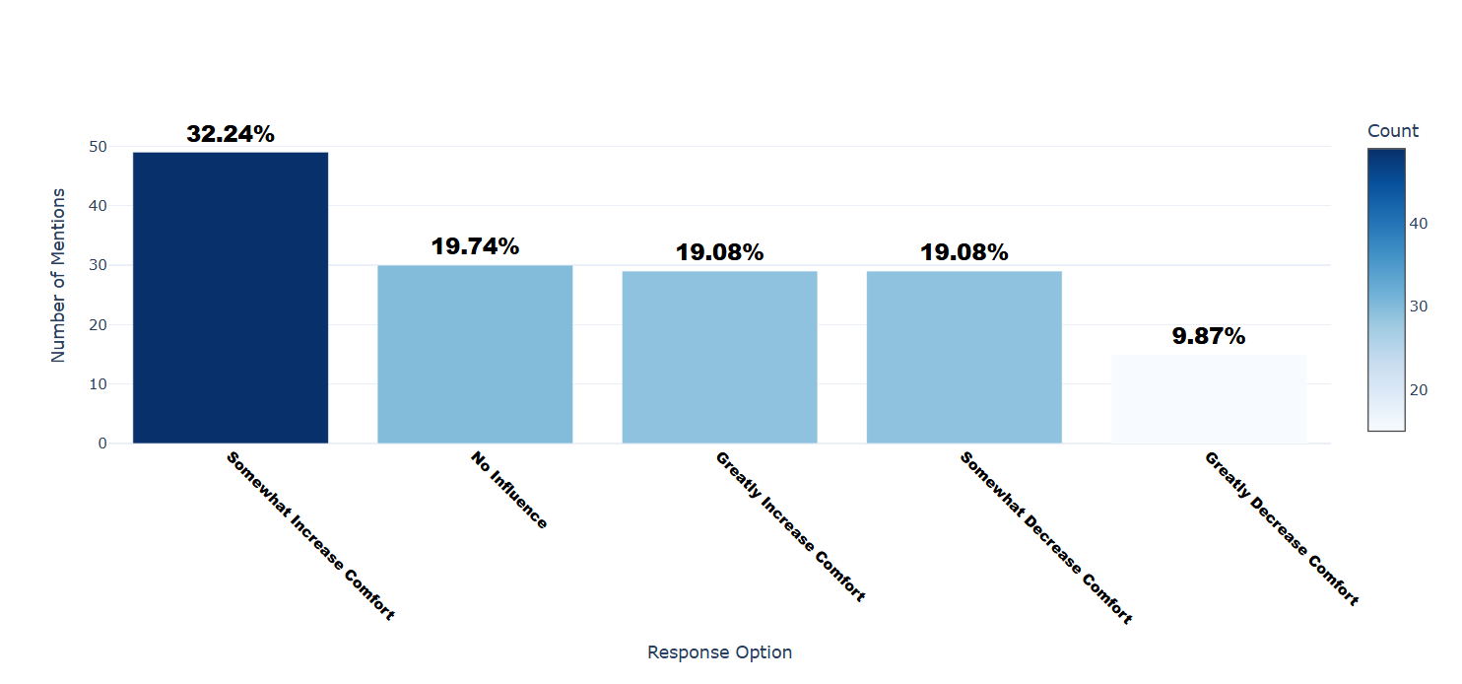

Number of respondents: 152

Breakdown of responses:

Somewhat Increase Comfort: 49 (32.24%)

No Influence: 30 (19.74%)

Greatly Increase Comfort: 29 (19.08%)

Somewhat Decrease Comfort: 29 (19.08%)

Greatly Decrease Comfort: 15 (9.87%)

## Q3.7_5: To what extent do the following factors influence your comfort level with sharing location data with apps? - Government Surveillance

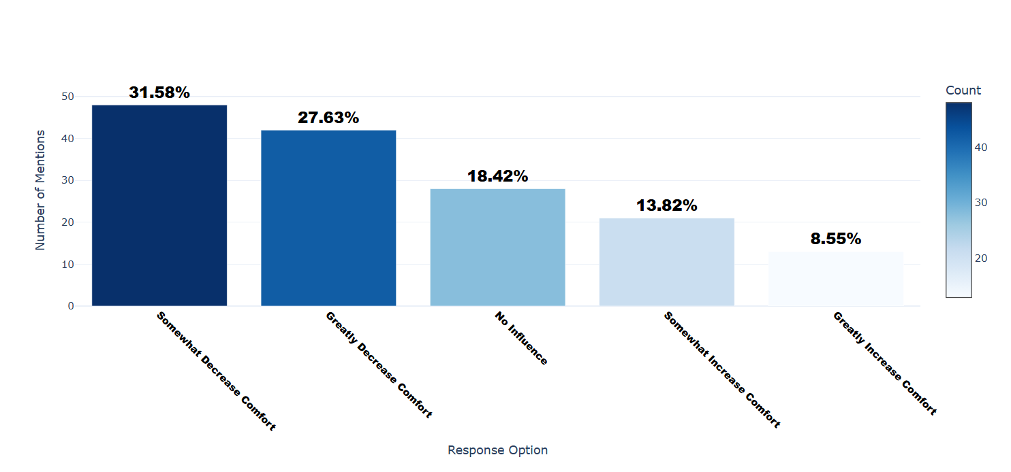

Number of respondents: 152

Breakdown of responses:

Somewhat Decrease Comfort: 48 (31.58%)

Greatly Decrease Comfort: 42 (27.63%)

No Influence: 28 (18.42%)

Somewhat Increase Comfort: 21 (13.82%)

Greatly Increase Comfort: 13 (8.55%)

## Q3.7_6: To what extent do the following factors influence your comfort level with sharing location data with apps? - Social Norms

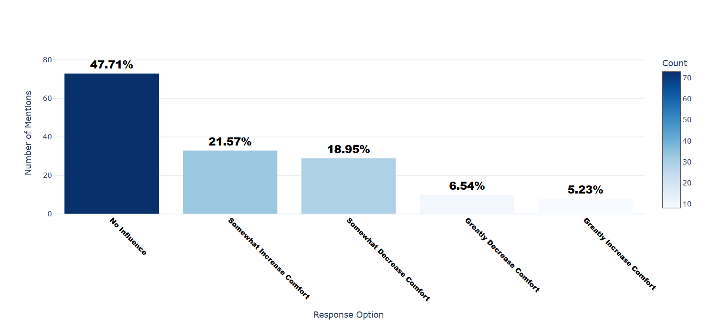

Number of respondents: 153

Breakdown of responses:

No Influence: 73 (47.71%)

Somewhat Increase Comfort: 33 (21.57%)

Somewhat Decrease Comfort: 29 (18.95%)

Greatly Decrease Comfort: 10 (6.54%)

Greatly Increase Comfort: 8 (5.23%)

## Q4.1: How much do you agree with the following statement? 'Cultural values and norms in my country influence how people view online privacy'.

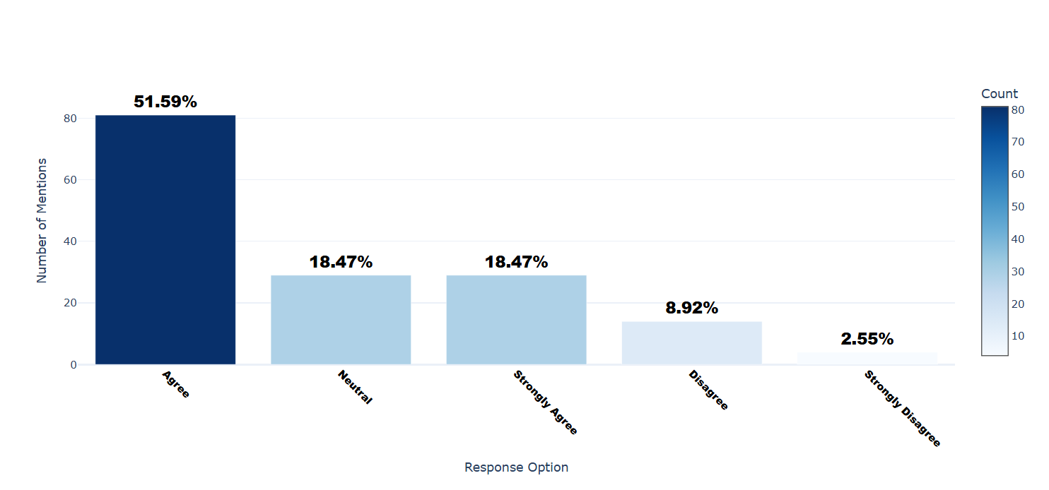

Number of respondents: 157

Breakdown of responses:

Agree: 81 (51.59%)

Neutral: 29 (18.47%)

Strongly Agree: 29 (18.47%)

Disagree: 14 (8.92%)

Strongly Disagree: 4 (2.55%)

## Q5.1_1: How important are the following values to you when it comes to online privacy? - Indivisualism (e.g. Independence)

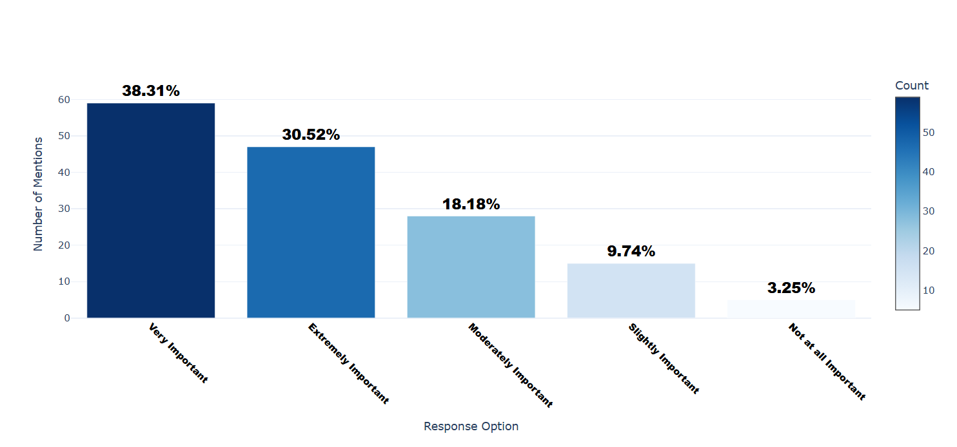

Number of respondents: 154

Breakdown of responses:

Very Important: 59 (38.31%)

Extremely Important: 47 (30.52%)

Moderately Important: 28 (18.18%)

Slightly Important: 15 (9.74%)

Not at all Important: 5 (3.25%)

## Q5.1_2: How important are the following values to you when it comes to online privacy? - Collectivism (e.g. Community influence)

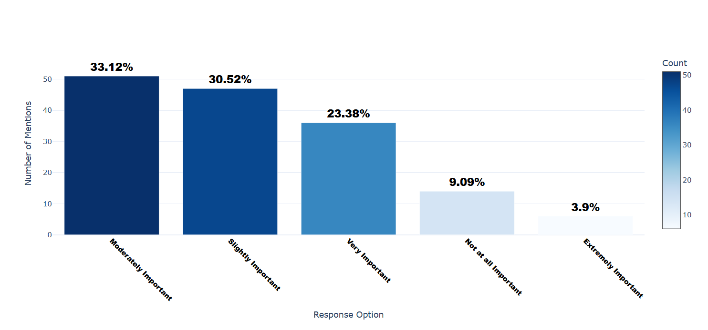

Number of respondents: 154

Breakdown of responses:

Moderately Important: 51 (33.12%)

Slightly Important: 47 (30.52%)

Very Important: 36 (23.38%)

Not at all Important: 14 (9.09%)

Extremely Important: 6 (3.9%)

## Q5.1_3: How important are the following values to you when it comes to online privacy? - Power Distance (e.g. Income inequality)

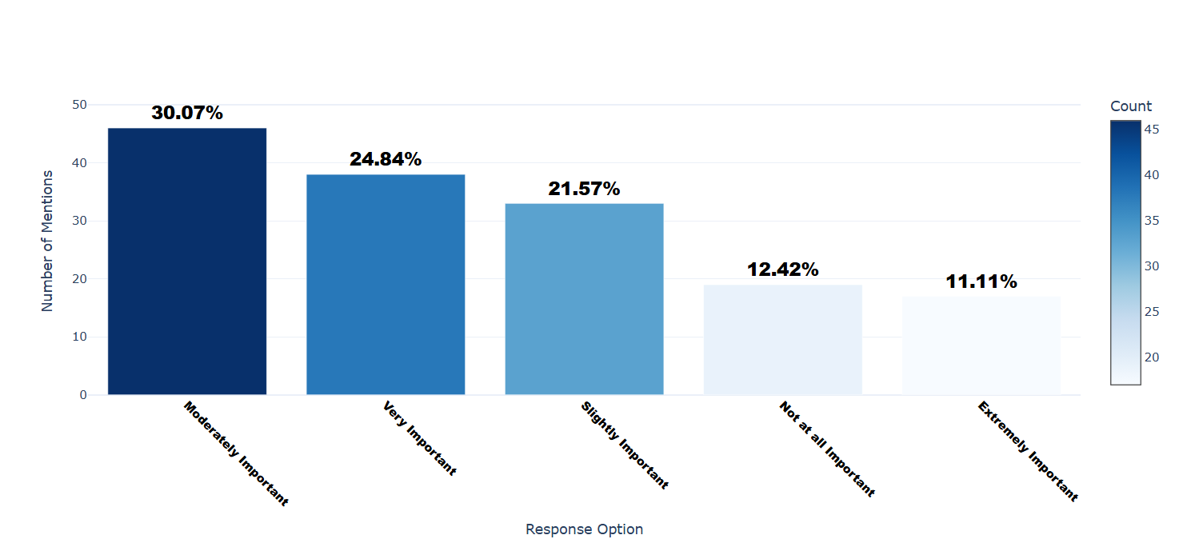

Number of respondents: 153

Breakdown of responses:

Moderately Important: 46 (30.07%)

Very Important: 38 (24.84%)

Slightly Important: 33 (21.57%)

Not at all Important: 19 (12.42%)

Extremely Important: 17 (11.11%)

## Q5.1_4: How important are the following values to you when it comes to online privacy? - Uncertainty Avoidance (e.g. How well you handle the unknown)

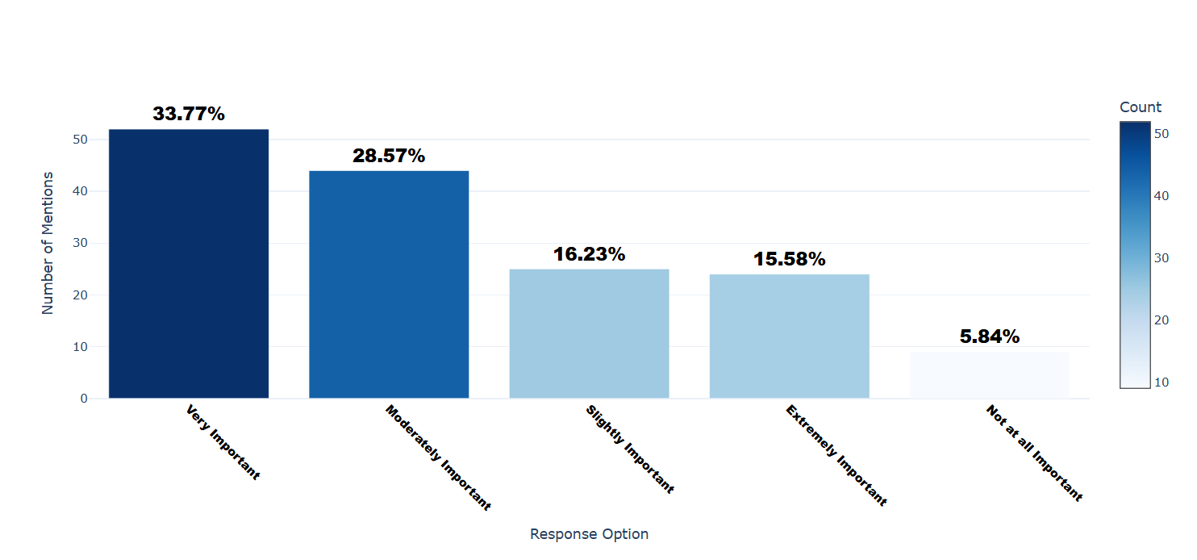

Number of respondents: 154

Breakdown of responses:

Very Important: 52 (33.77%)

Moderately Important: 44 (28.57%)

Slightly Important: 25 (16.23%)

Extremely Important: 24 (15.58%)

Not at all Important: 9 (5.84%)

## Q5.1_5: How important are the following values to you when it comes to online privacy? - Masculinity (e.g. Focus on achieving goals)

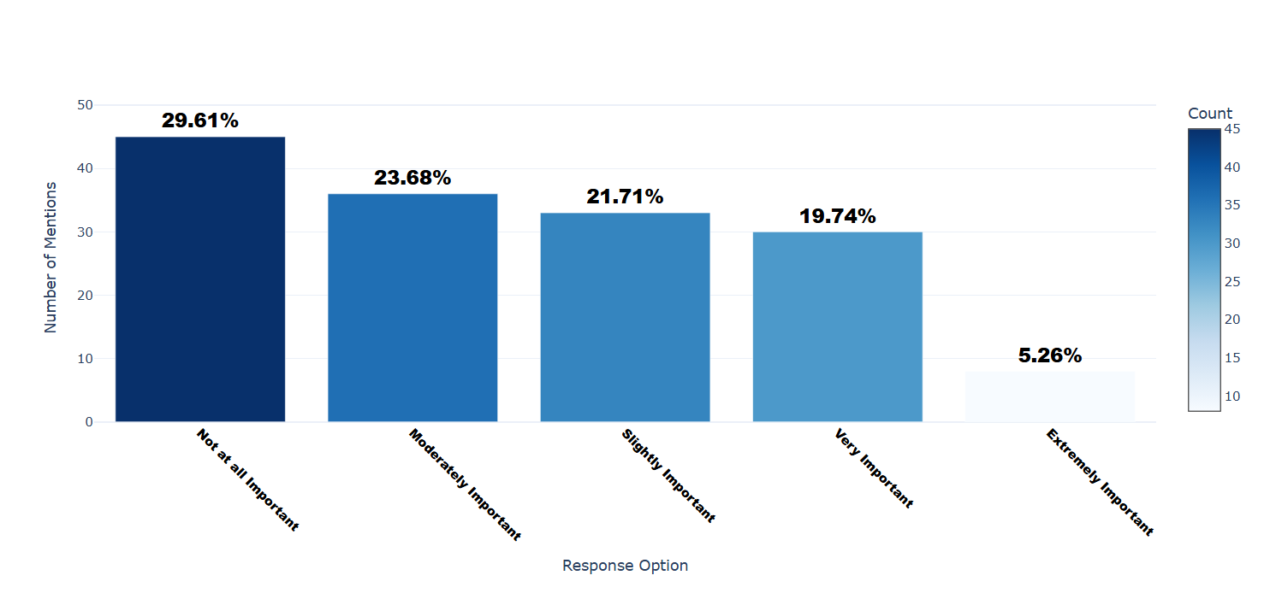

Number of respondents: 152

Breakdown of responses:

Not at all Important: 45 (29.61%)

Moderately Important: 36 (23.68%)

Slightly Important: 33 (21.71%)

Very Important: 30 (19.74%)

Extremely Important: 8 (5.26%)

## Q5.1_6: How important are the following values to you when it comes to online privacy? - Femininity (e.g. Focus on building relations)

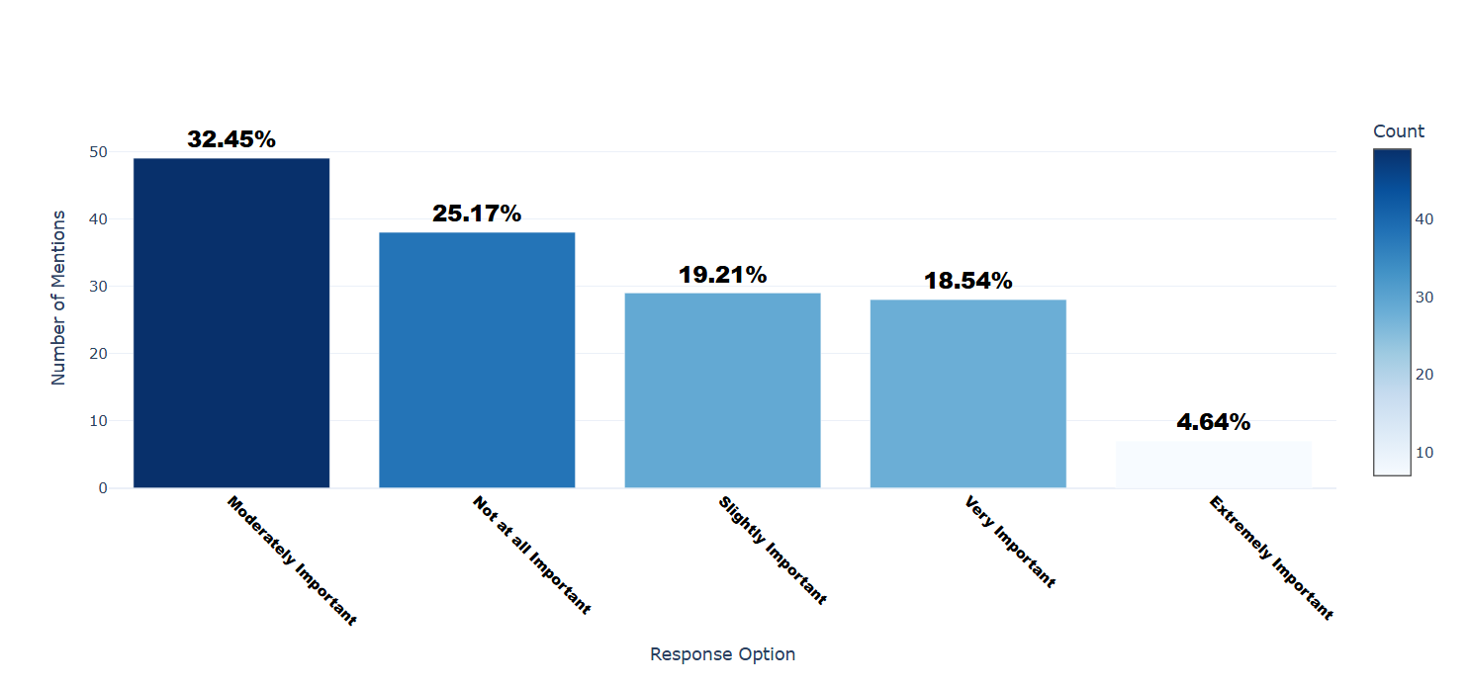

Number of respondents: 151

Breakdown of responses:

Moderately Important: 49 (32.45%)

Not at all Important: 38 (25.17%)

Slightly Important: 29 (19.21%)

Very Important: 28 (18.54%)

Extremely Important: 7 (4.64%)

## Q5.1_7: How important are the following values to you when it comes to online privacy? - Long-term Orientation (e.g. Future focused)

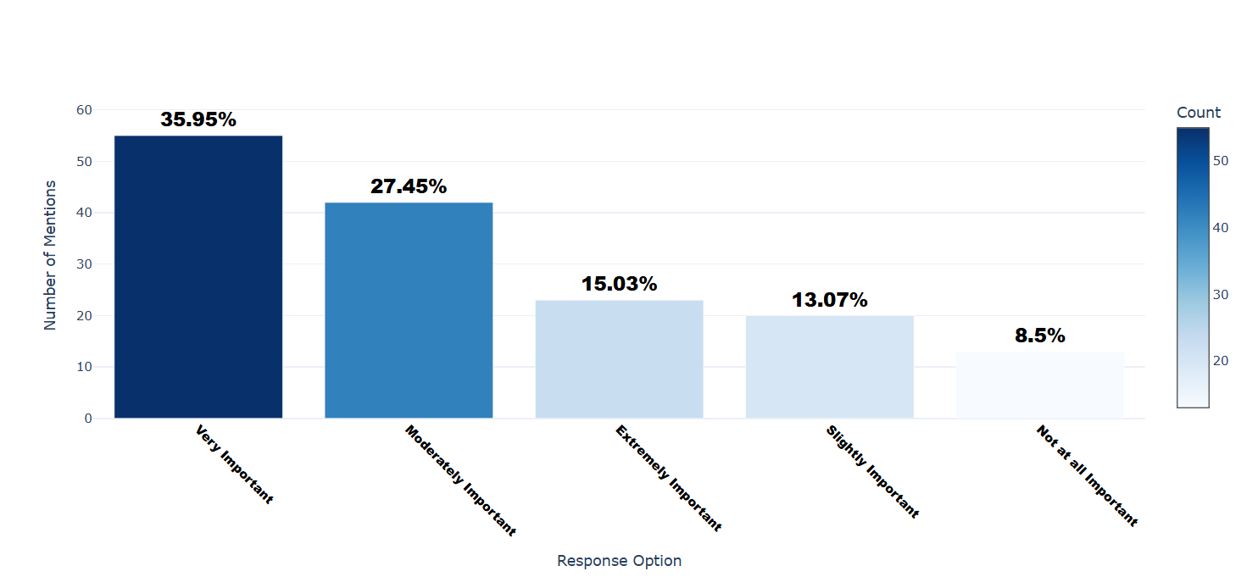

Number of respondents: 153

Breakdown of responses:

Very Important: 55 (35.95%)

Moderately Important: 42 (27.45%)

Extremely Important: 23 (15.03%)

Slightly Important: 20 (13.07%)

Not at all Important: 13 (8.5%)

## Q5.1_8: How important are the following values to you when it comes to online privacy? - Short-term Orientation (e.g. Present focused)

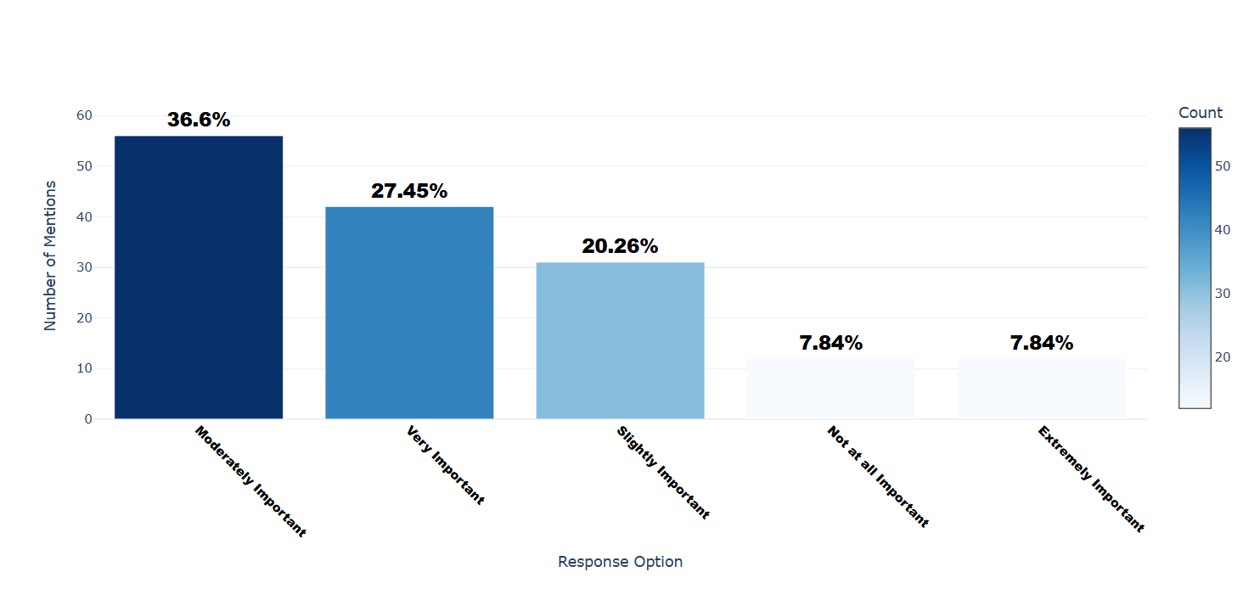

Number of respondents: 153

Breakdown of responses:

Moderately Important: 56 (36.6%)

Very Important: 42 (27.45%)

Slightly Important: 31 (20.26%)

Not at all Important: 12 (7.84%)

Extremely Important: 12 (7.84%)

## Q5.1_9: How important are the following values to you when it comes to online privacy? - Trust (e.g.. Do you trust the app)

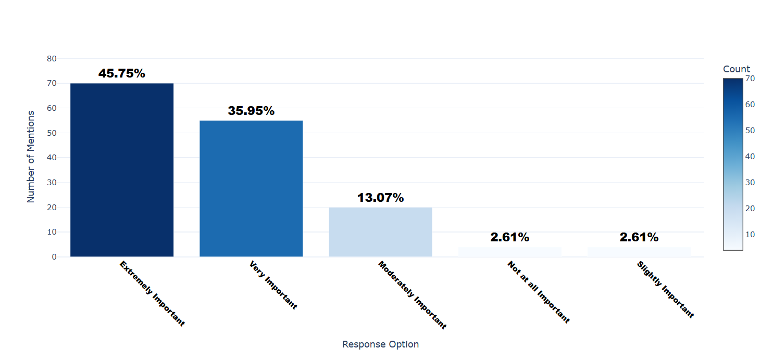

Number of respondents: 153

Breakdown of responses:

Extremely Important: 70 (45.75%)

Very Important: 55 (35.95%)

Moderately Important: 20 (13.07%)

Not at all Important: 4 (2.61%)

Slightly Important: 4 (2.61%)

## Q5.1_10: How important are the following values to you when it comes to online privacy? - Control (e.g. How much control do you want companies to have over your data)

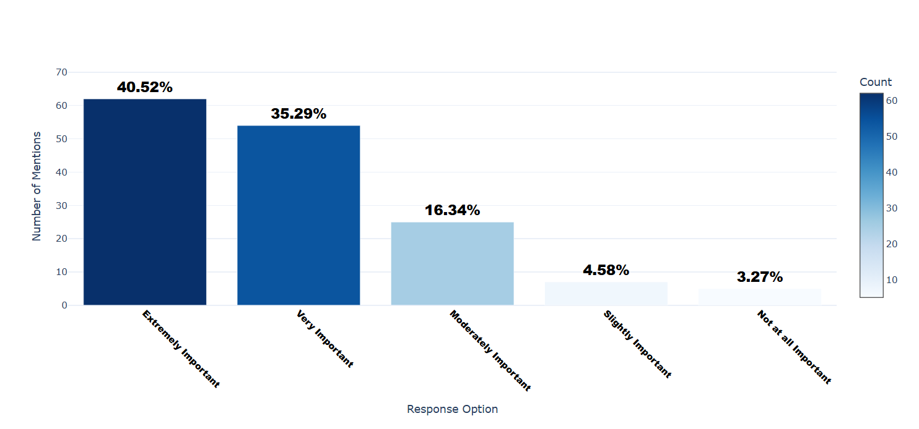

Number of respondents: 153

Breakdown of responses:

Extremely Important: 62 (40.52%)

Very Important: 54 (35.29%)

Moderately Important: 25 (16.34%)

Slightly Important: 7 (4.58%)

Not at all Important: 5 (3.27%)

## Q5.1_11: How important are the following values to you when it comes to online privacy? - Security (e.g.. How protected do you want your information to be)

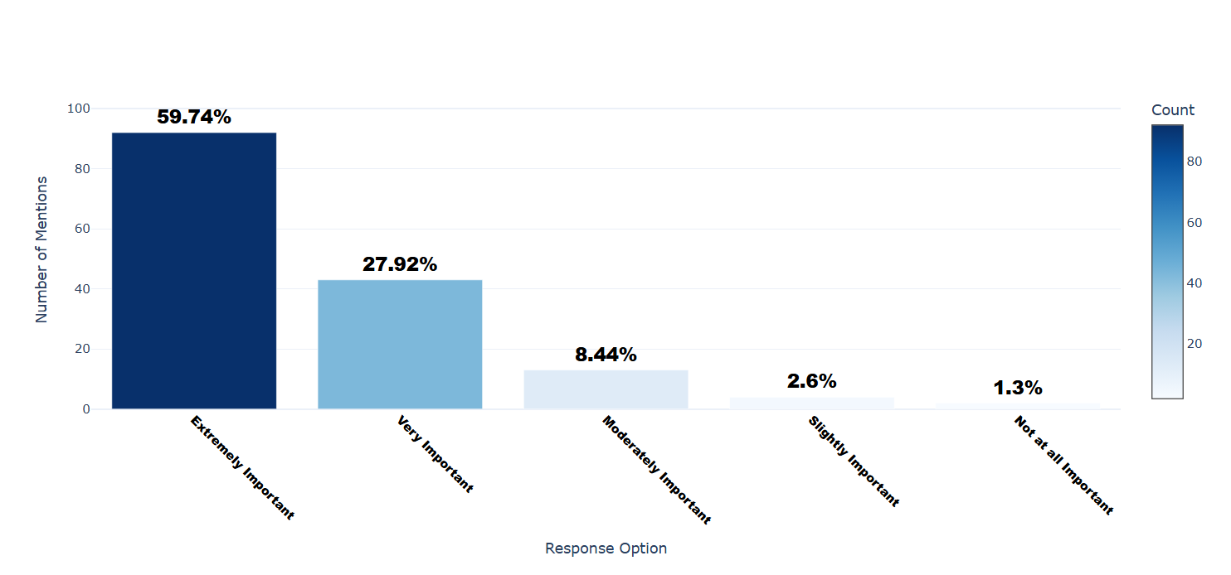

Number of respondents: 154

Breakdown of responses:

Extremely Important: 92 (59.74%)

Very Important: 43 (27.92%)

Moderately Important: 13 (8.44%)

Slightly Important: 4 (2.6%)

Not at all Important: 2 (1.3%)

## Q5.1_12: How important are the following values to you when it comes to online privacy? - Ethics

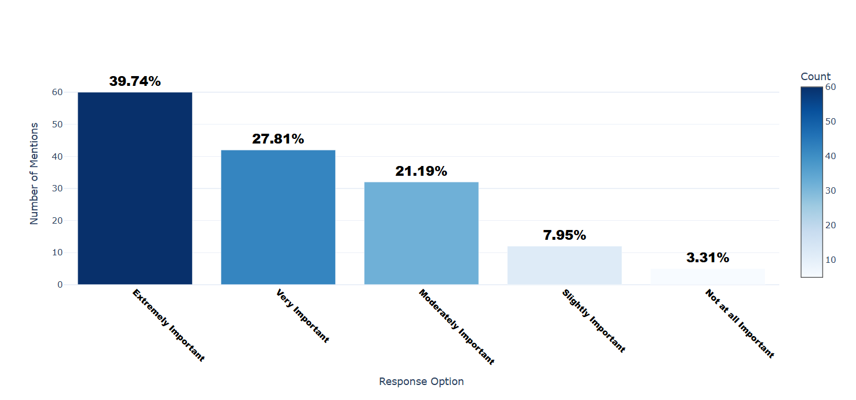

Number of respondents: 151

Breakdown of responses:

Extremely Important: 60 (39.74%)

Very Important: 42 (27.81%)

Moderately Important: 32 (21.19%)

Slightly Important: 12 (7.95%)

Not at all Important: 5 (3.31%)

## Q5.1_13: How important are the following values to you when it comes to online privacy? - Group (e.g. Do you use apps more if people you know use it)

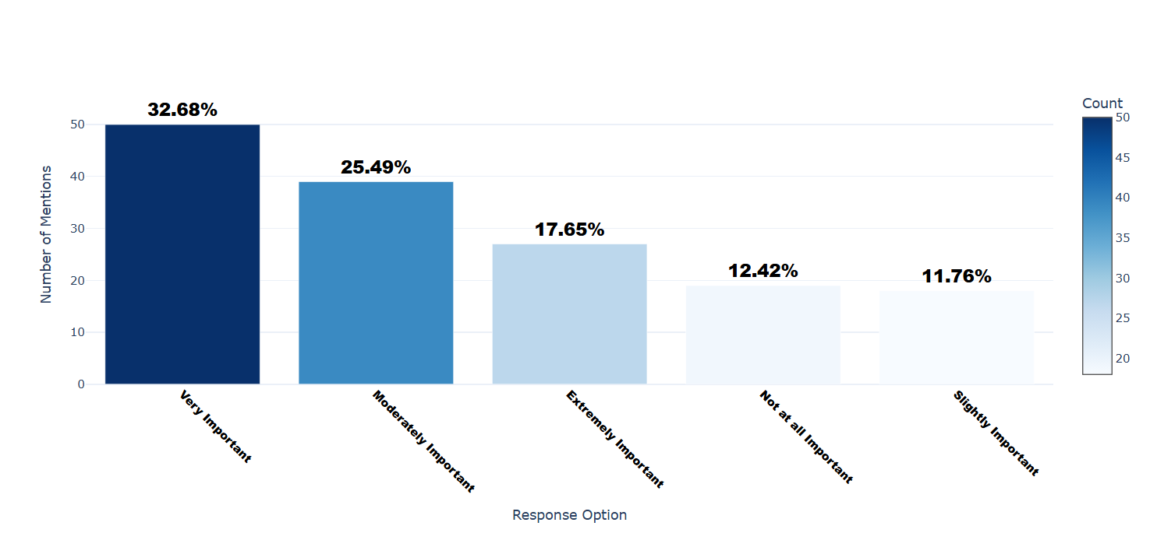

Number of respondents: 153

Breakdown of responses:

Very Important: 50 (32.68%)

Moderately Important: 39 (25.49%)

Extremely Important: 27 (17.65%)

Not at all Important: 19 (12.42%)

Slightly Important: 18 (11.76%)

## Q5.1_14: How important are the following values to you when it comes to online privacy? - Family Values (e.g. Importance of family relationships)

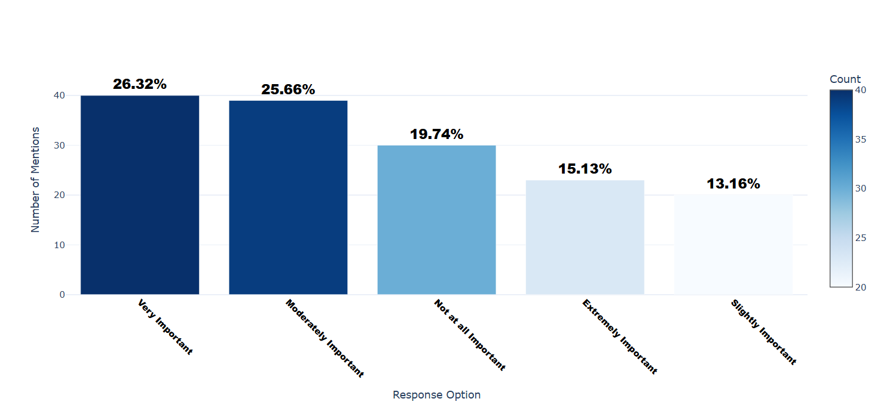

Number of respondents: 152

Breakdown of responses:

Very Important: 40 (26.32%)

Moderately Important: 39 (25.66%)

Not at all Important: 30 (19.74%)

Extremely Important: 23 (15.13%)

Slightly Important: 20 (13.16%)

## Q5.1_15: How important are the following values to you when it comes to online privacy? - Religious Beliefs (e.g.Religious teachings influencing behaivor)

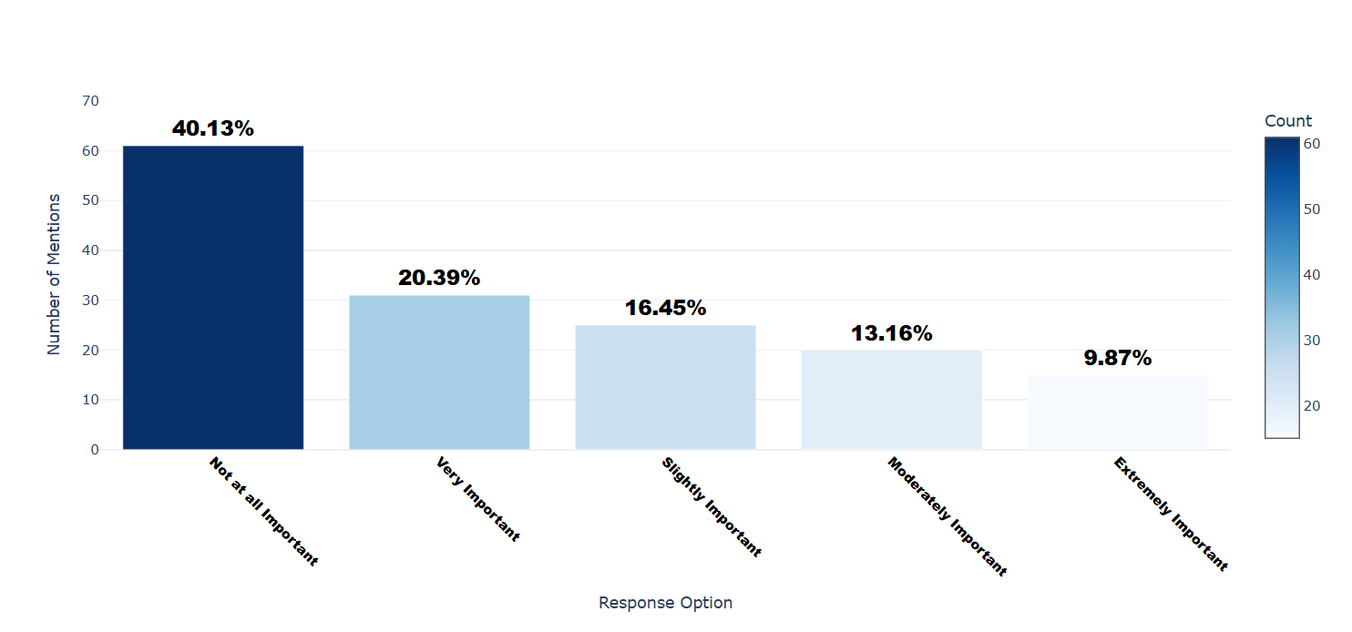

Number of respondents: 152

Breakdown of responses:

Not at all Important: 61 (40.13%)

Very Important: 31 (20.39%)

Slightly Important: 25 (16.45%)

Moderately Important: 20 (13.16%)

Extremely Important: 15 (9.87%)

## Q5.1_16: How important are the following values to you when it comes to online privacy? - Media and news outlets(e.g. Influence local media has)

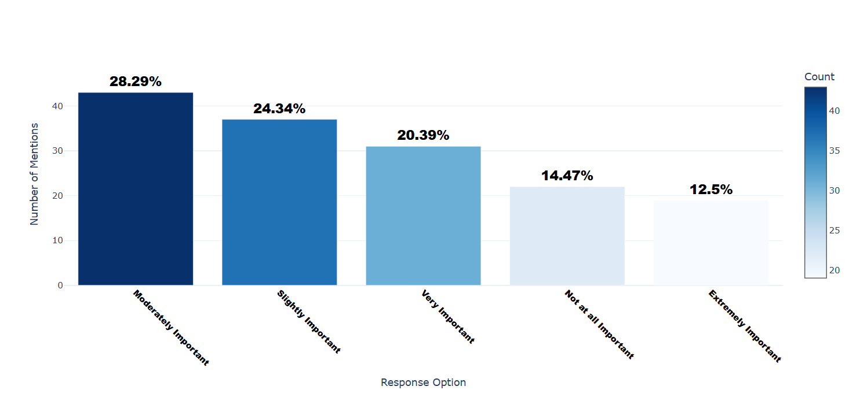

Number of respondents: 152

Breakdown of responses:

Moderately Important: 43 (28.29%)

Slightly Important: 37 (24.34%)

Very Important: 31 (20.39%)

Not at all Important: 22 (14.47%)

Extremely Important: 19 (12.5%)

## Q5.1_17: How important are the following values to you when it comes to online privacy? - Educational Backgrounds (e.g. Level and type of education influencing understanding of privacy)

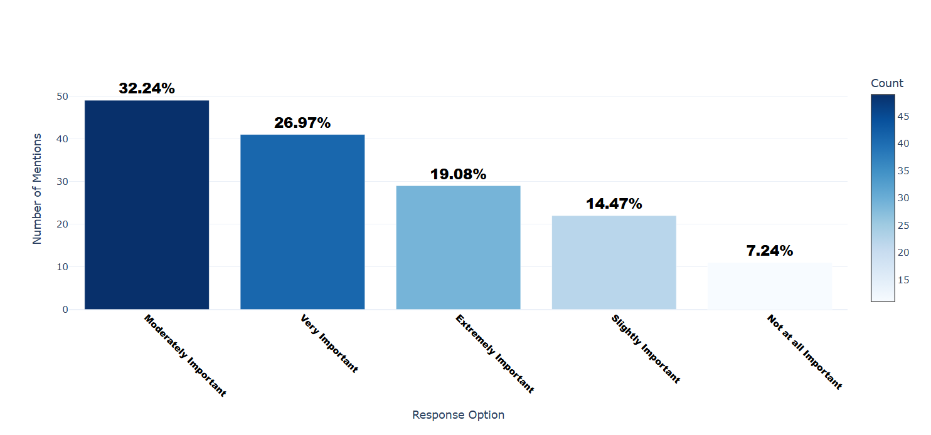

Number of respondents: 152

Breakdown of responses:

Moderately Important: 49 (32.24%)

Very Important: 41 (26.97%)

Extremely Important: 29 (19.08%)

Slightly Important: 22 (14.47%)

Not at all Important: 11 (7.24%)

## Q5.1_18: How important are the following values to you when it comes to online privacy? - Others (please specify)

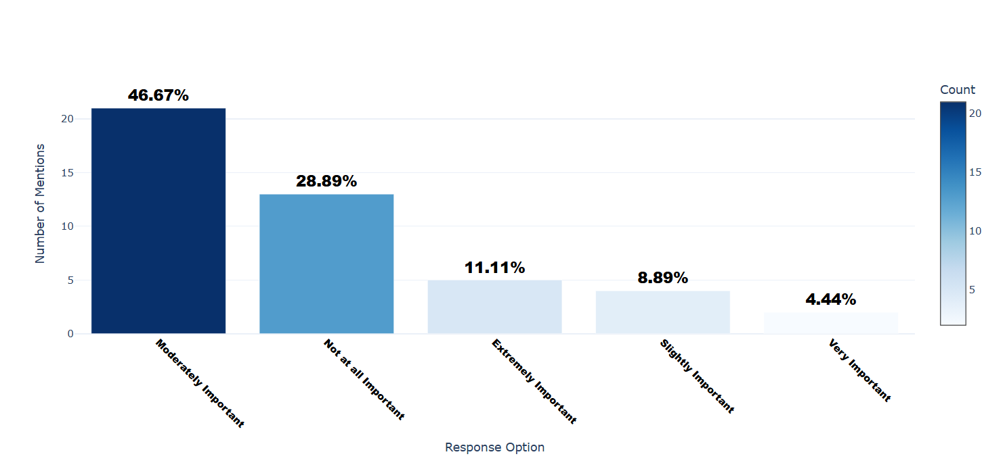

Number of respondents: 45

Breakdown of responses:

Moderately Important: 21 (46.67%)

Not at all Important: 13 (28.89%)

Extremely Important: 5 (11.11%)

Slightly Important: 4 (8.89%)

Very Important: 2 (4.44%)

## Q5.1_18_TEXT: How important are the following values to you when it comes to online privacy? - Others (please specify) - Text

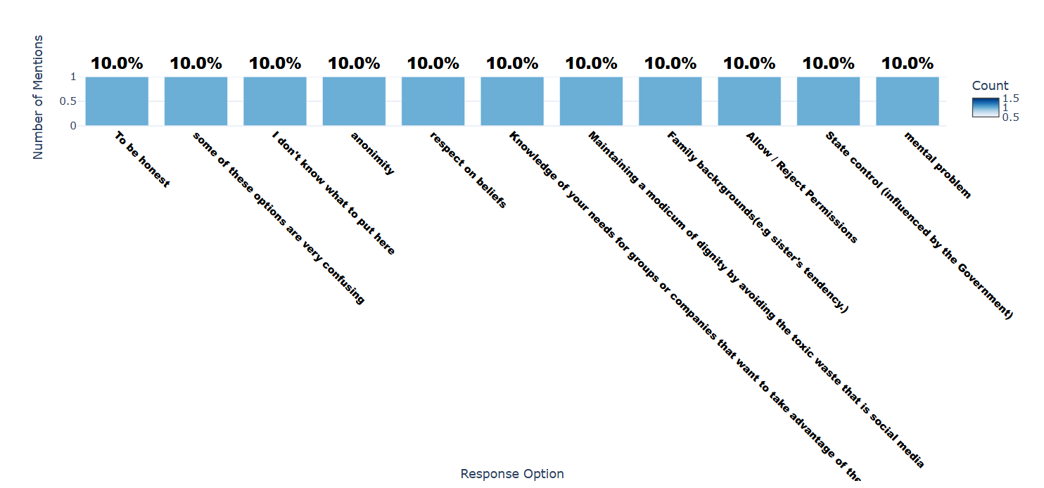

Number of respondents: 10

Breakdown of responses:

To be honest: 1 (10.0%)

some of these options are very confusing: 1 (10.0%)

I don't know what to put here: 1 (10.0%)

anonimity: 1 (10.0%)

respect on beliefs: 1 (10.0%)

Knowledge of your needs for groups or companies that want to take advantage of them: 1 (10.0%)

Maintaining a modicum of dignity by avoiding the toxic waste that is social media: 1 (10.0%)

Family backrgrounds(e.g sister's tendency.): 1 (10.0%)

Allow / Reject Permissions: 1 (10.0%)

State control (influenced by the Government): 1 (10.0%)

mental problem: 1 (10.0%)

## Q6.1: Have you lived in a country that is culturally different from your own (e.g., moving from an Eastern country to a Western country or vice versa) for more than six months? - Selected Choice

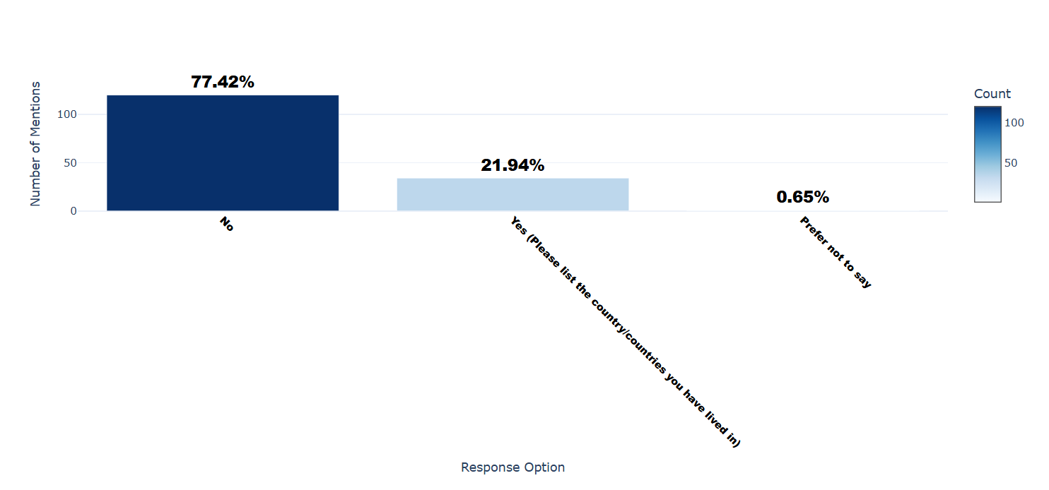

Number of respondents: 155

Breakdown of responses:

No: 120 (77.42%)

Yes (Please list the country/countries you have lived in): 34 (21.94%)

Prefer not to say: 1 (0.65%)

## Q6.1_1_TEXT: Have you lived in a country that is culturally different from your own (e.g., moving from an Eastern country to a Western country or vice versa) for more than six months? - Yes (Please list the country/countries you have lived in) - Text

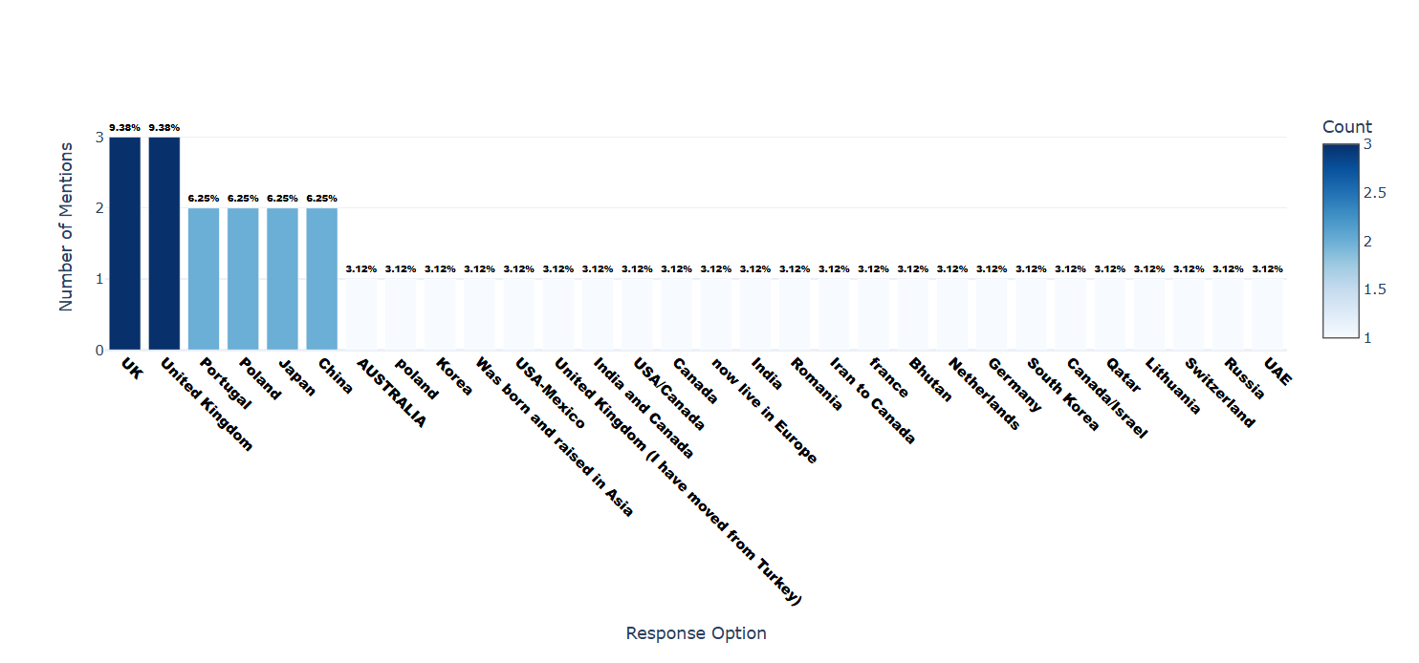

Number of respondents: 32

Breakdown of responses:

UK: 3 (9.38%)

United Kingdom: 3 (9.38%)

Portugal: 2 (6.25%)

Poland: 2 (6.25%)

Japan: 2 (6.25%)

China: 2 (6.25%)

AUSTRALIA: 1 (3.12%)

poland: 1 (3.12%)

Korea: 1 (3.12%)

Was born and raised in Asia: 1 (3.12%)

USA-Mexico: 1 (3.12%)

United Kingdom (I have moved from Turkey): 1 (3.12%)

India and Canada: 1 (3.12%)

USA/Canada: 1 (3.12%)

Canada: 1 (3.12%)

now live in Europe: 1 (3.12%)

India: 1 (3.12%)

Romania: 1 (3.12%)

Iran to Canada: 1 (3.12%)

france: 1 (3.12%)

Bhutan: 1 (3.12%)

Netherlands: 1 (3.12%)

Germany: 1 (3.12%)

South Korea: 1 (3.12%)

Canada/Israel: 1 (3.12%)

Qatar: 1 (3.12%)

Lithuania: 1 (3.12%)

Switzerland: 1 (3.12%)

Russia: 1 (3.12%)

UAE: 1 (3.12%)

## Q6.2: Did you move from an Eastern country to a Western country, or from a Western country to an Eastern country? Alternatively, did you move between countries within the Eastern region or within the Western region? Please Specify. - Selected Choice

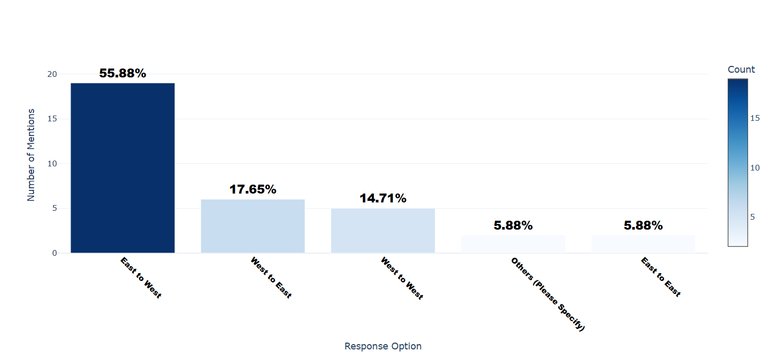

Number of respondents: 34

Breakdown of responses:

East to West: 19 (55.88%)

West to East: 6 (17.65%)

West to West: 5 (14.71%)

Others (Please Specify): 2 (5.88%)

East to East: 2 (5.88%)

## Q6.2_5_TEXT: Did you move from an Eastern country to a Western country, or from a Western country to an Eastern country? Alternatively, did you move between countries within the Eastern region or within the Western region? Please Specify. - Others (Please Specify) - Text

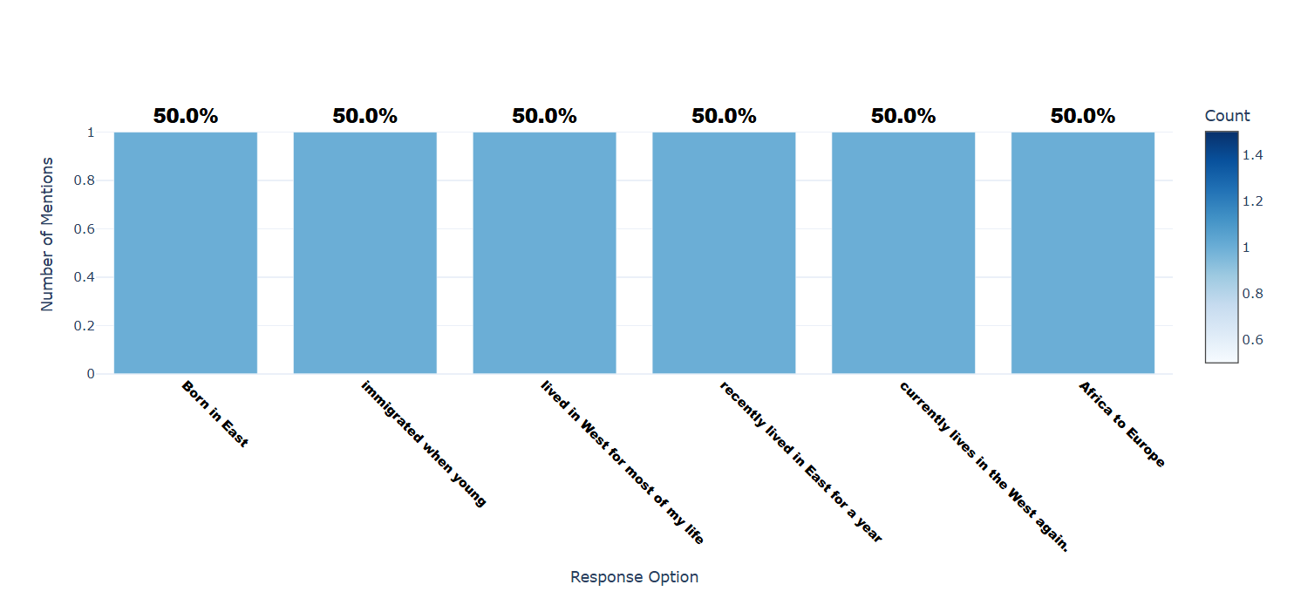

Number of respondents: 2

Breakdown of responses:

Born in East: 1 (50.0%)

immigrated when young: 1 (50.0%)

lived in West for most of my life: 1 (50.0%)

recently lived in East for a year: 1 (50.0%)

currently lives in the West again.: 1 (50.0%)

Africa to Europe: 1 (50.0%)

## Q6.3: After I moved, I care more about my online privacy after interacting with people from different cultures.

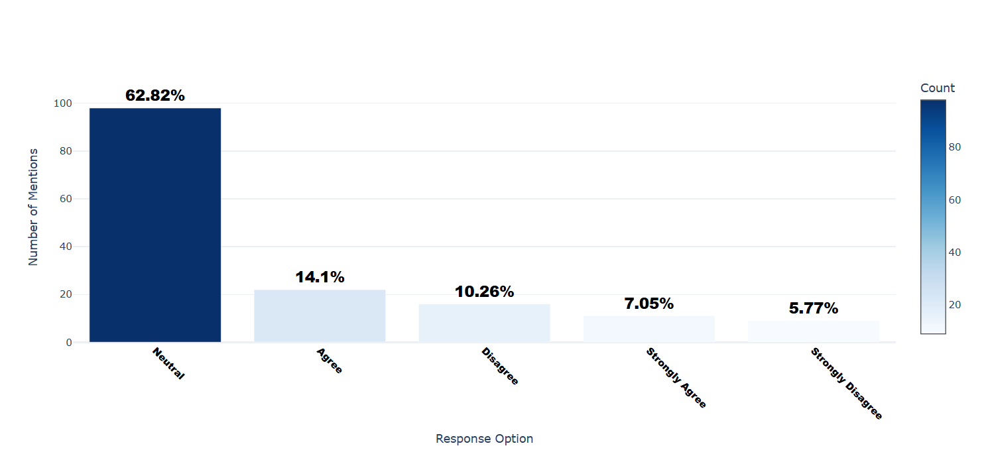

Number of respondents: 156

Breakdown of responses:

Neutral: 98 (62.82%)

Agree: 22 (14.1%)

Disagree: 16 (10.26%)

Strongly Agree: 11 (7.05%)

Strongly Disagree: 9 (5.77%)

## Q6.5: I care more about my online privacy after living in a Western country.

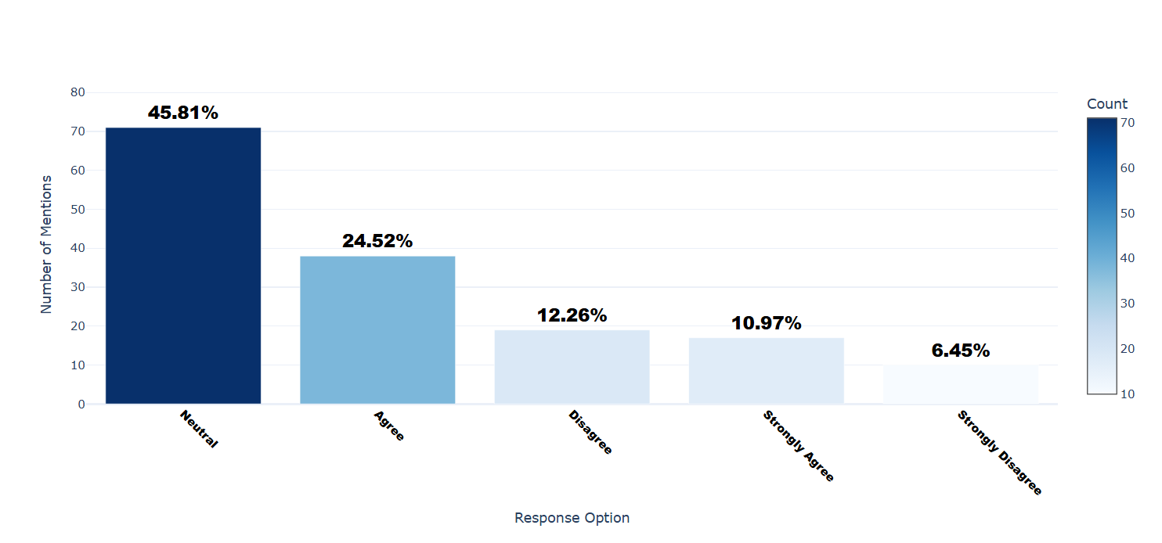

Number of respondents: 155

Breakdown of responses:

Neutral: 71 (45.81%)

Agree: 38 (24.52%)

Disagree: 19 (12.26%)

Strongly Agree: 17 (10.97%)

Strongly Disagree: 10 (6.45%)

## Q6.6: I care more about my online privacy after living in an Eastern country.

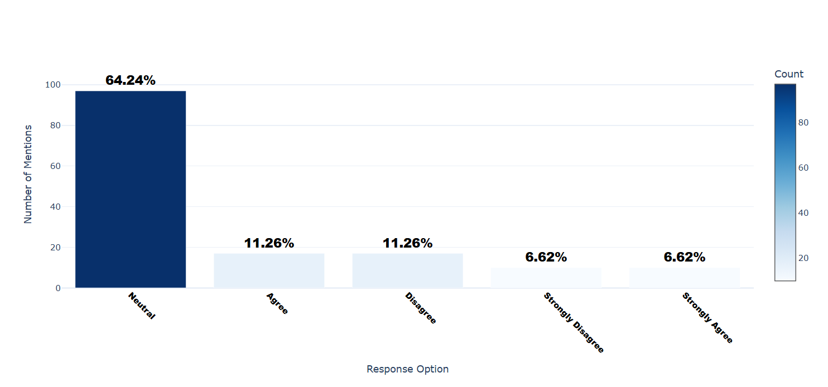

Number of respondents: 151

Breakdown of responses:

Neutral: 97 (64.24%)

Agree: 17 (11.26%)

Disagree: 17 (11.26%)

Strongly Disagree: 10 (6.62%)

Strongly Agree: 10 (6.62%)

## Q6.7: I became more privacy-conscious after interacting with people from other cultures.

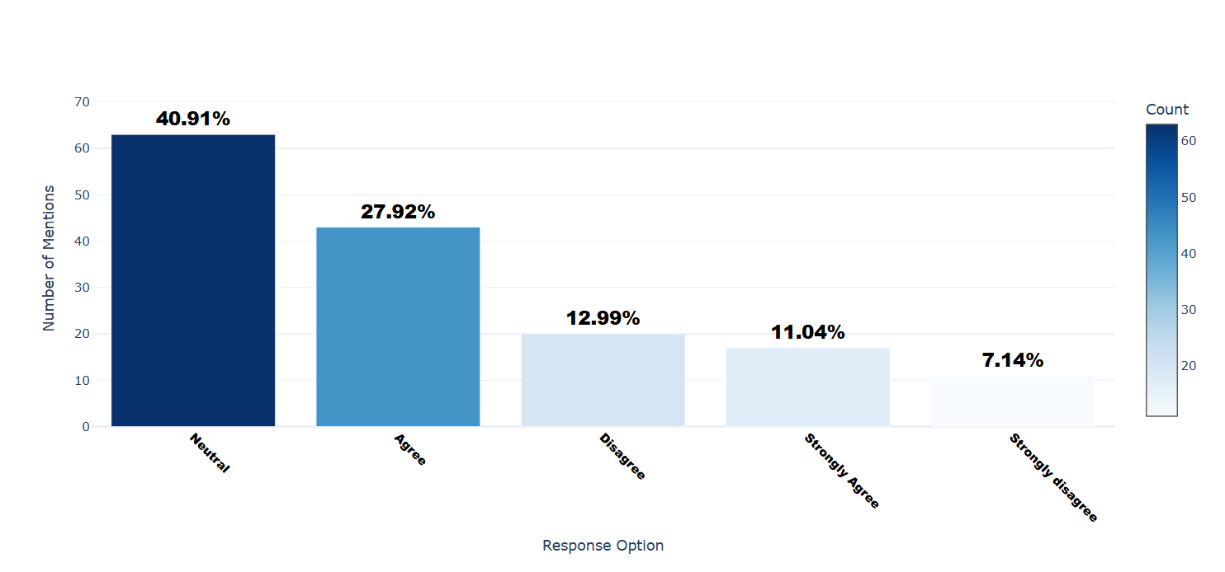

Number of respondents: 154

Breakdown of responses:

Neutral: 63 (40.91%)

Agree: 43 (27.92%)

Disagree: 20 (12.99%)

Strongly Agree: 17 (11.04%)

Strongly disagree: 11 (7.14%)

## Q6.11: For quality assurance, please select "Somewhat Comfortable" for this item.

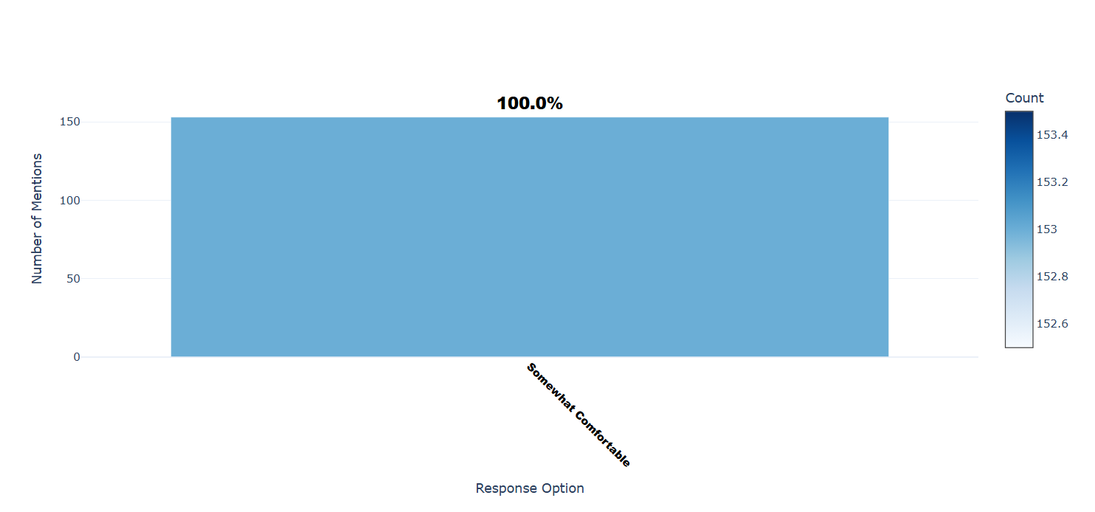

Number of respondents: 153

Breakdown of responses:

Somewhat Comfortable: 153 (100.0%)

## Q6.12: I share less personal information online after interacting with people from different cultures.

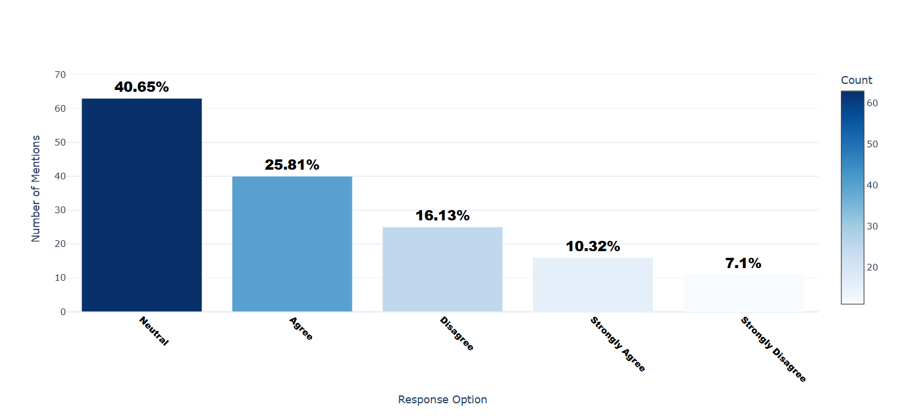

Number of respondents: 155

Breakdown of responses:

Neutral: 63 (40.65%)

Agree: 40 (25.81%)

Disagree: 25 (16.13%)

Strongly Agree: 16 (10.32%)

Strongly Disagree: 11 (7.1%)

## Q7.1: How much influence does your cultural background and personal values have on your trust in social media platforms regarding privacy?

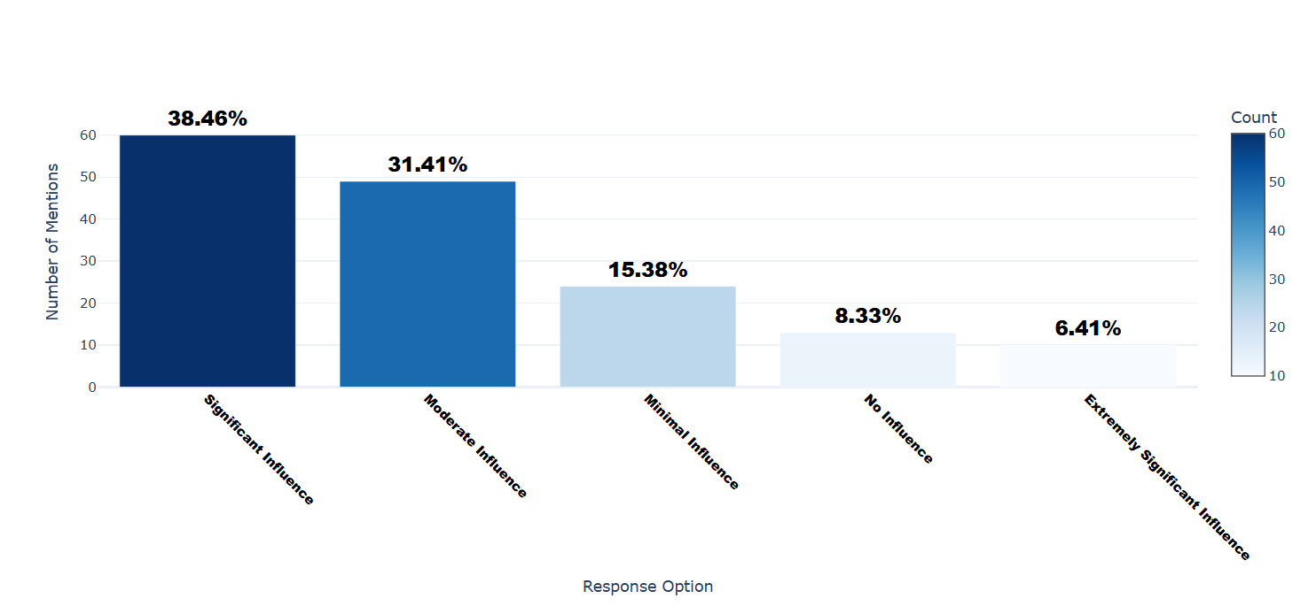

Number of respondents: 156

Breakdown of responses:

Significant Influence: 60 (38.46%)

Moderate Influence: 49 (31.41%)

Minimal Influence: 24 (15.38%)

No Influence: 13 (8.33%)

Extremely Significant Influence: 10 (6.41%)

## Q7.3: How much influence does your technological literacy have on your trust in social media platforms regarding privacy?

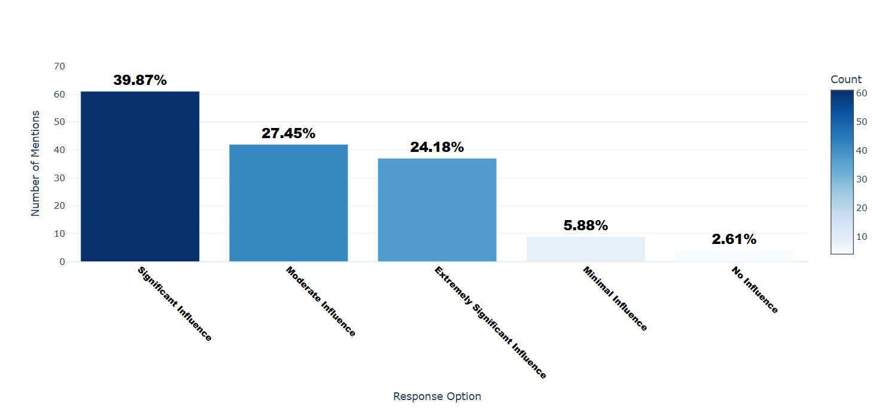

Number of respondents: 153

Breakdown of responses:

Significant Influence: 61 (39.87%)

Moderate Influence: 42 (27.45%)

Extremely Significant Influence: 37 (24.18%)

Minimal Influence: 9 (5.88%)

No Influence: 4 (2.61%)

## Q7.5_1: Have you ever felt pressured by any of the following cultural norms to share more personal information than you were comfortable with online? (Select all that apply) - Family Expectation

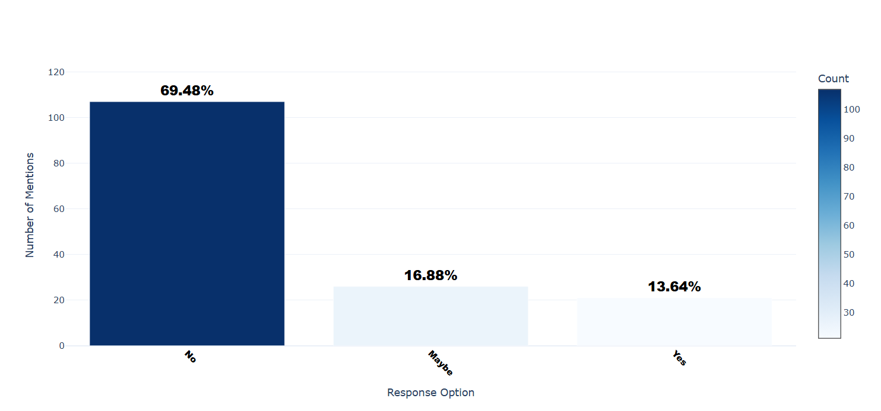

Number of respondents: 154

Breakdown of responses:

No: 107 (69.48%)

Maybe: 26 (16.88%)

Yes: 21 (13.64%)

## Q7.5_2: Have you ever felt pressured by any of the following cultural norms to share more personal information than you were comfortable with online? (Select all that apply) - Peer Pressure

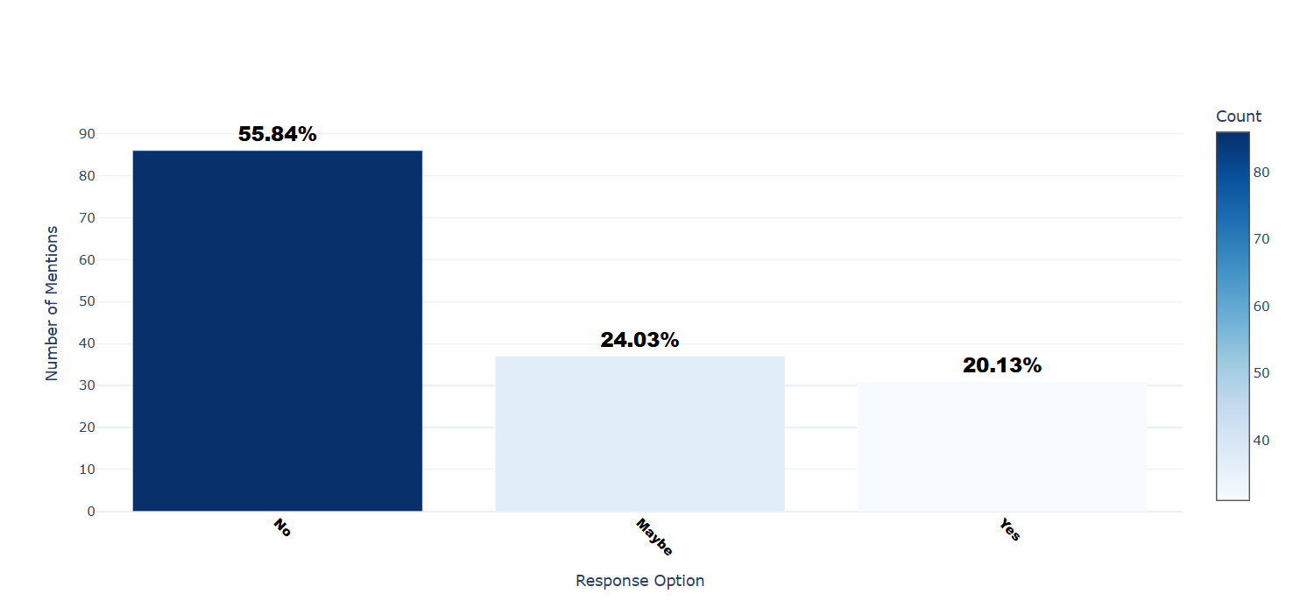

Number of respondents: 154

Breakdown of responses:

No: 86 (55.84%)

Maybe: 37 (24.03%)

Yes: 31 (20.13%)

## Q7.5_3: Have you ever felt pressured by any of the following cultural norms to share more personal information than you were comfortable with online? (Select all that apply) - Social Media Trends

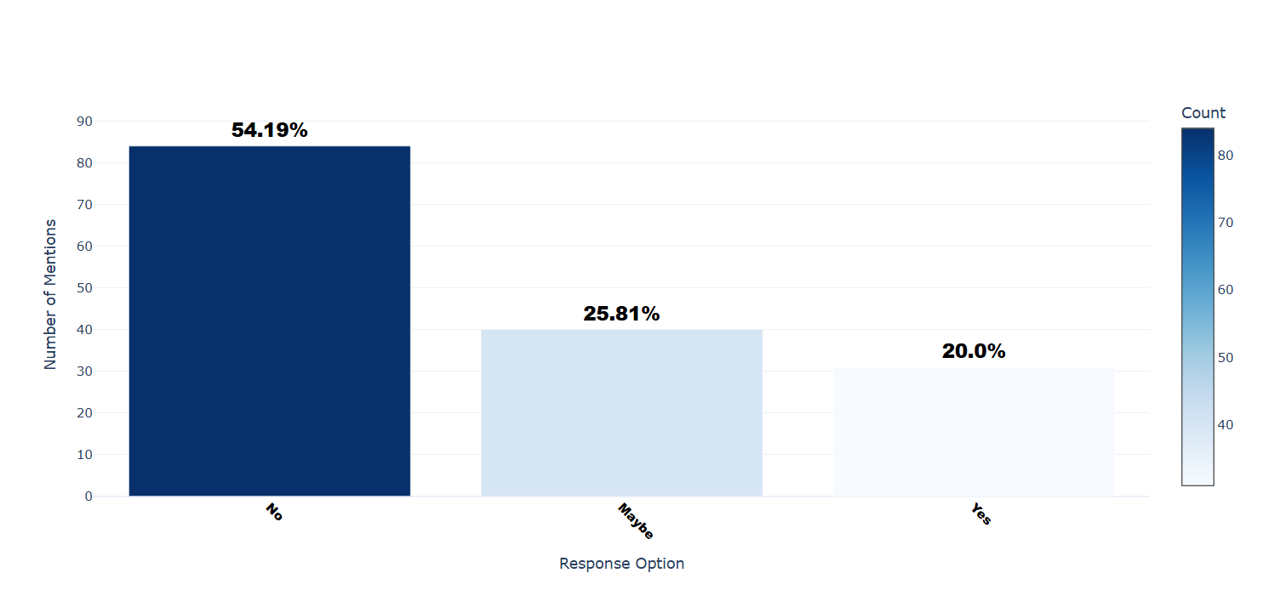

Number of respondents: 155

Breakdown of responses:

No: 84 (54.19%)

Maybe: 40 (25.81%)

Yes: 31 (20.0%)

## Q7.5_4: Have you ever felt pressured by any of the following cultural norms to share more personal information than you were comfortable with online? (Select all that apply) - Cultural Values

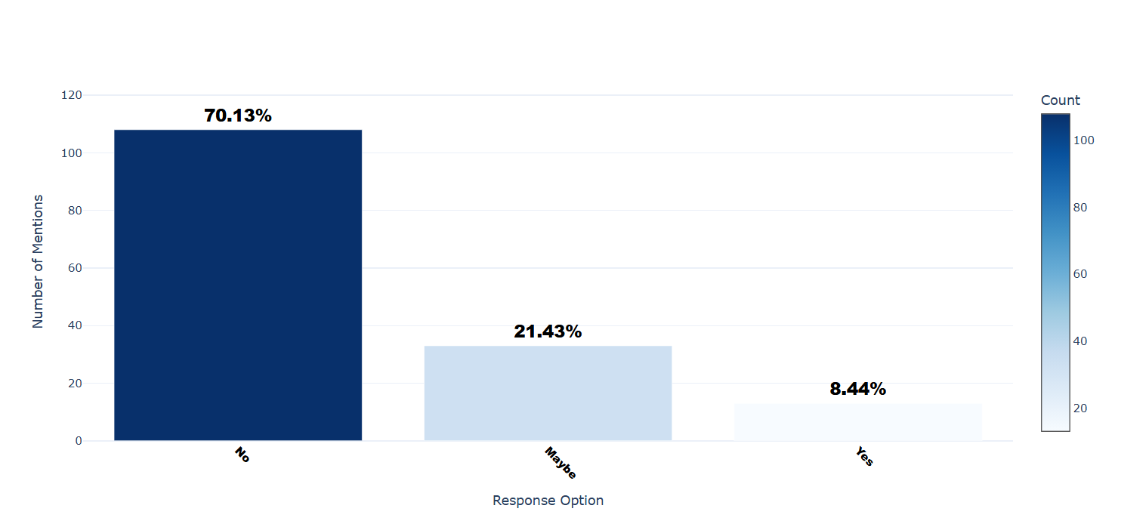

Number of respondents: 154

Breakdown of responses:

No: 108 (70.13%)

Maybe: 33 (21.43%)

Yes: 13 (8.44%)

## Q7.6: If 'Other', please specify.

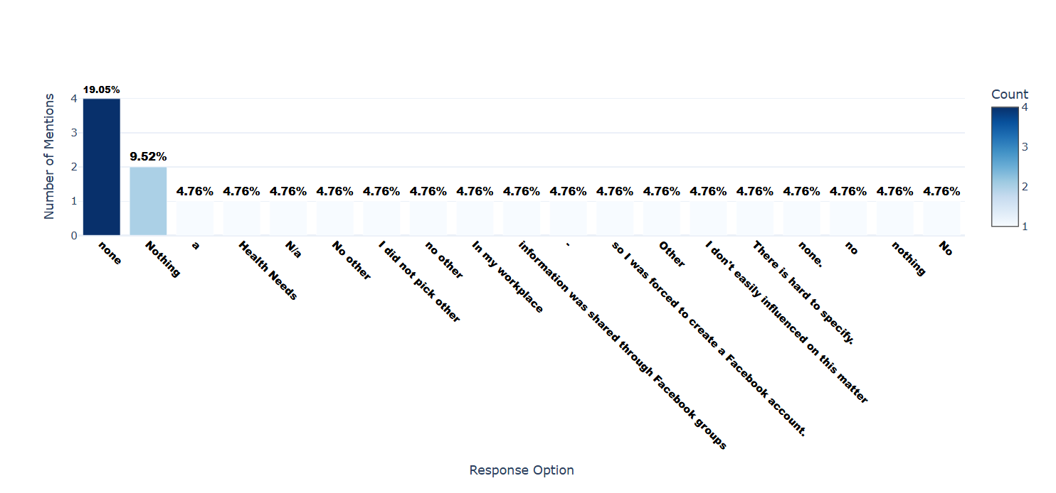

Number of respondents: 21

Breakdown of responses:

none: 4 (19.05%)

Nothing: 2 (9.52%)

a: 1 (4.76%)

Health Needs: 1 (4.76%)

N/a: 1 (4.76%)

No other: 1 (4.76%)

I did not pick other: 1 (4.76%)

no other: 1 (4.76%)

In my workplace: 1 (4.76%)

information was shared through Facebook groups: 1 (4.76%)

-: 1 (4.76%)

so I was forced to create a Facebook account.: 1 (4.76%)

Other: 1 (4.76%)

I don't easily influenced on this matter: 1 (4.76%)

There is hard to specify.: 1 (4.76%)

none.: 1 (4.76%)

no: 1 (4.76%)

nothing: 1 (4.76%)

No: 1 (4.76%)

## Q7.8: To what extent do cultural norms (e.g., family expectations, social norms) influence how often you adjust your online privacy settings?

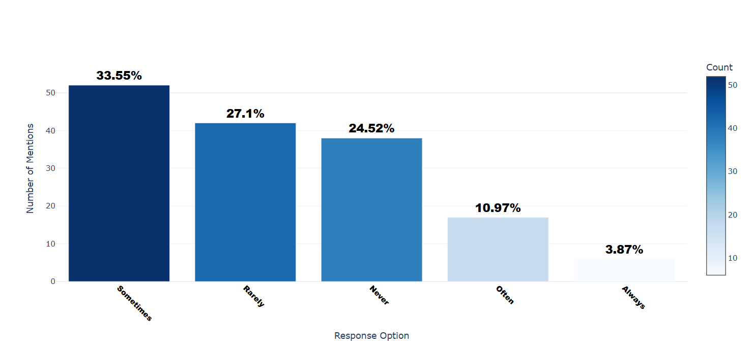

Number of respondents: 155

Breakdown of responses:

Sometimes: 52 (33.55%)

Rarely: 42 (27.1%)

Never: 38 (24.52%)

Often: 17 (10.97%)

Always: 6 (3.87%)

## Q7.9: Do you trust the privacy policies of platforms popular in your home country compared to global platforms (e.g., Facebook, Instagram, Twitter, TikTok, Google, etc)?

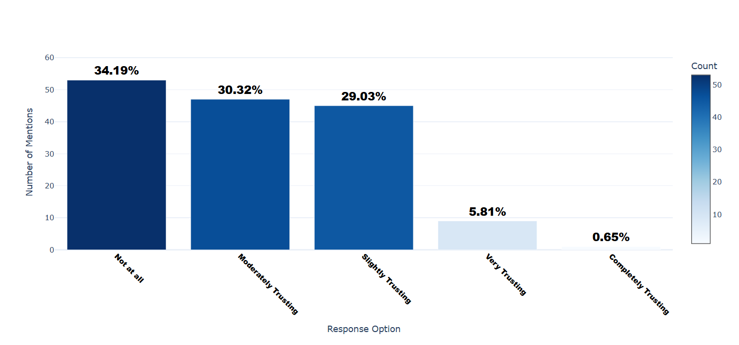

Number of respondents: 155

Breakdown of responses:

Not at all: 53 (34.19%)

Moderately Trusting: 47 (30.32%)

Slightly Trusting: 45 (29.03%)

Very Trusting: 9 (5.81%)

Completely Trusting: 1 (0.65%)

## Q8.1: Have you ever read a privacy policy of an application prior to use?

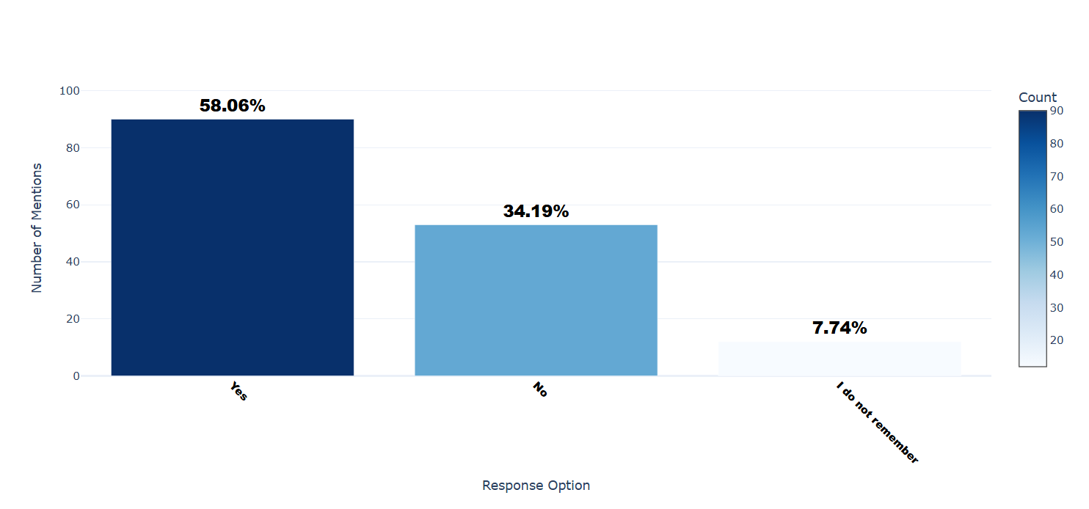

Number of respondents: 155

Breakdown of responses:

Yes: 90 (58.06%)

No: 53 (34.19%)

I do not remember: 12 (7.74%)

## Q8.2: How often do you read privacy policies for apps?

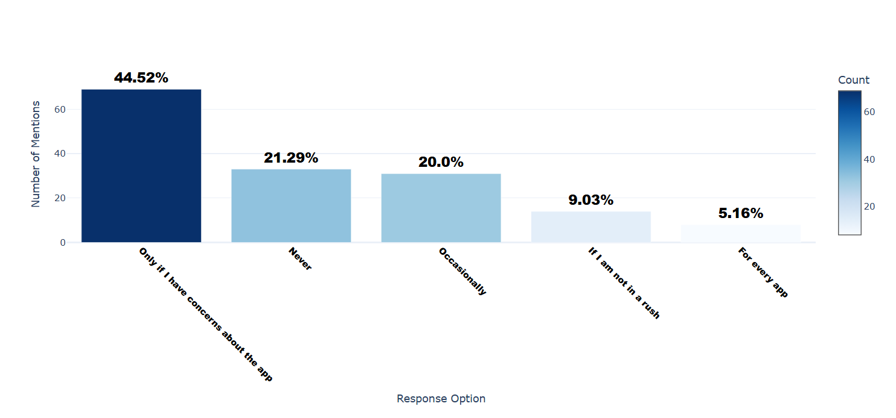

Number of respondents: 155

Breakdown of responses:

Only if I have concerns about the app: 69 (44.52%)

Never: 33 (21.29%)

Occasionally: 31 (20.0%)

If I am not in a rush: 14 (9.03%)

For every app: 8 (5.16%)

## Q8.3: Do you read privacy notices shown prior to using an app?

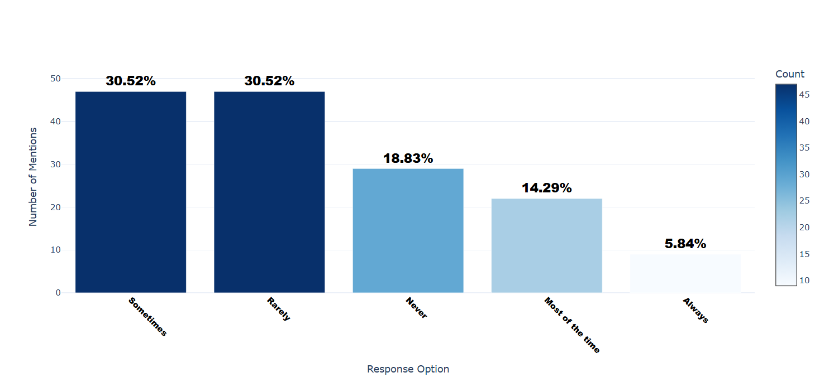

Number of respondents: 154

Breakdown of responses:

Sometimes: 47 (30.52%)

Rarely: 47 (30.52%)

Never: 29 (18.83%)

Most of the time: 22 (14.29%)

Always: 9 (5.84%)

## Q8.4: 'I accept the privacy notices for an app without reading them'. - Selected Choice

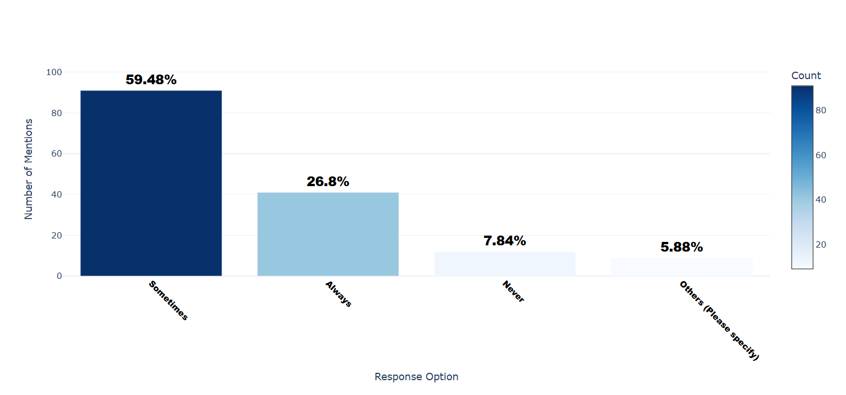

Number of respondents: 153

Breakdown of responses:

Sometimes: 91 (59.48%)

Always: 41 (26.8%)

Never: 12 (7.84%)

Others (Please specify): 9 (5.88%)

## Q8.4_4_TEXT: 'I accept the privacy notices for an app without reading them'. - Others (Please specify) - Text

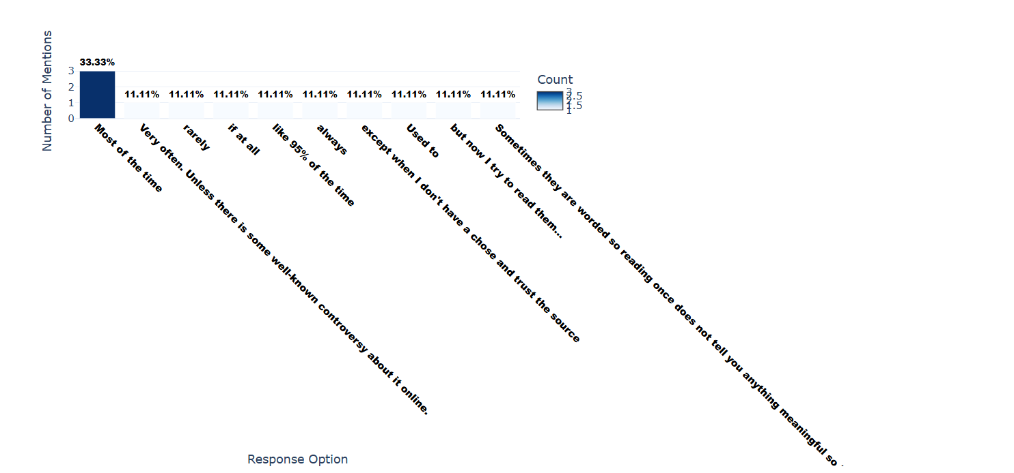

Number of respondents: 9

Breakdown of responses:

Most of the time: 3 (33.33%)

Very often. Unless there is some well-known controversy about it online.: 1 (11.11%)

rarely: 1 (11.11%)

if at all: 1 (11.11%)

like 95% of the time: 1 (11.11%)

always: 1 (11.11%)

except when I don't have a chose and trust the source: 1 (11.11%)

Used to: 1 (11.11%)

but now I try to read them…: 1 (11.11%)

Sometimes they are worded so reading once does not tell you anything meaningful so I might as well put sometimes for this.: 1 (11.11%)

## Q8.5: Are you familiar with privacy labels that provide information about an app's privacy practices?

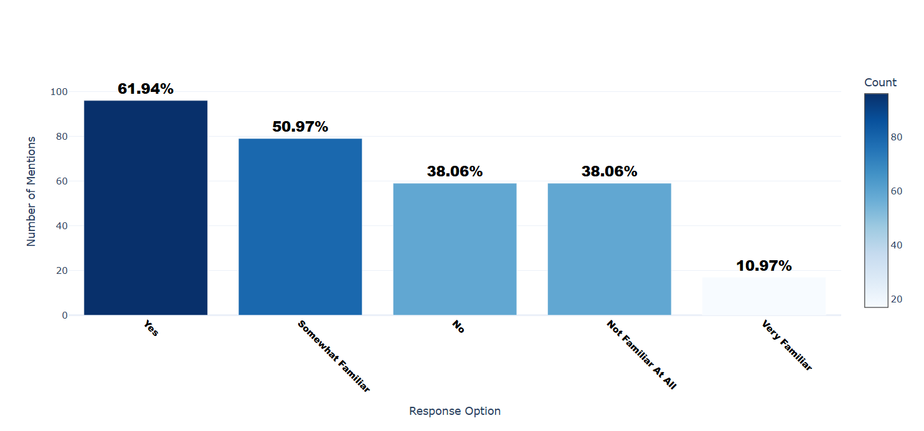

Number of respondents: 155

Breakdown of responses:

Yes: 96 (61.94%)

Somewhat Familiar: 79 (50.97%)

No: 59 (38.06%)

Not Familiar At All: 59 (38.06%)

Very Familiar: 17 (10.97%)

## Q8.6: How often do you review privacy labels before using a new application or service?

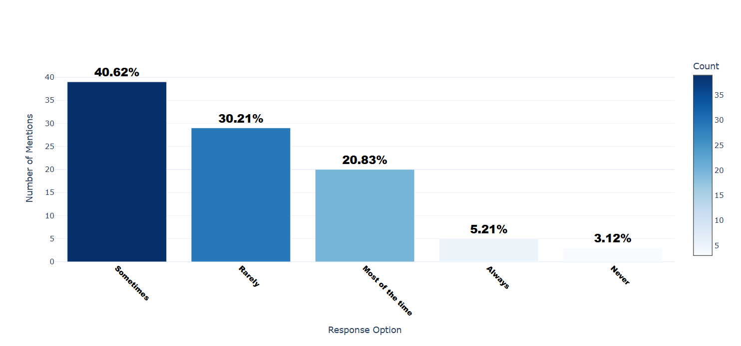

Number of respondents: 96

Breakdown of responses:

Sometimes: 39 (40.62%)

Rarely: 29 (30.21%)

Most of the time: 20 (20.83%)

Always: 5 (5.21%)

Never: 3 (3.12%)

## Q9.1: Do you regularly check and adjust the privacy settings of the applications and services you use?

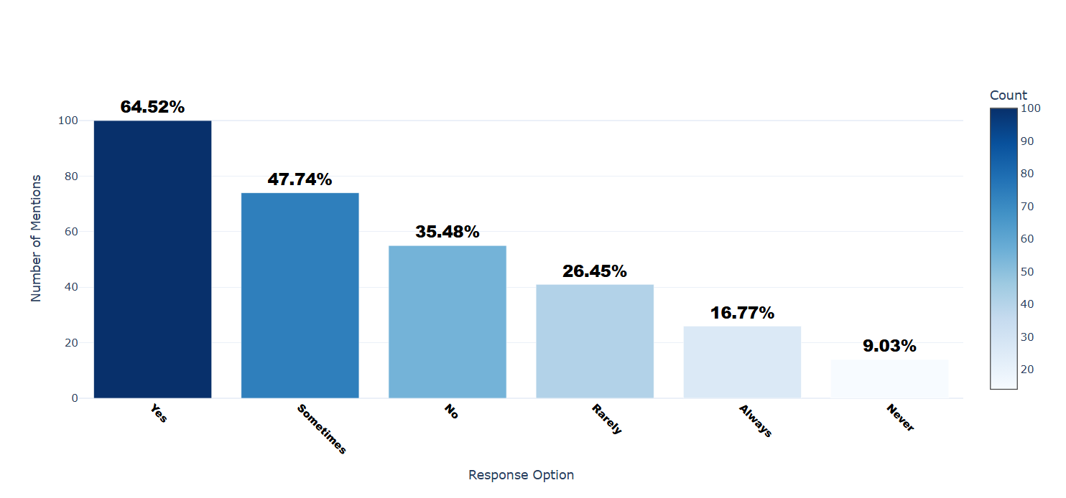

Number of respondents: 155

Breakdown of responses:

Yes: 100 (64.52%)

Sometimes: 74 (47.74%)

No: 55 (35.48%)

Rarely: 41 (26.45%)

Always: 26 (16.77%)

Never: 14 (9.03%)

## Q9.2: If you know that an application or service has experienced a data breach in the past, are you likely to continue using it?

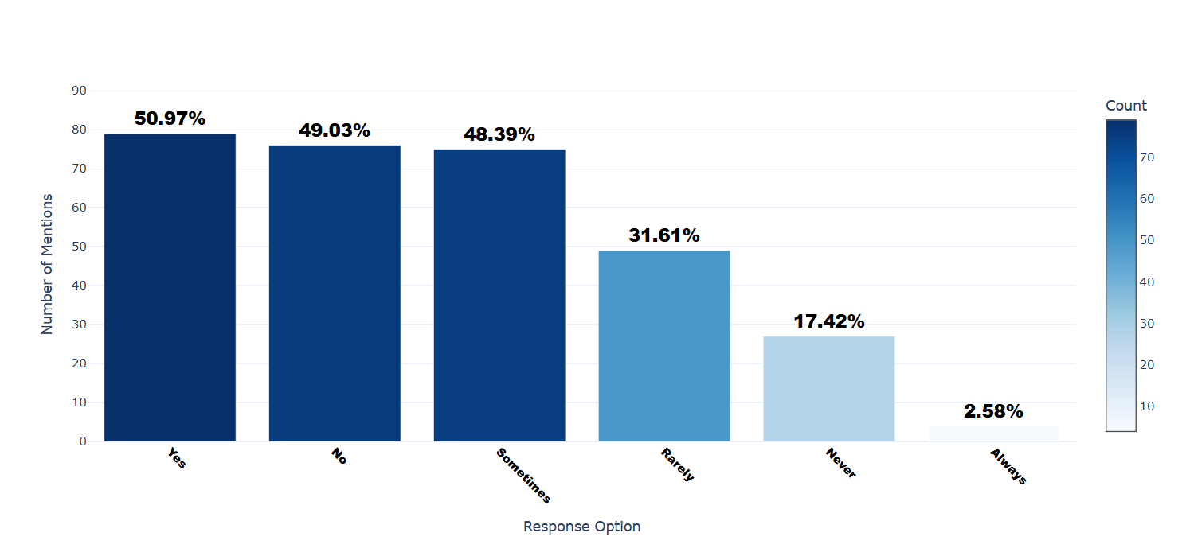

Number of respondents: 155

Breakdown of responses:

Yes: 79 (50.97%)

No: 76 (49.03%)

Sometimes: 75 (48.39%)

Rarely: 49 (31.61%)

Never: 27 (17.42%)

Always: 4 (2.58%)

## Q9.3: Consider two apps with similar features: App A requires full access to your photos but is free, while App B allows you to choose which photos to share but requires a fee. Which app are you more likely to use? - Selected Choice

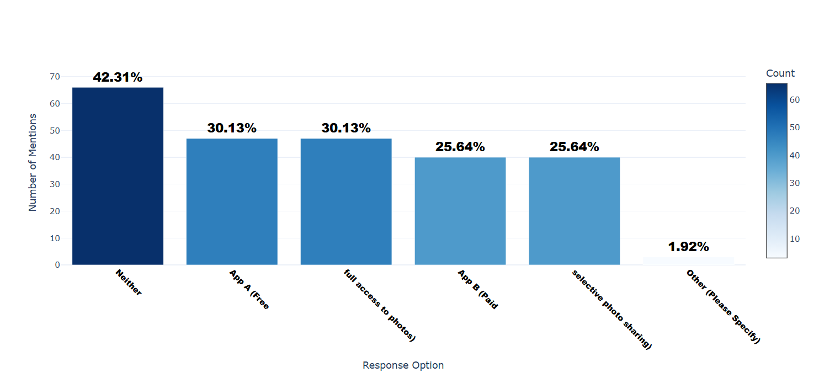

Number of respondents: 156

Breakdown of responses:

Neither: 66 (42.31%)

App A (Free: 47 (30.13%)

full access to photos): 47 (30.13%)

App B (Paid: 40 (25.64%)

selective photo sharing): 40 (25.64%)

Other (Please Specify): 3 (1.92%)

## Q9.3_4_TEXT: Consider two apps with similar features: App A requires full access to your photos but is free, while App B allows you to choose which photos to share but requires a fee. Which app are you more likely to use? - Other (Please Specify) - Text

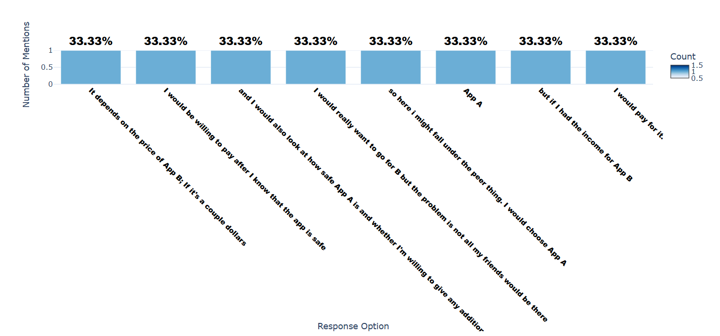

Number of respondents: 3

Breakdown of responses:

It depends on the price of App B; If it's a couple dollars: 1 (33.33%)

I would be willing to pay after I know that the app is safe: 1 (33.33%)

and I would also look at how safe App A is and whether I'm willing to give any additional information needed.: 1 (33.33%)

I would really want to go for B but the problem is not all my friends would be there: 1 (33.33%)

so here i might fall under the peer thing. I would choose App A: 1 (33.33%)

App A: 1 (33.33%)

but if I had the income for App B: 1 (33.33%)

I would pay for it.: 1 (33.33%)

## Q9.5: Which pricing option would you prefer?

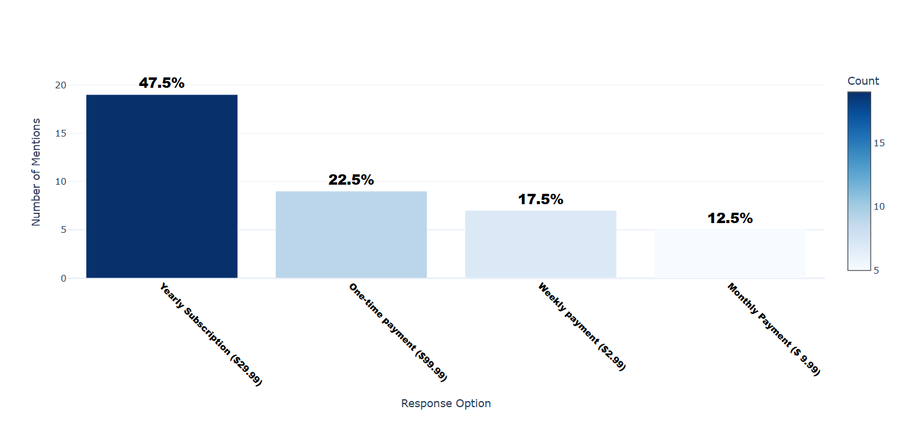

Number of respondents: 40

Breakdown of responses:

Yearly Subscription ($29.99): 19 (47.5%)

One-time payment ($99.99): 9 (22.5%)

Weekly payment ($2.99): 7 (17.5%)

Monthly Payment ($ 9.99): 5 (12.5%)

## Q9.6: Why did you choose App B?

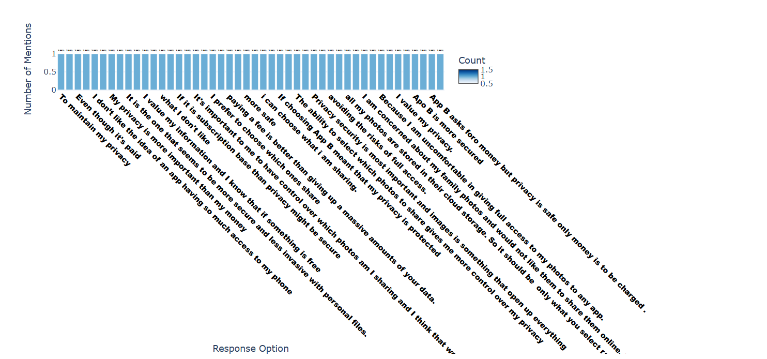

Number of respondents: 35

Breakdown of responses:

To maintain my privacy: 1 (2.86%)

I don't want anyone having access to all my photos.: 1 (2.86%)

Even though it's paid: 1 (2.86%)

it's best to be safe than sorry and try to keep my personal information as protected as possible: 1 (2.86%)

I don’t like the idea of an app having so much access to my phone: 1 (2.86%)

I've more control: 1 (2.86%)

My privacy is more important than my money: 1 (2.86%)

since it can lead to more serious concerns in the future.: 1 (2.86%)

It is the one that seems to be more secure and less invasive with personal files.: 1 (2.86%)

App A requires full access to my photos to operate and that is simply not agreeable.: 1 (2.86%)

I value my information and I know that if something is free: 1 (2.86%)

the information you give is the way to pay: 1 (2.86%)

what I don't like: 1 (2.86%)

because of the option to choose what you share: 1 (2.86%)

If it is subscription base than privacy might be secure: 1 (2.86%)

I would like to choose and pick what kind of data I want to share.: 1 (2.86%)

It's important to me to have control over which photos am I sharing and I think that we should rethink the model of everything is free but in return we have to share our entire life and create some options where we can have more control for a fee.: 1 (2.86%)

because I don't trust in them having total access to my photos: 1 (2.86%)

I prefer to choose which ones share: 1 (2.86%)

If finances allow it: 1 (2.86%)

paying a fee is better than giving up a massive amounts of your data.: 1 (2.86%)

Its more secure than App A: 1 (2.86%)

more safe: 1 (2.86%)

I am ok to pay for something which offers more privacy: 1 (2.86%)

i can choose what i am sharing.: 1 (2.86%)

Because of cheaper than A.: 1 (2.86%)

If choosing App B meant that my privacy is protected: 1 (2.86%)

I am willing to pay a small fee for it.: 1 (2.86%)

The ability to select which photos to share gives me more control over my privacy: 1 (2.86%)

even though it requires a fee.: 1 (2.86%)

Privacy security is most important and images is something that open up everything: 1 (2.86%)

I prefer App B for data control and privacy: 1 (2.86%)

avoiding the risks of full access.: 1 (2.86%)

It really felt very odd to me when I found out that by just unknowingly giving permission to Google photos: 1 (2.86%)

all my photos are stored in their cloud storage. So it should be only what you select rather than everything: 1 (2.86%)

Because App A is control and use my all photos but App B is not use all of my photos instead of it's use the photos which is shared by me. So i choose App B.: 1 (2.86%)

I am concerned about my family photos and would not like them to share them online. Therefore: 1 (2.86%)

I would pay a fee so that I can chose not to select my family photos.: 1 (2.86%)

Because I am uncomfortable in giving full access to my photos to any app.: 1 (2.86%)

ITs better to be in control of what you can share. There might be private photos i dont want share with the app.: 1 (2.86%)

I value my privacy.: 1 (2.86%)

Just as a safety precaution if the price is right: 1 (2.86%)

Apo B is more secured: 1 (2.86%)

Beacause of privacy concerns. Why should we give full permissions?: 1 (2.86%)

App B asks foro money but privacy is safe only money is to be charged .: 1 (2.86%)

Because I believe that true privacy is priceless: 1 (2.86%)

## Q9.7: How important is it to you to have control over which photos you share with apps?

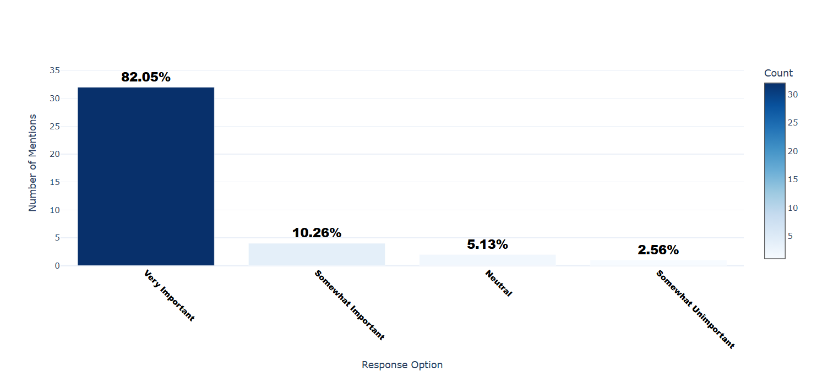

Number of respondents: 39

Breakdown of responses:

Very Important: 32 (82.05%)

Somewhat Important: 4 (10.26%)

Neutral: 2 (5.13%)

Somewhat Unimportant: 1 (2.56%)

## Q10.1: Consider you downloaded an app, and it asks you to give access to your location. Which option do you choose?

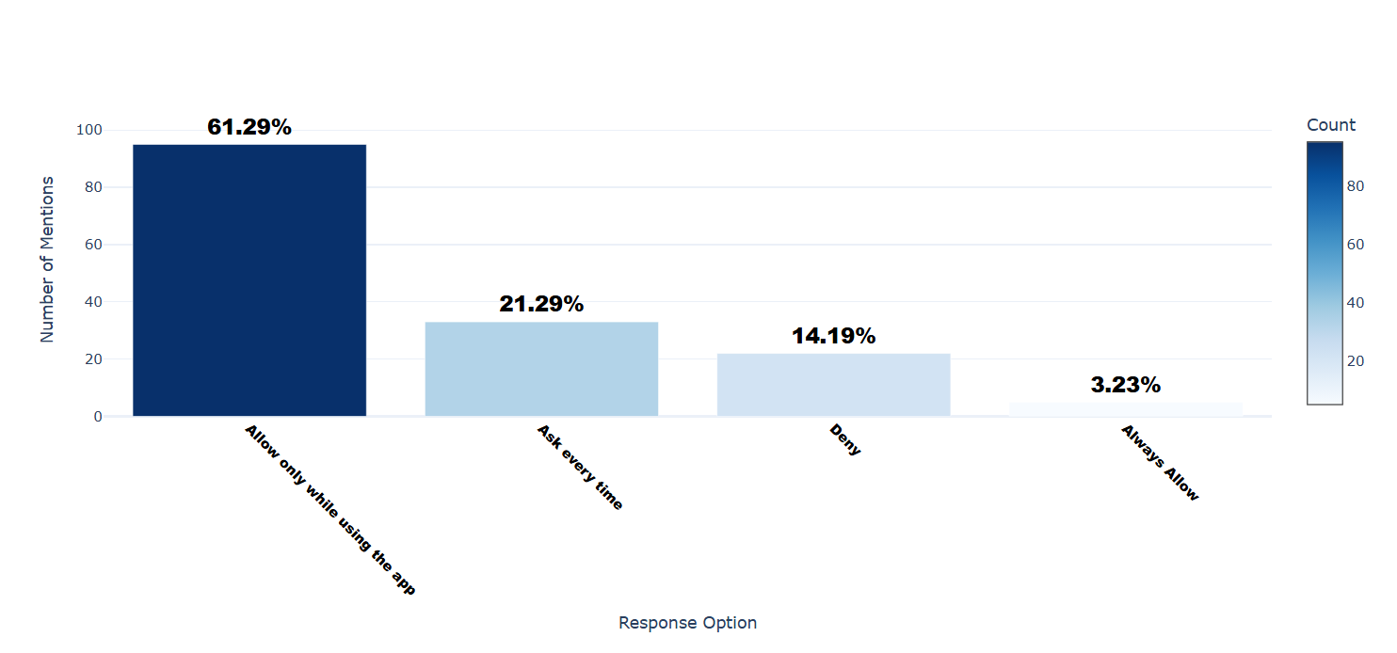

Number of respondents: 155

Breakdown of responses:

Allow only while using the app: 95 (61.29%)

Ask every time: 33 (21.29%)

Deny: 22 (14.19%)

Always Allow: 5 (3.23%)

## Q10.2: Consider you downloaded an app, and it asks you to give access to your photos. Which option do you choose?

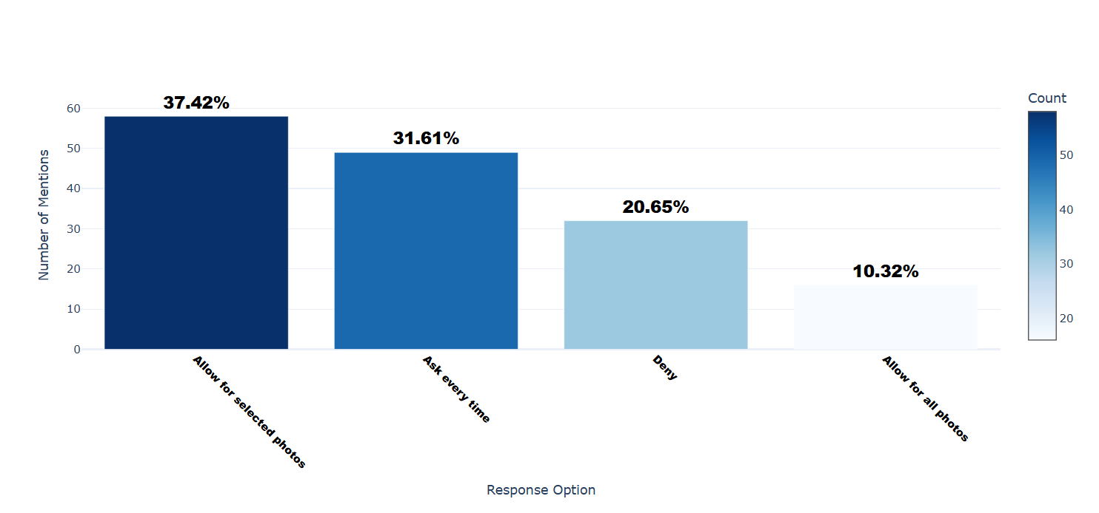

Number of respondents: 155

Breakdown of responses:

Allow for selected photos: 58 (37.42%)

Ask every time: 49 (31.61%)

Deny: 32 (20.65%)

Allow for all photos: 16 (10.32%)

## Q10.3: Consider you downloaded an app, and it asks you to give access to your microphone. Which option do you choose?

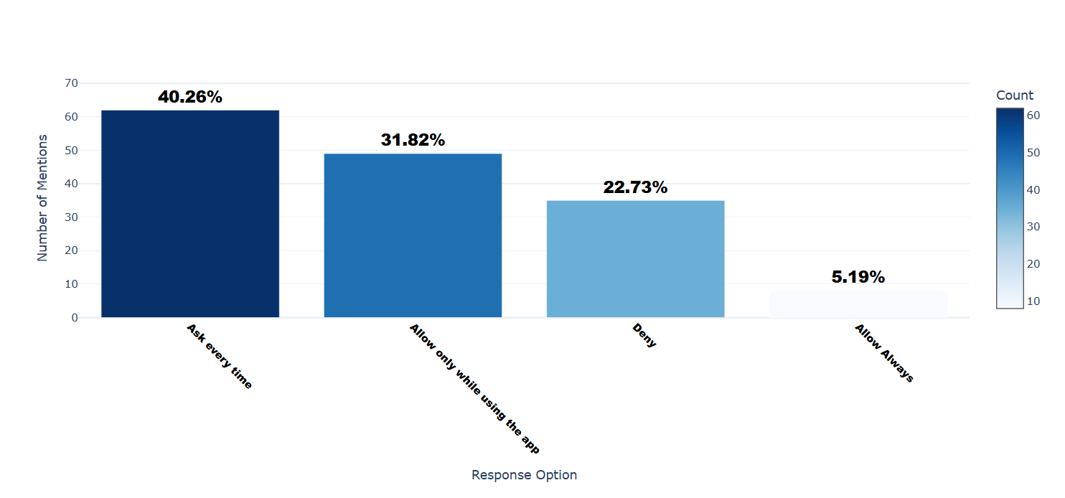

Number of respondents: 154

Breakdown of responses:

Ask every time: 62 (40.26%)

Allow only while using the app: 49 (31.82%)

Deny: 35 (22.73%)

Allow Always: 8 (5.19%)

## Q10.4: Consider you downloaded an app, and it asks you to give access to your camera. Which option do you choose?

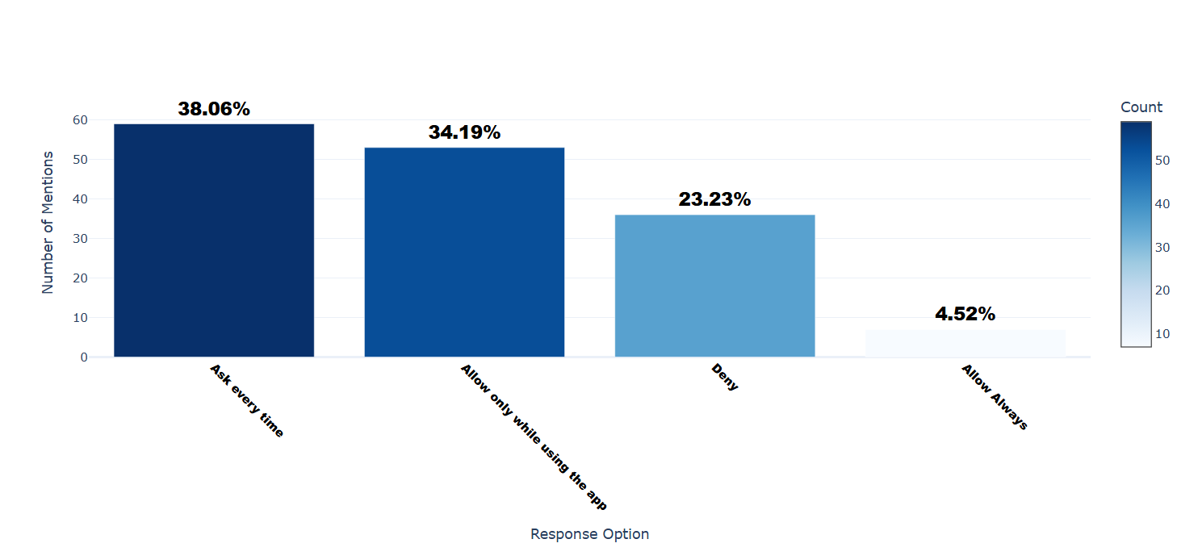

Number of respondents: 155

Breakdown of responses:

Ask every time: 59 (38.06%)

Allow only while using the app: 53 (34.19%)

Deny: 36 (23.23%)

Allow Always: 7 (4.52%)

## Q11.1: How familiar are you with privacy regulations in your country?

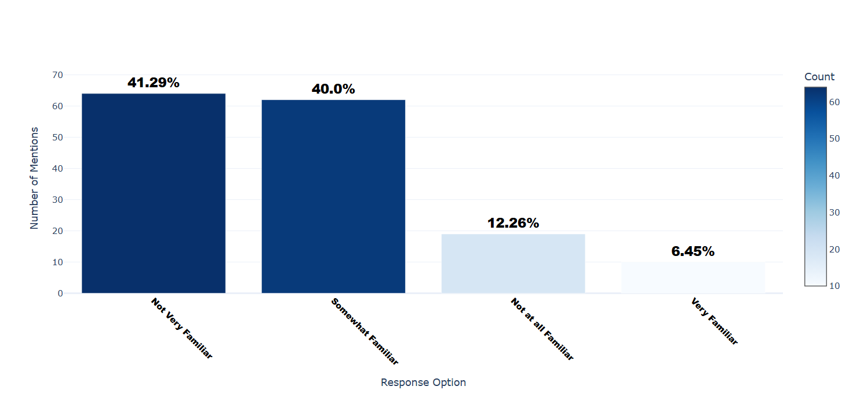

Number of respondents: 155

Breakdown of responses:

Not Very Familiar: 64 (41.29%)

Somewhat Familiar: 62 (40.0%)

Not at all Familiar: 19 (12.26%)

Very Familiar: 10 (6.45%)

## Q11.3: Do you support the idea of government regulations to protect online privacy?

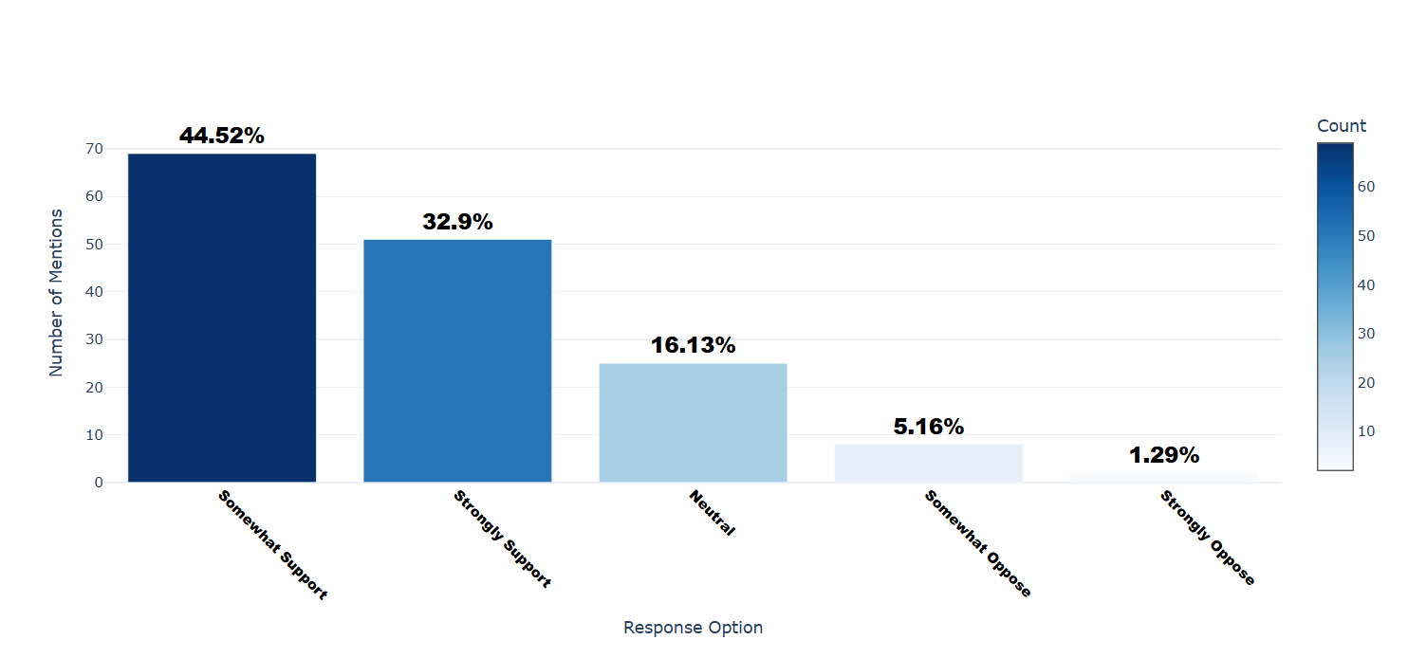

Number of respondents: 155

Breakdown of responses:

Somewhat Support: 69 (44.52%)

Strongly Support: 51 (32.9%)

Neutral: 25 (16.13%)

Somewhat Oppose: 8 (5.16%)

Strongly Oppose: 2 (1.29%)

## Q11.4: Which of the following types of legal requirements do you think are most important? (Select all that apply) - Selected Choice

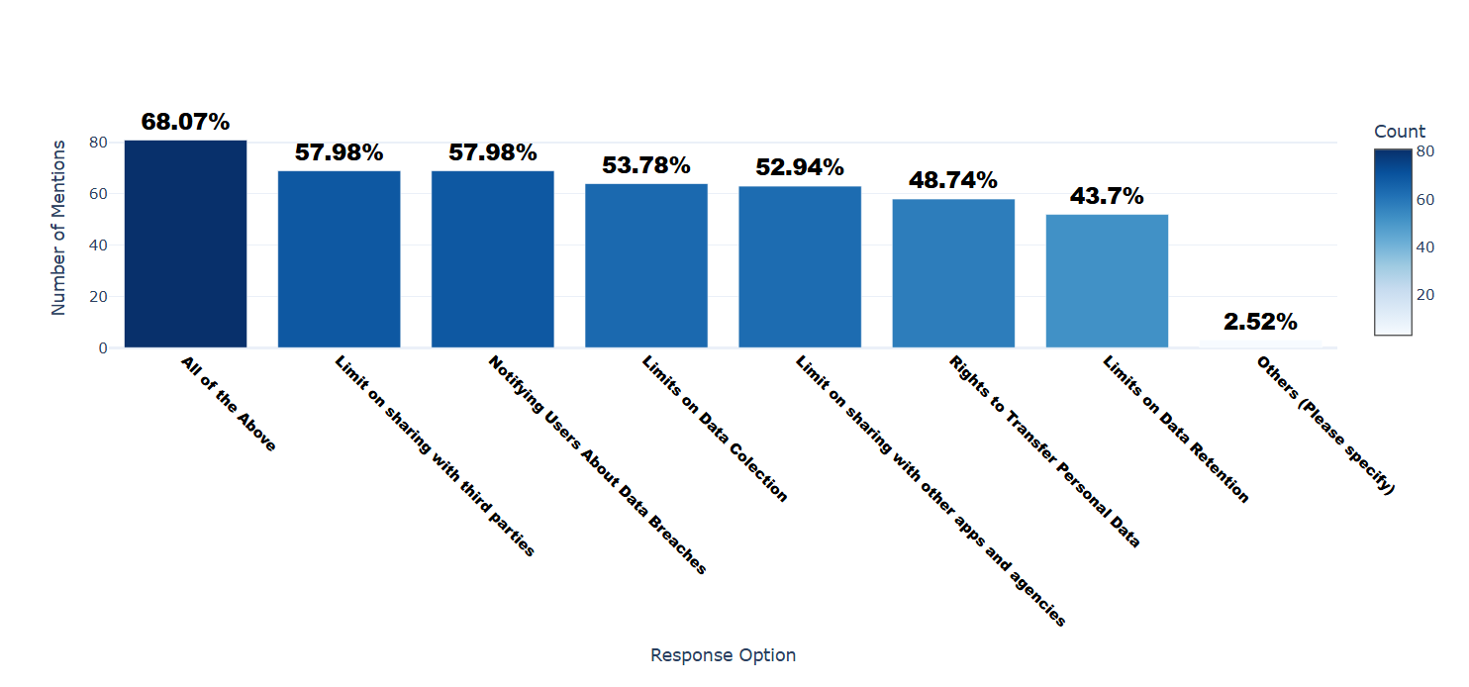

Number of respondents: 119

Breakdown of responses:

All of the Above: 81 (68.07%)

Limit on sharing with third parties: 69 (57.98%)

Notifying Users About Data Breaches: 69 (57.98%)

Limits on Data Colection: 64 (53.78%)

Limit on sharing with other apps and agencies: 63 (52.94%)

Rights to Transfer Personal Data: 58 (48.74%)

Limits on Data Retention: 52 (43.7%)

Others (Please specify): 3 (2.52%)

## Q11.4_4_TEXT: Which of the following types of legal requirements do you think are most important? (Select all that apply) - Others (Please specify) - Text

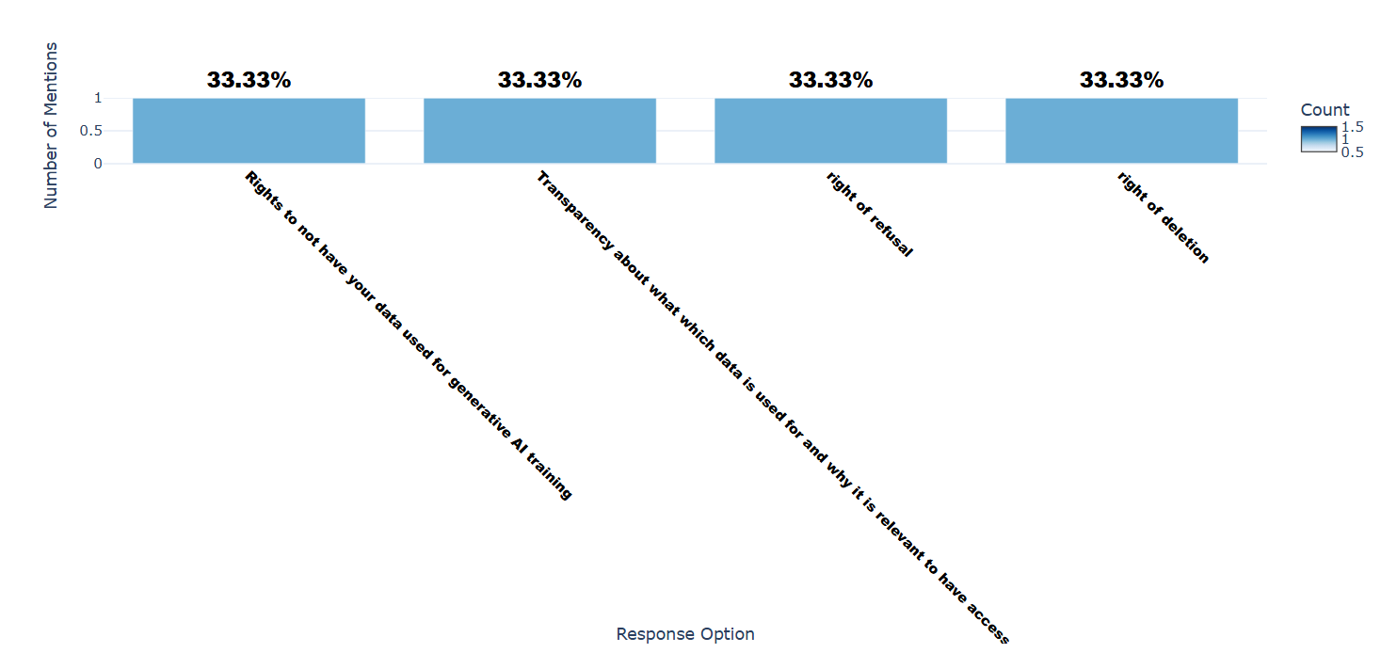

Number of respondents: 3

Breakdown of responses:

Rights to not have your data used for generative AI training: 1 (33.33%)

Transparency about what which data is used for and why it is relevant to have access to it in this context.: 1 (33.33%)

right of refusal: 1 (33.33%)

right of deletion: 1 (33.33%)

## Q11.5: What are your main concerns about government involvement in privacy protection?

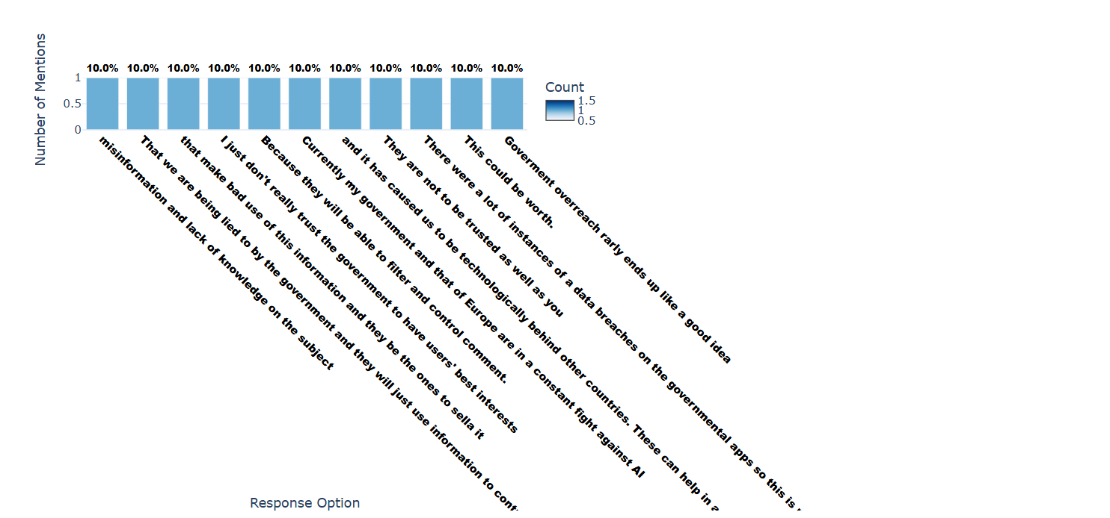

Number of respondents: 10

Breakdown of responses:

misinformation and lack of knowledge on the subject: 1 (10.0%)

That we are being lied to by the government and they will just use information to control us: 1 (10.0%)

that make bad use of this information and they be the ones to sella it: 1 (10.0%)

I just don't really trust the government to have users' best interests: 1 (10.0%)

Because they will be able to filter and control comment.: 1 (10.0%)

Currently my government and that of Europe are in a constant fight against AI: 1 (10.0%)

and it has caused us to be technologically behind other countries. These can help in a more personal way to raise awareness about data protection among the population.: 1 (10.0%)

They are not to be trusted as well as you: 1 (10.0%)

There were a lot of instances of a data breaches on the governmental apps so this is my biggest concern.: 1 (10.0%)

This could be worth.: 1 (10.0%)

Goverment overreach rarly ends up like a good idea: 1 (10.0%)

## Q12.1: Which types of devices do you use regularly? - Selected Choice

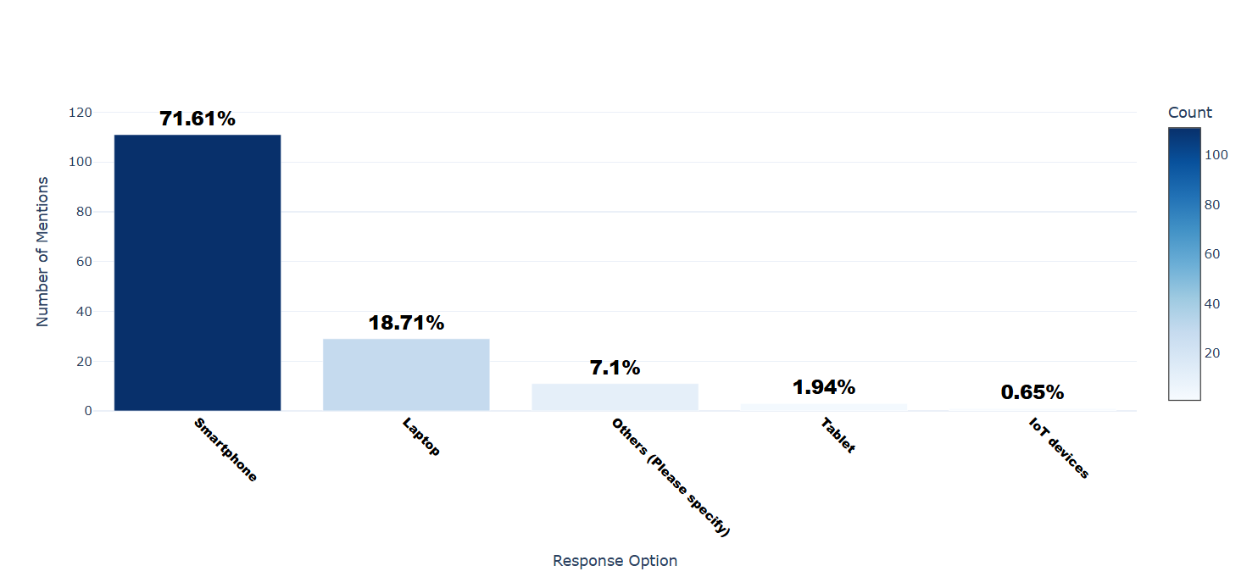

Number of respondents: 155

Breakdown of responses:

Smartphone: 111 (71.61%)

Laptop: 29 (18.71%)

Others (Please specify): 11 (7.1%)

Tablet: 3 (1.94%)

IoT devices: 1 (0.65%)

## Q12.1_5_TEXT: Which types of devices do you use regularly? - Others (Please specify) - Text

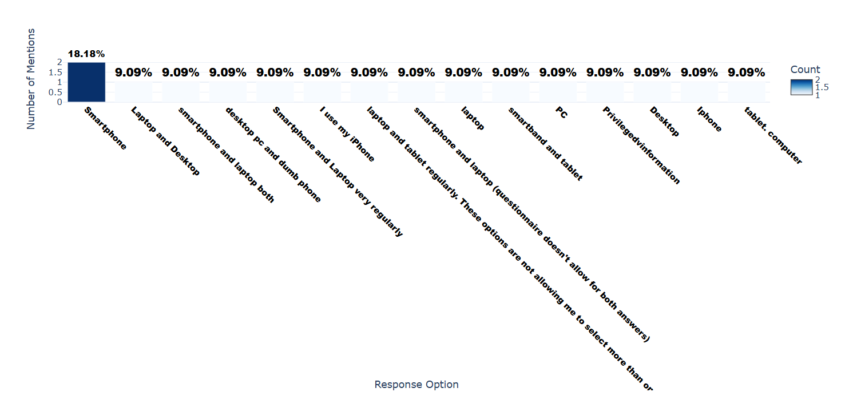

Number of respondents: 11

Breakdown of responses:

Smartphone: 2 (18.18%)

Laptop and Desktop: 1 (9.09%)

smartphone and laptop both: 1 (9.09%)

desktop pc and dumb phone: 1 (9.09%)

Smartphone and Laptop very regularly: 1 (9.09%)

I use my iPhone: 1 (9.09%)

laptop and tablet regularly. These options are not allowing me to select more than one.: 1 (9.09%)

smartphone and laptop (questionnaire doesn't allow for both answers): 1 (9.09%)

laptop: 1 (9.09%)

smartband and tablet: 1 (9.09%)

PC: 1 (9.09%)

Privilegedvinformation: 1 (9.09%)

Desktop: 1 (9.09%)

Iphone: 1 (9.09%)

tablet. computer: 1 (9.09%)

## Q12.2: Which of the following social media platforms do you use most frequently? - Selected Choice

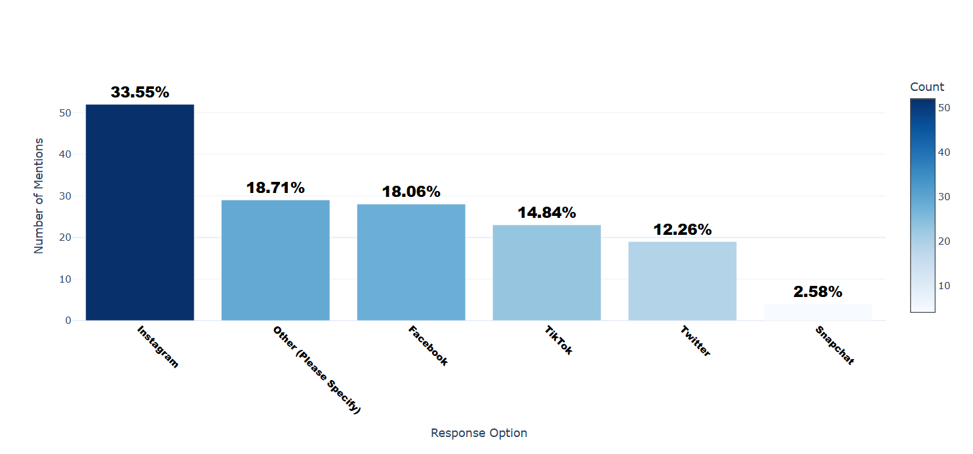

Number of respondents: 155

Breakdown of responses:

Instagram: 52 (33.55%)

Other (Please Specify): 29 (18.71%)

Facebook: 28 (18.06%)

TikTok: 23 (14.84%)

Twitter: 19 (12.26%)

Snapchat: 4 (2.58%)

## Q12.2_6_TEXT: Which of the following social media platforms do you use most frequently? - Other (Please Specify) - Text

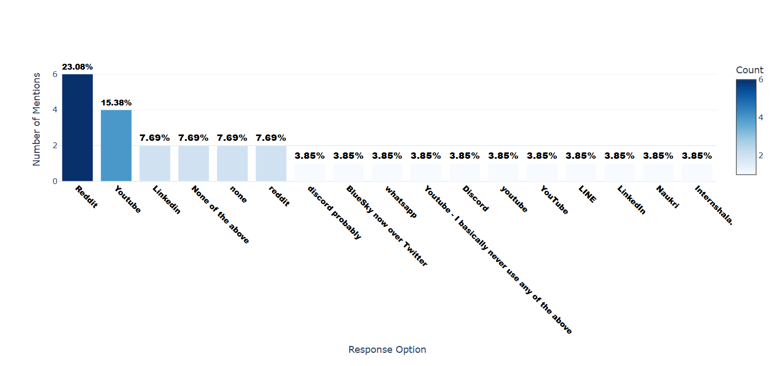

Number of respondents: 26

Breakdown of responses:

Reddit: 6 (23.08%)

Youtube: 4 (15.38%)

Linkedin: 2 (7.69%)

None of the above: 2 (7.69%)

none: 2 (7.69%)

reddit: 2 (7.69%)

discord probably: 1 (3.85%)

BlueSky now over Twitter: 1 (3.85%)

whatsapp: 1 (3.85%)

Youtube - I basically never use any of the above: 1 (3.85%)

Discord: 1 (3.85%)

youtube: 1 (3.85%)

YouTube: 1 (3.85%)

LINE: 1 (3.85%)

LinkedIn: 1 (3.85%)

Naukri: 1 (3.85%)

Internshala.: 1 (3.85%)

## Q12.3: Do you feel more comfortable using social media platforms that are popular in your country versus global platforms (e.g., Facebook, Instagram, Twitter, TikTok, WhatsApp, Messenger, Telegram, etc)? - Selected Choice

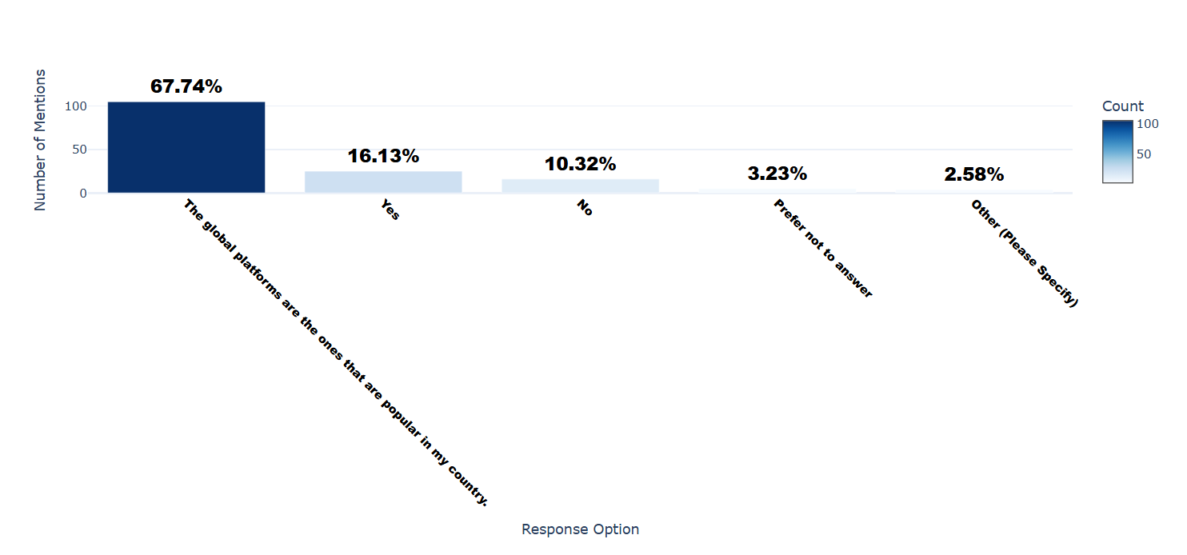

Number of respondents: 155

Breakdown of responses:

The global platforms are the ones that are popular in my country.: 105 (67.74%)

Yes: 25 (16.13%)

No: 16 (10.32%)

Prefer not to answer: 5 (3.23%)

Other (Please Specify): 4 (2.58%)

## Q12.3_4_TEXT: Do you feel more comfortable using social media platforms that are popular in your country versus global platforms (e.g., Facebook, Instagram, Twitter, TikTok, WhatsApp, Messenger, Telegram, etc)? - Other (Please Specify) - Text

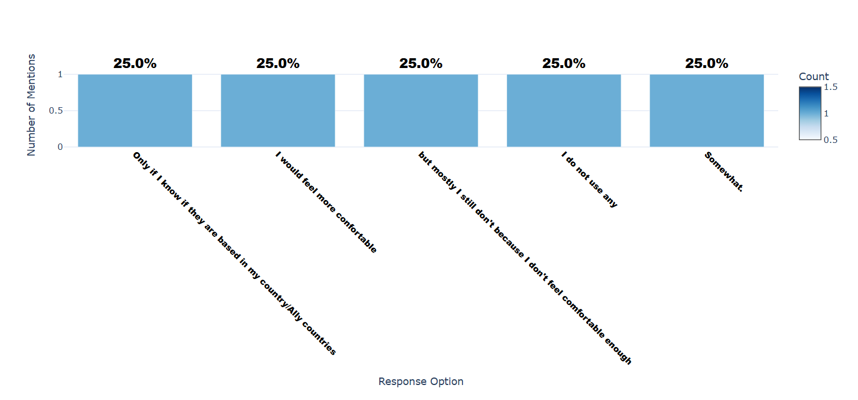

Number of respondents: 4

Breakdown of responses:

Only if I know if they are based in my country/Ally countries: 1 (25.0%)

I would feel more confortable: 1 (25.0%)

but mostly I still don't because I don't feel comfortable enough: 1 (25.0%)

I do not use any: 1 (25.0%)

Somewhat.: 1 (25.0%)

## Q12.4: How frequently do you use privacy-focused web browsers (e.g., Brave, Tor, Duck Duck Go, etc)?

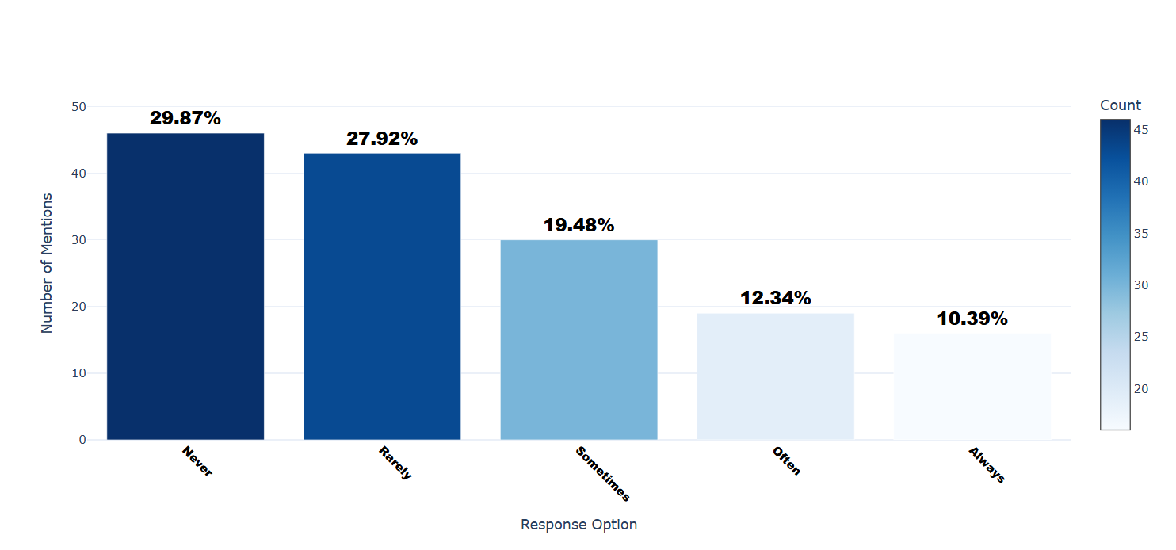

Number of respondents: 154

Breakdown of responses:

Never: 46 (29.87%)

Rarely: 43 (27.92%)

Sometimes: 30 (19.48%)

Often: 19 (12.34%)

Always: 16 (10.39%)

## Q13.1: What is your age?

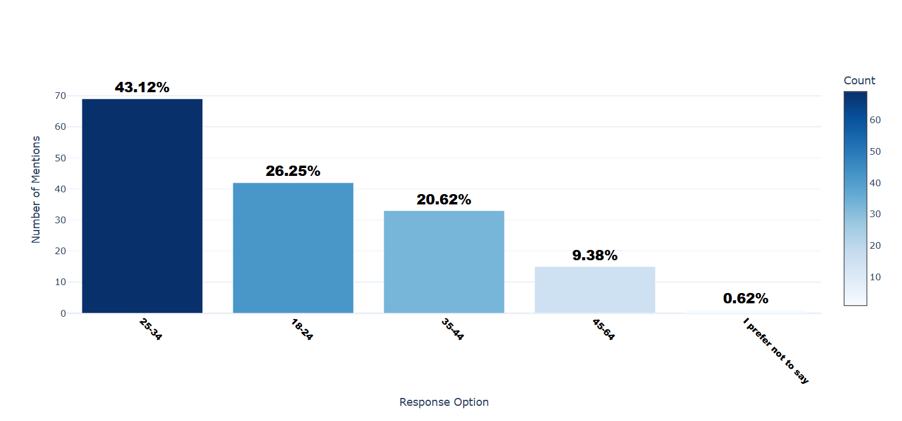

Number of respondents: 160

Breakdown of responses:

25-34: 69 (43.12%)

18-24: 42 (26.25%)

35-44: 33 (20.62%)

45-64: 15 (9.38%)

I prefer not to say: 1 (0.62%)

## Q13.2: What is your gender?

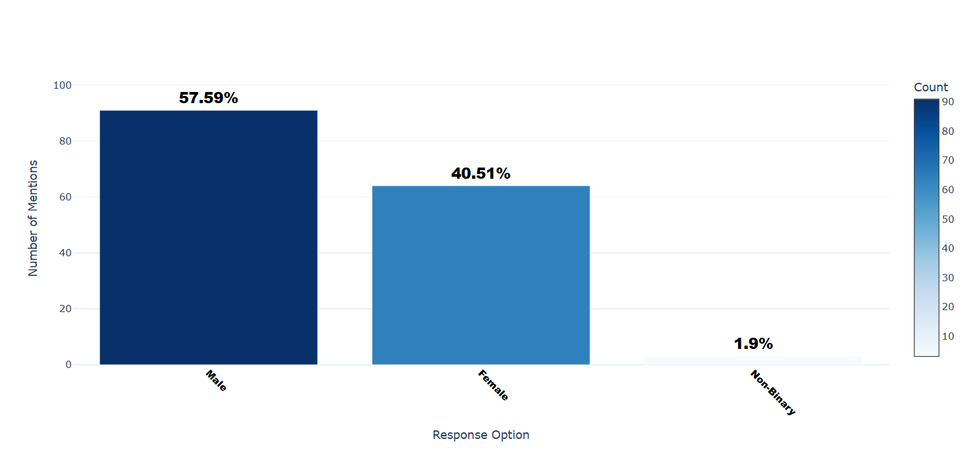

Number of respondents: 158

Breakdown of responses:

Male: 91 (57.59%)

Female: 64 (40.51%)

Non-Binary: 3 (1.9%)

## Q13.3: What is your highest level of education? - Selected Choice

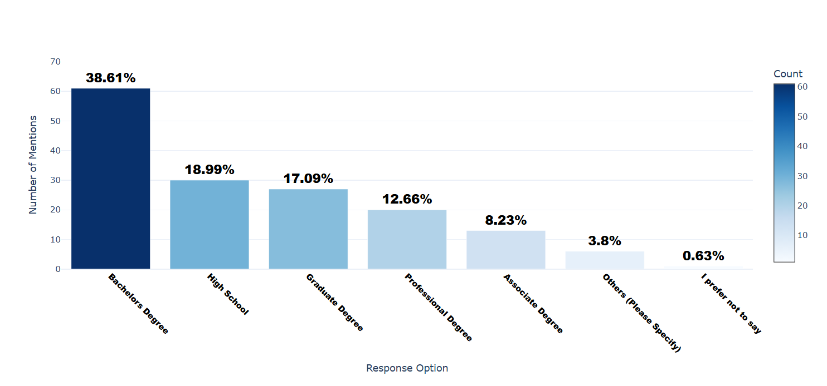

Number of respondents: 158

Breakdown of responses:

Bachelors Degree: 61 (38.61%)

High School: 30 (18.99%)

Graduate Degree: 27 (17.09%)

Professional Degree: 20 (12.66%)

Associate Degree: 13 (8.23%)

Others (Please Specify): 6 (3.8%)

I prefer not to say: 1 (0.63%)

## Q13.3_8_TEXT: What is your highest level of education? - Others (Please Specify) - Text

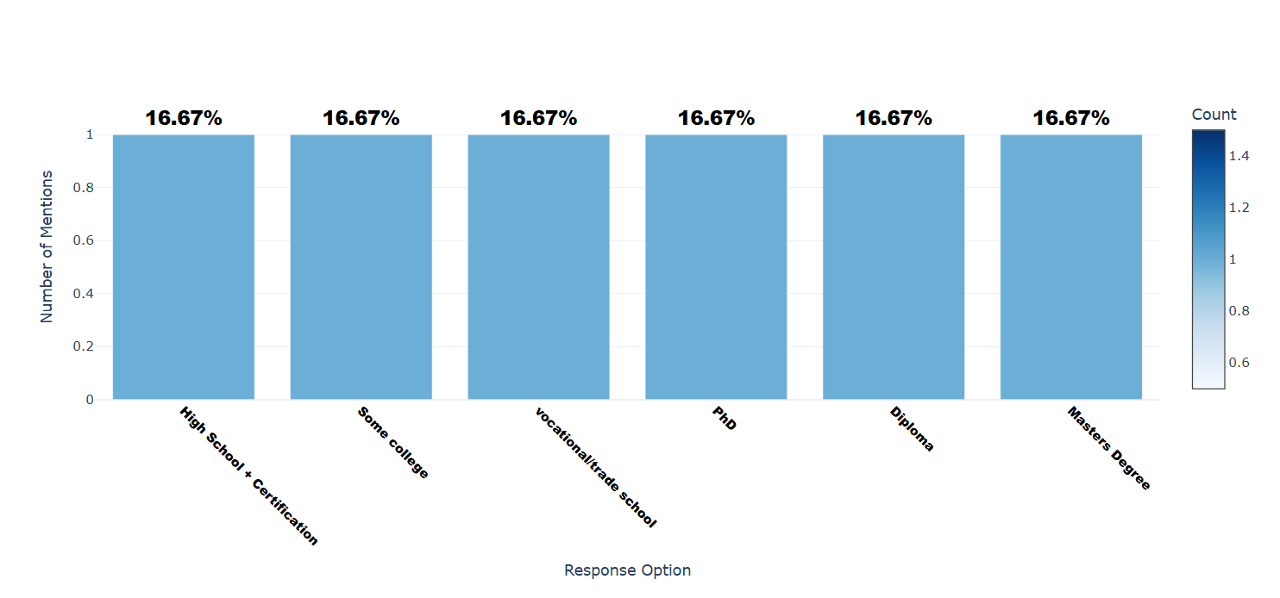

Number of respondents: 6

Breakdown of responses:

High School + Certification: 1 (16.67%)

Some college: 1 (16.67%)

vocational/trade school: 1 (16.67%)

PhD: 1 (16.67%)

Diploma: 1 (16.67%)

Masters Degree: 1 (16.67%)

## Q13.4: If you have obtained a degree, which fields did you study? (Select all that apply) - Selected Choice

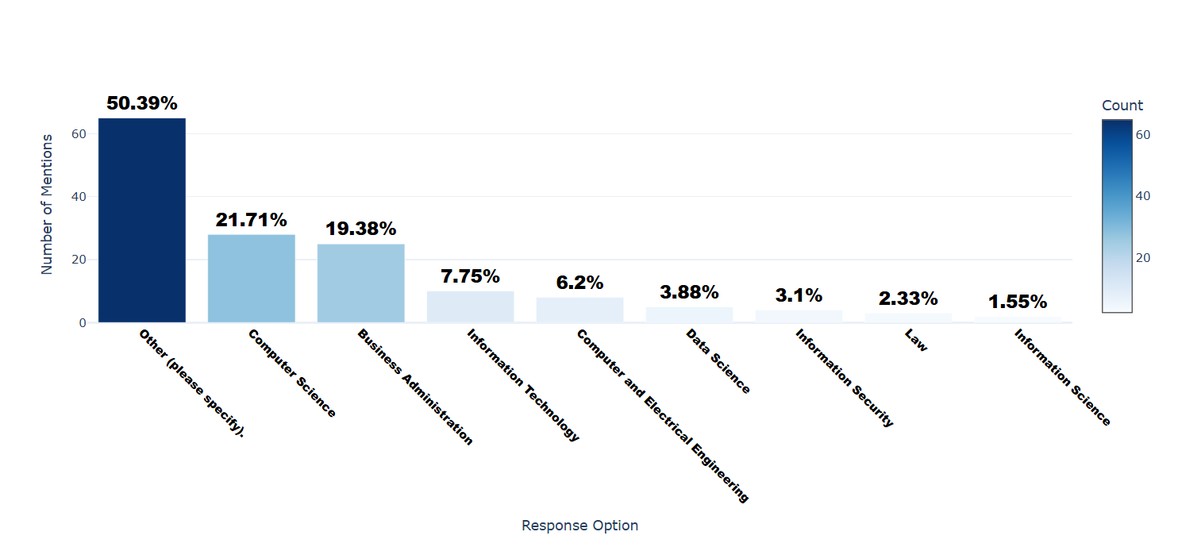

Number of respondents: 129

Breakdown of responses:

Other (please specify).: 65 (50.39%)

Computer Science: 28 (21.71%)

Business Administration: 25 (19.38%)

Information Technology: 10 (7.75%)

Computer and Electrical Engineering: 8 (6.2%)

Data Science: 5 (3.88%)

Information Security: 4 (3.1%)

Law: 3 (2.33%)

Information Science: 2 (1.55%)

## Q13.5: What is your religious affliation? - Selected Choice

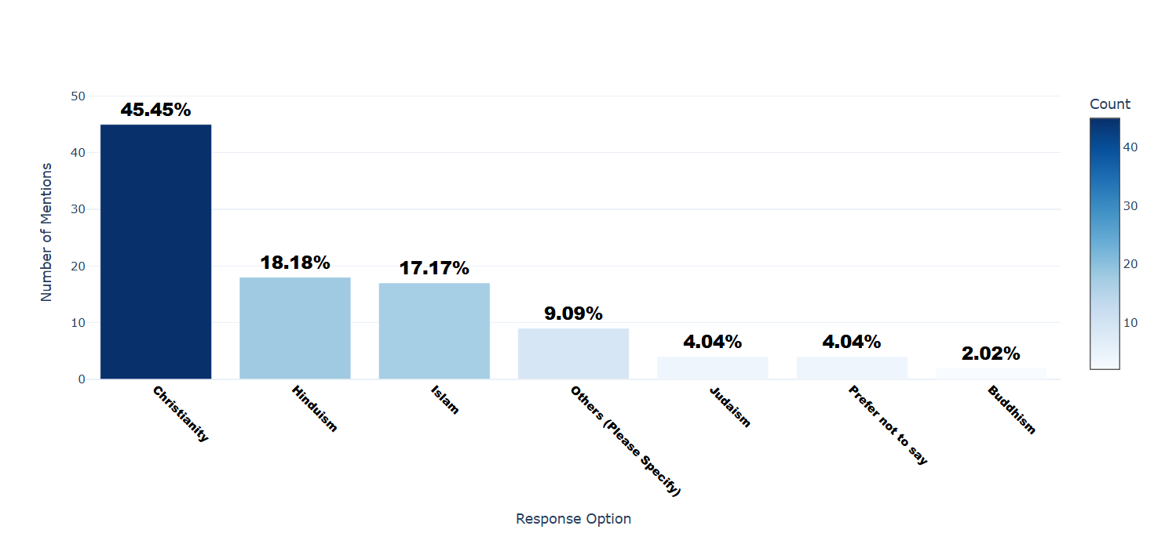

Number of respondents: 99

Breakdown of responses:

Christianity: 45 (45.45%)

Hinduism: 18 (18.18%)

Islam: 17 (17.17%)

Others (Please Specify): 9 (9.09%)

Judaism: 4 (4.04%)

Prefer not to say: 4 (4.04%)

Buddhism: 2 (2.02%)

## Q13.5_6_TEXT: What is your religious affliation? - Others (Please Specify) - Text

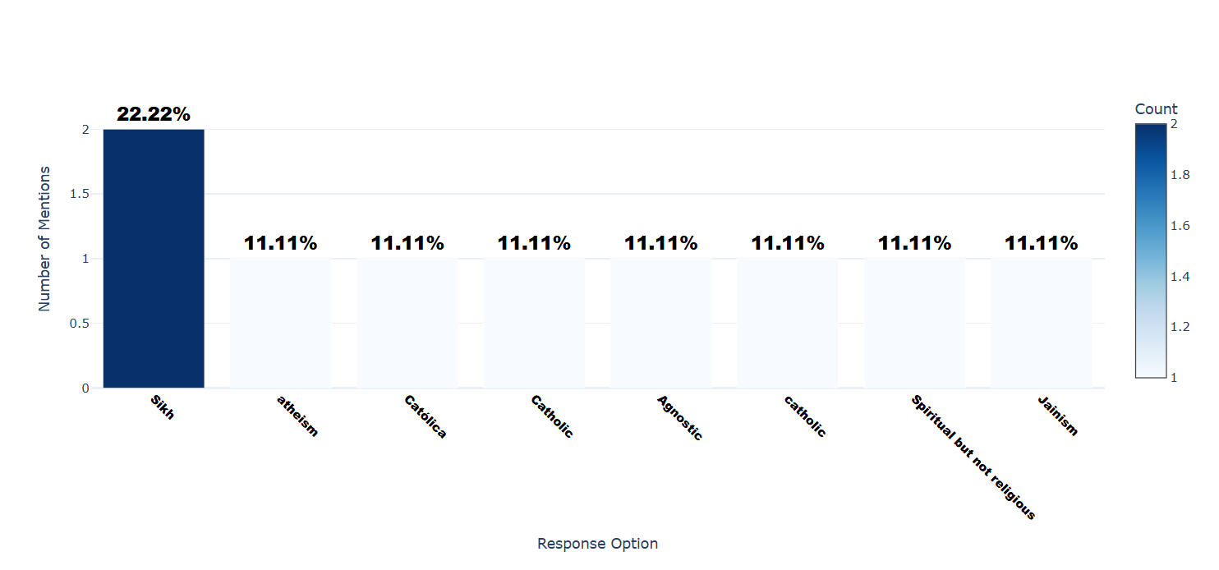

Number of respondents: 9

Breakdown of responses:

Sikh: 2 (22.22%)

atheism: 1 (11.11%)

Católica: 1 (11.11%)

Catholic: 1 (11.11%)

Agnostic: 1 (11.11%)

catholic: 1 (11.11%)

Spiritual but not religious: 1 (11.11%)

Jainism: 1 (11.11%)

## Q13.6: How Important is religion in your daily life? - Selected Choice

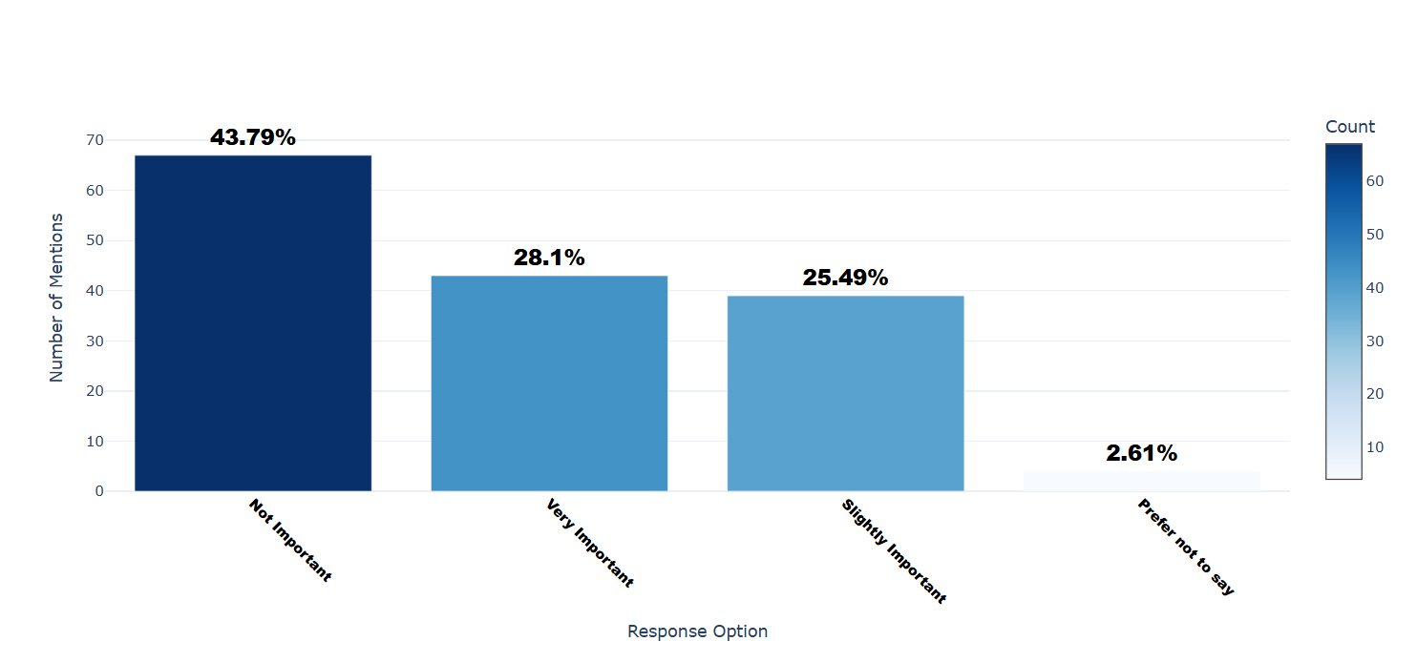

Number of respondents: 153

Breakdown of responses:

Not Important: 67 (43.79%)

Very Important: 43 (28.1%)

Slightly Important: 39 (25.49%)

Prefer not to say: 4 (2.61%)